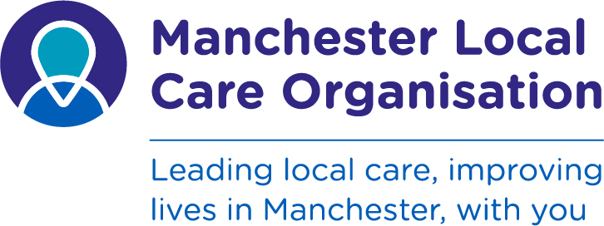

Manchester Local Care Organisation

Neighbourhood Lead

These roles are available through host employment with either Manchester City Council or Manchester University Hospitals Foundation Trust

Manchester City Council - Grade 12, £50,299 - £53,602 (Local Government Terms & Conditions)

Manchester University Hospitals Foundation Trust - Grade 8b, £49242 - £59,964 (NHS Agenda for Change Terms and Conditions)

In Manchester we’re transforming the way we work with people in our local communities to transform care and improve health. At Manchester Local Care Organisation - the new NHS and local authority partnership that is leading health and social care integration in the city – we are looking for Neighbourhood Leads who can drive that transformation and bring together health, care and other partners across areas of the city.
By working better together, we believe we will be able to plan and provide better care closer to home. We’ll be able to support the people of Manchester to live healthier, more independent and fulfilling lives. We’ll help them to be part of thriving and supportive communities.
We’re currently working to establish our 12 Integrated Neighbourhood Teams across the city and our Neighbourhood Leads play a crucial role in this. You’ll be leading health, primary care and social care professionals who will be working together as one team. You’ll help them work collaboratively with voluntary and community groups to empower people to take control of their care and improve wellbeing. It’s ‘devolution in action’: the people of Manchester taking control of the way their own health and care services best meet their needs.
These roles will:
  - Facilitate each neighbourhood to make positive changes to population health and wellbeing, with genuine co-production with the community.
  - Lead the quintet of professional leads from different professions and organisations
  - Develop a team with the right values, attitudes, behaviours, knowledge and skills to support the neighbourhood
  - Ensure effective partnerships are developed with the Voluntary, Community and Social Enterprise (VCSE) sector
  - In collaboration with community partners, understand the needs of each neighbourhood and develop and deliver the long term strategic plan for the neighbourhood

If you would like to discuss this role further, please contact Marie Daniel - Executive Assistant (mobile no. 07779 981 001) who will be able to connect you with a member of the MLCO Leadership team.

Closing date
To apply for these exciting and transformational new roles please submit your application by 12.00 Monday 29th October.
Role Profile
Application Form
To apply via Manchester City Council - click here
To apply via Manchester University Hospitals Foundation Trust - click here

