Tackling Inactivity Initiative, Winning Hearts and Minds Programme
GRANTS PROSPECTUS
September 2018

We are seeking a partner or partners to design and develop new approaches to tackling inactivity in North Manchester as part of the Winning Hearts and Minds Programme.
The Tackling Inactivity Initiative brief for the Winning Hearts and Minds Programme is provided in further detail herein.
To apply to be a partner, we require an expression of interest from your organisation. Please submit these using the guidance in this brief to a.martin@manchester.gov.uk by 5pm on 28th September 2018.

Thank you for your time in reading this prospectus and good luck with your application.

- Key Information:
Application closing date | 5pm on 28th September 2018
Applications reviewed | 1st – 12th October 2018
Interviews held | w/c 22nd October 2018
Applicants informed | w/c 29th October 2018

- Background
The partnership delivering the Winning Hearts and Minds programme (WHM) includes Manchester Health & Care Commissioning, Manchester City Council and Eastlands Trust.
WHM is a whole system approach to improving heart (cardiovascular disease) and mental health outcomes, and associated inequalities in Manchester, with an initial focus in North Manchester. The WHM programme consists of four main workstreams:

- Community-led Initiatives (CLI): using the ‘Our Manchester’ approach, this workstream draws on the evidence-base from the HELP (Health Empowerment Leverage Projects) model, and is central to delivery of the entire programme. Resident-led partnership groups for a number of ‘neighbourhoods’ (based on populations of around 5,000 people that are recognised as ‘neighbourhoods’ by local people) will develop and deliver initiatives for the WHM programme.

Relationships will be built with current groups and community development work where they already exist, and new groups will be facilitated where there are gaps. Delivery of this workstream will be facilitated through place-based approaches taking place in the city. The two initial areas we will pilot work in are Collyhurst and Cheetham.

- Healthy Lifestyles: this area of work will focus on promoting and increasing physical activity. This workstream includes the tackling inactivity initiative supported by Sport England, for which this prospectus directly relates.

- Healthy Hearts: this workstream is focussed on improving detection of cardiovascular disease (CVD) and its risk factors, optimising care and reducing variation. The first phase will focus on NHS Health Checks, atrial fibrillation and hypertension.

- Healthy Minds: this workstream will focus on improving the physical health of people with severe and enduring mental illness (SMI) through overcoming current barriers to good physical health and wellbeing for this group of people.

Please see the summary diagram below for an overview of the programme.
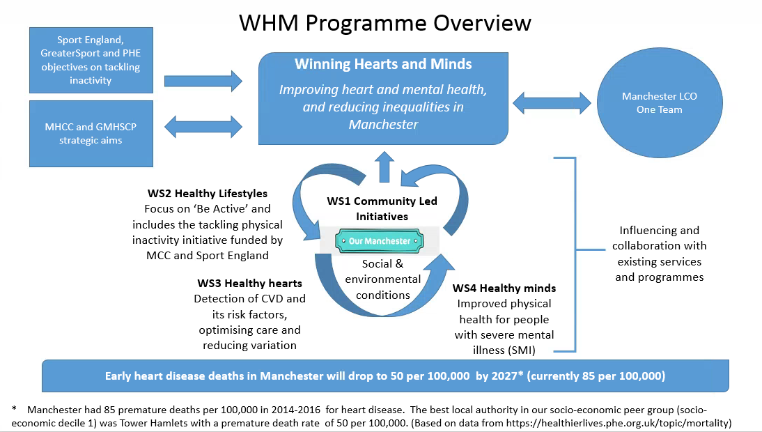

- Tackling Inactivity Initiative (TII)
The TII sits in the Healthy Lifestyles workstream.
There is robust evidence demonstrating the positive impact of increasing levels of physical activity on physical and mental health outcomes. Manchester is currently performing in line with national averages with “fairly active” and “active” residents; however, performance is significantly below national averages for “inactive” residents. We are therefore interested in testing new approaches to tackle physical inactivity.
This initiative, funded by Sport England and Manchester City Council, will enable the design, development and delivery of a new approach or approaches to tackling physical inactivity in two specific neighbourhoods of North Manchester, Cheetham and Collyhurst, with a view to improving the health outcomes of participants.
We are providing a grant to design and deliver a model/intervention(s) on the basis of co-produced outcomes. The grant applicant will be expected to take a community-centred approach, in line with the ‘Our Manchester’ strategy [https://www.manchester.gov.uk/downloads/download/6426/the_manchester_strategy], to co-produce an intervention(s) with residents and partners and to test new ways of working to achieve sustainable behaviour change in relation to physical activity at individual and community levels. The intervention is expected to operate for a maximum of 12 months.
We have defined the target audience for the initiative as:
- Adults aged 40-60 years old who are suffering from, or at risk of suffering from, poor heart and / or mental health outcomes and
- who are currently inactive (those doing less than 30 minutes per week of physical activity).
Through the co-production process, we acknowledge that the target audience may be further refined.

The TII will be supported by a research and evaluation partner – Manchester Metropolitan University (MMU). Their role is to support the development and delivery of this initiative by bringing research and evaluation experience and expertise in the field of tackling physical inactivity to improve health.

3.1 Co-production
The applicant is required to co-produce the outcomes and intervention. This will require the applicant to:
- engage with communities to co-produce, this may take the form of meetings or workshops;
- design the approach/ model and intervention(s) in line with local, national and international good practice and current thinking in the field of tackling physical inactivity to improve health outcomes; and
- develop scalable models/ interventions to tackle inactivity that can be tested locally.
Key partners involved in Winning Hearts and Minds will be required to join the co-production group for example the research and evaluation partner MMU, the programme lead for the Healthy Lifestyles workstream etc.

- Grant programme:
This grant programme is funded by Sport England and administered by Winning Hearts and Minds (Manchester City Council), it is overseen by a programme board made up of a range of stakeholders.
The total amount for the grant programme is up to £100,000. We are looking to provide 2 grants of up to £45,000 for each of Cheetham and Collyhurst. A further £5,000 (max) per area will be made available for co-production costs.

4.1 Who can apply?
a) Organisations must have:
- A recent (in the last two years) track record of work within the city of Manchester
- Three or more committee members with designated roles
- Aims, objectives or purpose (e.g. constitution, set of rules or other governing document)
- Appropriate mechanisms to ensure financial accountability

b) Applications will only be accepted from:
- Unincorporated associations, incorporated associations, trusts or companies that are set up and registered as a charity.
- An unincorporated association set up as a voluntary or community group
- An industrial and provident society
- A community interest company
- A not for profit company limited by guarantee
- A community benefit society
- A Charitable Incorporated Organisation (CIO)
c) The following cannot apply:
- Private sector or ‘for profit’ organisations
- Statutory/ public sector organisations e.g. local authorities, educational institutions and health authorities.
- Individuals and sole traders (unless established as one of the listed in 4.1 (b)).
The organisations listed in 4.1(c) can be included in formal/ informal partnership applications (but cannot receive income directly from the programme).

4.2 Partnership and collaboration
Formal and informal partnership and all forms of collaboration are encouraged.
By partnership we mean that the grant-holder has a continuing relationship with one or more other organisations who contribute in an agreed and practical way to the outcomes of the activities being funded by this grant programme. The agreement does not have to be formal or written down.
We understand the applicant may need to source sub-contractors depending on the design of the intervention required; we request this is limited to a maximum of 5 sub-contractors per area.

4.3 Funds
There are a maximum of 2 grants, one for each of Cheetham and Collyhurst. The same organisation can be the main applicant for both. Applicants can also apply for just one of the areas.
The co-production activities must start within one month of receiving the letter confirming a grant award.
The maximum length of funding for the intervention is 12 months from the agreed start point for the proposed activities. The funding will be paid in quarterly payments in advance.
Grant money that is unspent or unaccounted for will be dealt with in accordance with MCC’s recovery policy.

4.4 What can be applied for?
Although grants can be for capital and revenue activity (capital is defined as equipment in excess of £500) they must be predominantly revenue.
Full cost recovery is encouraged including reasonable contribution to core organisational costs dependent on the nature of the project.

4.5 How to apply?
Expressions of interest should be sent by email to arrive by 5:00pm, Friday 28th September 2018.
All expressions of interest received by this time will be acknowledged by email to confirm receipt and will be considered.
Expressions of interest should include the following:
- Contact details of the organisation (lead) – name, position, contact information.
- Demonstrate a track record of effective work with Manchester residents.
- Evidence of a strength-based approach: how your organisation carries out activities in a way that builds on the skills, abilities, knowledge, connections and capacities of the people that will directly benefit.
- Evidence of co-production and how your organisation has worked in collaboration with other stakeholders in Manchester, relevant to the activities they carry out.
- Demonstrate that your organisation has adequate governance and is well run.
The expression of interest should be presented so that each of the above five requirements are easily extracted from the submission by the review panel.
Expressions of interest should be provided as a Word document. Supporting documents can be included as appendices.
Whilst there is no word limit for the expressions of interest, applicants are asked to be succinct, directly responding on each of the above five points, and clearly articulating their position.

4.6 How will decisions be made?
Expressions of interest are invited, and subject to the criteria being met, applicants will be invited to attend an interview. The format of the interview will be notified to those applicants to whom it is relevant.
At interview, a selection panel will use a set of criteria to rank the applications and then balance the applications to ensure the applicant:
- Can demonstrate experience of co-production
- Will focus the intervention in the geographical areas of Collyhurst and Cheetham
- Can work with a wide range of types of communities and in an ‘Our Manchester’ way
- Considers sustainability of projects, how to create lasting impacts and alternatives to sourcing additional funding.
The recommendations of the selection panel will then go to the Winning Hearts and Minds Programme Board before final confirmation is made to the applicants.
Both successful and unsuccessful applicants will be informed by email. There is no appeals process. The decisions notified at this stage are final.
Grants will only be released once MCC has carried out due diligence checks on applicant organisations. Grant offers will be withdrawn from organisations that fail due diligence checks.
Feedback will only be provided on request.

5. Monitoring and Evaluation
Applicants should be aware of the following information, and be willing and able to work with the Winning Hearts and Minds programme and MMU to effectively achieve in these areas:
- Outcomes will be co-produced, therefore there will be a number of agreed key performance indicators (KIPs) and outcomes to report against on a regular basis.

- Costings must include sufficient time to carry out the following activities:
  - Introductory meeting – to take place shortly after the grant has been awarded and before co-production starts with key personnel involved in Winning Hearts and Minds.
  - Regular progress updates – e.g. every three months after the starting point of the activities – providing how the project is going, any changes from the original proposal, any changes in budget, knowledge and insights etc.
  - Final report.

- Data collection is required to be built in to the intervention, this is likely to include:
  - Basic service user demographic information (gender, ethnicity, age etc.)
  - Numbers of sessions/ interventions delivered, by location
  - Details of other outputs delivered, e.g. number of marketing or awareness raising interventions, by project
  - Volunteering – number of volunteers/ hours (if applicable)
  - Evidence of impacts emerging (e.g. service user feedback, plus other evidence as available)

  - Financial information: Expenditure and details of any further funding sourced.

  - Compliance with the Data Protection Act 2018 and General Data Protection Regulation.

As the research and evaluation partner, MMU will need some assistance with the following:
- Identifying participants for interviews (MMU will assist)
- Identifying participants for focus groups
- Distributing pre and post intervention questionnaires (ensuring these are completed and returned to MMU)
- Providing attendance information throughout the course of the intervention.
PLEASE NOTE: MMU will not be required to provide venue hire, catering, travel, interpretation or incentives for focus group attendees and interviews.

6. Point of Contact
If you require any further information or have any questions the principal point of contact is:
Angela Martin
Sport & Leisure, Manchester City Council
a.martin@manchester.gov.uk
07795 651 960 or 0161 219 2563

