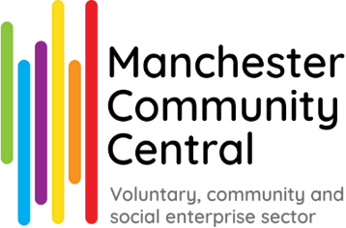

Recruitment Pack
Organisational Development Worker

Manchester Community Central
St Thomas Centre Ardwick Green North Manchester
M12 6FZ

0161 834 9823
manchestercommunitycentral.org

If you need this information in alternative formats, please contact us at Michaux@macc.org.uk or call us on 0161 834 9823.

Thank you for your interest in joining the team at Manchester Community Central.

Manchester Community Central is a charity, and put simply, our purpose is the city of Manchester. We work to inspire, enable and support the people of Manchester to get involved and build the communities where we live, work and grow. Manchester Community Central delivers a wide range of activities including:

- Helping local charities, community groups and social enterprises to be well-run, successful organisations with the resources they need to make a real difference
- Supporting local people to be active citizens through volunteering – matching local people with local organisations and causes through our Volunteer Centre
- Building an influential and connected community through policy, insight and collaboration – convening the spaces for groups and organisations to work together and share insights, building partnerships between charities, the local public sector and private businesses
- Celebrating the work, talents, creativity and diversity of all our local communities through our annual Spirit of Manchester programme, telling the story of the wealth of activity in local communities across the city

We believe every individual and community has unique skills, talents, knowledge and insights that are important. We also believe that our collective skills, knowledge and lived experience uniquely equip us to do the work we do. All of our work is informed by three key values:

- Being supportive – providing mutual support and encouraging one another
- Being collaborative – facilitating positive change in society by working with people
- Being influential – harnessing people’s skills and building their confidence to shape and inform policy and practice

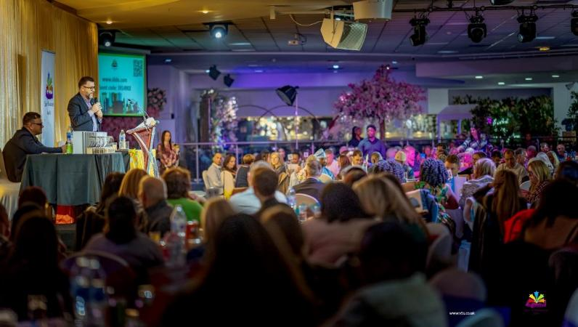
Spirit of Manchester Awards 2024
A Message from the Chief Executive

When people ask me what my job is, I often say that it’s to make more good stuff happen in Manchester.

Manchester Community Central (usually known just as “Macc”) has a unique position is at the heart of Manchester’s voluntary, community and social enterprise sector, working alongside public bodies and local businesses. Our role is unlike any other organisation in Manchester and gives us a unique perspective on this city.

We support, encourage and celebrate the amazing work of our local voluntary, community, and social enterprise organisations (including the community work done by faith organisations across the city) – VCSE sector for short. We help new groups get started and provide guidance for existing ones to grow and improve. We help organisations find the funding and resources they need to succeed. We help local people be active in their communities through our Volunteer Centre and we advocate for the VCSE sector to make sure that our voices and insights feed into decisions that affect Greater Manchester.

Part of our role is to bring organisations together so they can collaborate and have a stronger voice when working with the City Council, the NHS, and other public services. We do much of this work collaboratively with our neighbours in other parts of Greater Manchester through our 10GM partnership.

We also run the St Thomas Centre, a meeting space which is also home to a number of local community organisations and a popular space for events, cross-sector working and collaboration.

We champion equity and inclusion, celebrating the diversity of our local communities at our annual Spirit of Manchester Awards. We encourage climate action and work with businesses to create positive impact through social value. Manchester Community Central aims to be an active, influential and inspiring voice in the life of our city.

I’m proud of what we do and the impact we help create in local communities. As we do that, we try to lead by example in being a good employer and a great place to work. It’s important to us to provide a safe, welcoming and supportive environment for all our staff where you can develop your skills and knowledge whilst supporting our communities. We’ve shaped our offer to reflect the kind of workplace we’re proud to be – you'll find all the details of what Manchester Community Central offers below.

Thanks for your interest in Manchester Community Central. We look forward to hearing from you.


Best wishes,

Mike Wild
Chief Executive

Key Figures from the 2021 ‘State of the Sector Report’
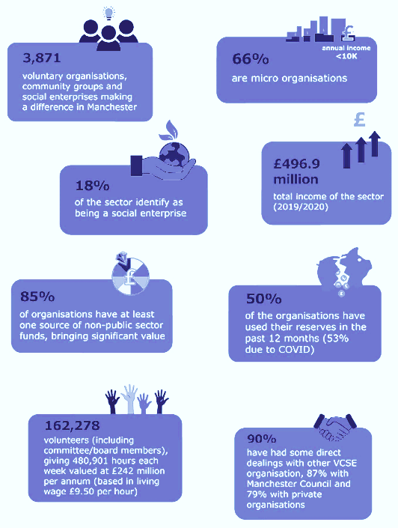

Key facts from Manchester Community Central’s State of the Sector research into the scale of the work done by charities, community groups and social enterprises across Manchester. This was part of a collaborative project with partners across Greater Manchester to show the contribution we make to the city region.

Some of Manchester Community Central’s achievements of the last few years
Manchester Community Central’s response to Covid19 included….
- Volunteer recruitment and support
- Practical advice on running services safely, obtaining PPE, workforce wellbeing
- Funding advice and distribution
- Organising early provision of advice and support in community languages and prioritising culturally appropriate responses
- Peer support for VCSE staff and volunteers
- Organising vaccinations for frontline VCSE staff and volunteers
- Representing & connecting with local regional and national bodies
- Kindness Stories campaigns celebrating local people supporting each other
- Monitoring and reporting the impacts on local communities and VCSE organisations

568
charities and community groups given focused support to develop their organisation
Over £2million additional funding brought into local VCSE organisations through Manchester Community Central
support

Action through collaboration
- Supporting Manchester Homelessness Partnership and GM Older People’s Network
- Working with Eric Wright Charitable Trust on grants for charities facing increased pressures in the cost of living crisis
- Partnership with CAHN and Comic Relief to give grants to Black-led community groups
- Bringing together VCSE organisations to support people arriving in Manchester from Afghanistan, Ukraine and Palestine.
- Building the 10GM partnership with other Local Infrastructure Organisations in Greater Manchester
- Facilitating peer support between leaders in Manchester VCSE organisations

6,246 volunteers recruited

New Premises
In early 2025, Macc took over the running of the St Thomas Centre in Ardwick.
Macc moved offices for the first time in our history!

Manchester Community Central Transformation Plan
- Updated Manchester Community Central Strategy
- Anti-racism strategy
- Climate action strategy
- New hybrid working approach
- Team restructure
- New staff support and accountability approach
13th annual
Spirit of Manchester Awards
held in October 2025

Over 5,000
individual hardship grants distributed to local residents
What the people we work with say about us

On support from Manchester Community Central
“Thank you so much for the great guidance and support in building [our group]!”

“It is going well with the volunteers – there is no way we could have done this without you holding my hand. You have done a great job!”

“I have been to other Manchester Community Central training sessions. I found all of them very helpful and knew this one was going to be the same”
“The Health check is a fantastic opportunity for us all to learn and grow as an organisation so all the Board is really appreciative of the time and effort Manchester Community Central have put in to it.”
“You never cease to be amazingly helpful and supportive. It's been so good to know you're there, during what has been a tough few years.”

“We’ve had some serious challenges – [the kinds of] Covid-generated crises familiar across the voluntary sector. Manchester Community Central has been a consistent source of practical help and I just wanted to let you know how incredibly valuable Manchester Community Central’s support has been. Thank you all!”

On our role in the city
“Manchester Community Central's policy and influence bulletin is always the most insightful, and useful newsletter/update I receive”

“Plays a critical linking role between different sectors, organisations and individuals with roles to play in building a better society; builds understanding and encourages people to think differently about their work”

“Thanks for showing and demonstrating much needed leadership and for being there for our sector in unprecedented times.”

On the Spirit of Manchester
“Our hearts are full after an amazing celebration of Manchester's community groups and charities. It’s such a privilege to be part of this group of change makers.”
Congratulations and huge thank you to all involved.”

“Thanks for lifting my spirits this evening, it’s just been brilliant. Thanks again to everyone working across the voluntary sector”

About the Role
Salary: £25,573 - £31,174 (Pro-rata)
Hours: 28 hours per week (0.8FTE) Mon-Fri. Flexible with core hours 10am-3pm
Location: St Thomas Centre and the job offers some delivery at local community venues and some working from home flexibility
Contract: Permanent (subject to funding)
Reporting to: Capacity Building Manager

Key responsibilities
- The sector: Manchester’s Voluntary, Community and Social Enterprise (VCSE) sector is made of thousands of organisations and individuals who use their time, skills, creativity and energy to improve the quality of life in the city. Macc brings together VCSE organisations from across the city to provide support, encourage collaboration and build the sector’s influence.
- Capacity Building: The organisational development worker role is to work with and develop a diverse range of local voluntary, community and social enterprise (VCSE) sector organisations, assessing their needs for group development support. The role entails delivering information, advice, guidance and bespoke support interventions along with peer learning and training as appropriate and through a mixture of in-person and online support delivery
- Purpose: To help VCSE groups become stronger, safer, more effective and more sustainable, contributing to improved outcomes for the people of Manchester. Our VCSE strategy takes this as a key feature of Macc’s role to support local VCSE organisations to set up, develop and thrive.
- Team: The post-holder will be one of three development workers in the team, assisting the Capacity Building Manager in the development and delivery of group development, information, advice and guidance.

Main Duties of the Role
These are subject to change throughout employment in response to changes in priorities and ways of working. Your line manager will work with you to turn these into annual objectives.

Being Supportive
- Providing advice, support and guidance to a range of VCSE groups including Black, Asian and minority ethnic organisations and groups within other communities of place, identity or interest around Manchester
- Use a diagnostic approach to assess, plan and record support needs with realistic targets and measurable outcomes
- Support people to formalise new VCSE groups in the best way to create positive change for Manchester residents and communities
- Assist newly formed VCSE groups and well-established local organisations to develop and strengthen, which may include providing support to help them:
- understand their governance roles and responsibilities
- develop their governing body/board
- choose an appropriate structure
- develop a clear vision and strategy
- develop a business plan
- develop a funding strategy and apply for funding
- develop suitable policies and procedures
- ensure robust financial management and reporting
- Support groups to be well resourced and sustainable with diverse and secure income
- Work with the team to design and deliver varied learning sessions and opportunities
- Work with VCSE groups and liaise with other support providers to procure support services from a range of sources or to create other solutions to enable capacity building
- Use a basic casework management system to monitor the progress of work with each VCSE group, ensuring that the potential benefits to groups are maximised and achieved
- Contribute to the development of tools and resources for defining and supporting the organisational development needs of small and medium sized VCSE groups

Being Collaborative
- Create and support connections and opportunities for VCSE groups to work together
- Ensure partners, members, funders and other stakeholders are familiar with the service and know how to access support or make referrals
- Contribute to joint projects with partners and stakeholders to provide additional support services
- Attend a range of meetings and events as required to promote support services
- Contribute to maintaining Macc’s database of contacts and records of support provided to VCSE groups

Being Influential
- Share insight across Macc on opportunities, learning and policy issues arising from casework e.g. groups’ experiences of funding and commissioning processes
- Maintain a cross-cutting view of issues such as equality, diversity and inclusion, health, crime, education and the needs of unacknowledged and emerging communities
- Promote the role and needs of the sector to stakeholders when appropriate
- Support with recording and sharing stories through our digital platforms to celebrate the strengths of the sector as a call to action more people and organisations to get involved.

General Responsibilities of all Manchester Community Central Staff
- Uphold and promote the purpose, beliefs and values of Macc, supporting others to do so and reaching out to build new relationships
- Be kind: work to be inclusive and treat people with dignity, respect and empathy
- Be accountable internally and externally for your work
- Work collaboratively as a member of the Macc team, and to contribute to the development of ideas, thinking, policy and good practice within Macc
- Share general responsibility for:
  - Macc’s communications newsletters, bulletins, social media and online resources
  - Macc’s contact & casework database
  - Reporting and being accountable for Macc’s impact
  - Supporting meetings, events and training opportunities
  - Macc’s annual Spirit of Manchester programme celebrating the local voluntary, community and social enterprise sector’s work in the city
  - Responding to enquiries and administration
- Contribute to income generation and general fundraising, including providing charged-for services where required
- Always be willing to learn and to undertake training when required.
- Work in accordance with key policies to ensure Macc exemplifies good practice as a VCSE organisation
  - Value diversity and be inclusive in line with Macc’s Equality, Diversity and Inclusion statement, anti-racism policy and other relevant policies.
  - Stay safe and well, being responsible for your own health & safety and that of colleagues, in accordance with Macc’s policies on Health and Safety, Safeguarding and Staff Welfare
  - Protect the integrity of our information and systems, being mindful of Macc policies on Data Protection, Cybersecurity and Open Data

Who we’re looking for

We're looking for someone who is genuinely good with people, who enjoys being curious and can relate to others’ points of view and who takes the time to really listen. You'll be meeting and working with individuals who care deeply about their communities, so a real motivation to support that kind of commitment matters.

Experience of working within the VCSE sector is useful but transferrable skills are valued too. We are looking for someone who can bring practical skills, knowledge and experience to help support local groups to strengthen and develop their sustainability. Whether that's governance, funding, or other areas of organisational development and training, you'll need to be confident offering guidance that makes a real difference.

You’ll need to be able to proactive in finding solutions and helping others, confident to provide honest professional challenge when necessary (constructive critical friend approaches), as well as able to adapt solutions and approaches to meet individual needs.

The right candidate will be open to growing in the role. We don’t expect candidates to have all the answers and technical knowledge from day one in the role, but they will need to be willing to learn, reflect and develop with the support available to them.

You'll need to be comfortable working in a role that's fast-paced and varied. No two weeks will look the same, and the ability to adapt, stay organised and keep on top of a mixed workload is important. A collaborative and supportive style of working is essential and be willing and able to develop a wide range of relationships and to share information and knowledge with others.

You need to be willing and able to travel around Manchester - though driving ability is not essential as we encourage use of public transport and ’active travel’ (such as walking or cycling)

What Manchester Community Central offers

At Manchester Community Central, we are committed to being an inclusive and supportive employer. We believe in creating a workplace where everyone can thrive, and we offer:

- Flexible working: We value flexible working and offer options such as adjusted working hours, hybrid or home working. We have office space at our St Thomas Centre base in Ardwick but our approach balances personal choice, building teamwork and the needs of the people we work with.
- Wellbeing support: Our dedicated Health and Wellbeing team works to create a culture that supports everyone’s health and wellbeing at Manchester Community Central. This includes access to confidential, in-house mental health first aiders and regular team social activities. We also offer ‘Re-energise Afternoons’ – monthly sessions where staff can take time away from work to rest and recharge.
- Carers support: We are committed to supporting carers in the workplace, and we offer five days paid carers' leave per year for those with ongoing caring responsibilities, along with other support.
- Menstrual Health and Menopause friendly workplace: We are proud to be Menstruation and Menopause Friendly employers, providing a range of support to help staff to manage symptoms, as well as educating employees on these topics.
- Professional development: Personal Development Plans (PDPs) and dedicated budgets for external training and growth.
- Volunteering leave: Staff are entitled to up to 2 days per year (pro rata) with pay to engage in voluntary activities.
- Active travel incentives: Support for public transport season tickets, a Cycle to Work scheme, and travel expenses for cyclists.

These benefits reflect our commitment to supporting staff while working together to strengthen Manchester's communities.

If you have specific needs or requests (e.g. related to accessibility, caregiving, flexible working, or something else), we encourage you to let us know during the application process.
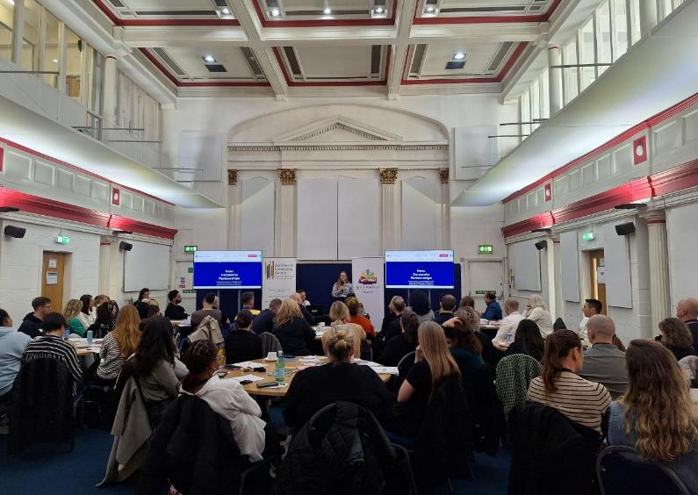
Macc Business Connect event at St Thomas Centre, October 2025
Equity and Inclusion

Manchester Community Central is passionate about ensuring that everyone has a fair chance and that they are treated equally.

We are aware of the underrepresentation of certain groups and communities in our sector. These include but are not limited to, people from racialised or minoritised backgrounds, people with disabilities, LGBTQIA+, people who are neurodivergent, and those from working-class backgrounds. We want to change this and commit to playing our part in eradicating inequalities in both what we do and the way we do it.

Manchester Community Central is an inclusive employer committed to building a diverse, effective workforce which reflects our local communities. We work hard to create a supportive, accessible working environment. We celebrate difference, and welcome applications from a wide range of backgrounds, skills and abilities, recognising value in different perspectives.

Our inclusion commitments:

 | 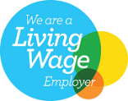 |  |  |  | 
 |  |  |  | 
 |  |  |  | 

How to apply
If you’re excited by this role and believe you can bring to it the skills and passion we’re looking for, we’d love to hear from you! Here’s how our recruitment process works:

1: Application Form
Attached with this pack is a short application form in which we ask you for some basic details and a few questions about your skills, knowledge and relevant experience. There is also an equalities monitoring form with simple questions and a privacy statement which we ask you to confirm you have read.

Once you’ve completed the form, please email it to: Michaux@macc.org.uk

We acknowledge all applications by e-mail (or post if email is not available) within 2 working days of receipt. If you don’t receive an acknowledgement, please contact us as soon as possible: if you haven’t heard from us, we may not have received your application.

2: Interviews
We will review all the applications we receive and then produce a shortlist of people we want to invite for an interview. These are usually held at our offices at St Thomas Centre in Ardwick. The interview gives us a chance to explore your application in more detail – and also for you to ask us questions about the role and our organisation. We might ask you to prepare a task in advance if that’s appropriate for the role.

If you are invited to interview, we’ll give you a copy of the questions when you arrive so you can have a few minutes to prepare your thoughts. After the interview we also give you an opportunity to share any feedback – or make a note of anything you forgot to mention.

Important dates:
- The closing date is 12pm midday Monday 6 July 2026
- Dates for interviews are Tuesday 21 July 2026

Need help or more information?
If you have any questions about the application process or to clarify any information in this Recruitment Pack, please email Michaux@macc.org.uk

While we can’t help you complete the application form, we recommend visiting the GM Recruitment Hub page ‘Tips for Applying for a Job in the VCSE Sector’. It includes helpful advice and resources to guide and inspire you as you write your application. You can find it by clicking the link or entering this web address into your internet browser: https://gmworkforcehub.org.uk/recruitment-hub/careers-advice/tips-for-applying-for-vcse-jobs/

Accessibility:
If you need this information in alternative formats or have suggestions to improve our recruitment process, please contact: Michaux@macc.org.uk or phone 0161 834 9823
Connect with us
Over 6,000 people signed up for our weekly news bulletin
 | @mcrcommcentral.bsky.social‬  Over 25,000 followers on our social media channels
 | VCM: www.facebook.com/VCMOfficial/  Spirit: www.facebook.com/spiritofmanchester/  GMOPN: www.facebook.com/gmopn/
 | Manchester Community Central Manchester
 | McrCommCentral  VolunteerCentreManchester
 | www.manchestercommunitycentral.org
 | Manchester Community Central,  St Thomas Centre, Ardwick Green North,  Manchester, M12 6FZ  Tel: 0161 834 9823

 | Manchester Community Central is a founding partner of 10GM, a joint venture to support the local VCSE sector in Greater Manchester
 |  | 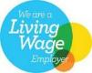 | 

Manchester Community Central is a Charity Registered in England and Wales No 1145921 and a Company Limited by Guarantee No. 7788593.

