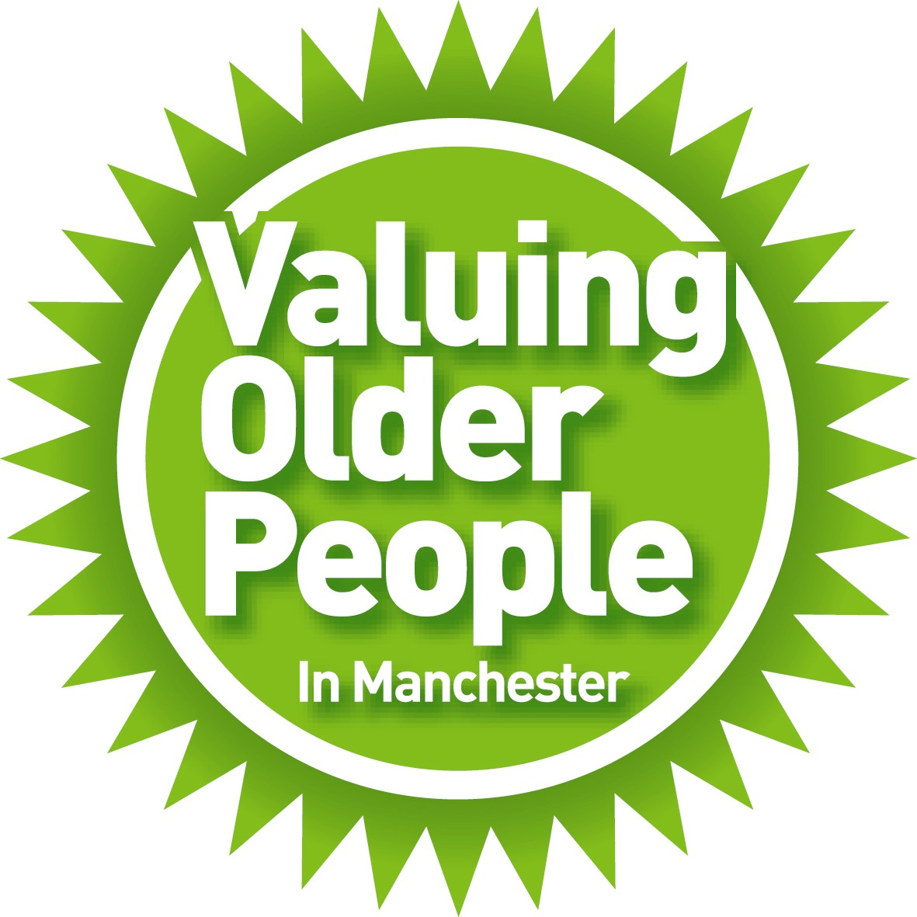


Dear Applicant,

Age Friendly Manchester – Small Grant Fund
Valuing Older People & Trinity House Community Resource Centre

Thank you for requesting an application pack for a Small Grant. The aim is to provide small grants for projects which benefit older people living in the City of Manchester. Priority will be given to grant applications looking to provide sustainable support to community groups and projects in Manchester, particularly projects tackling social isolation and loneliness Before completing the Application Form, please read the following guidelines.

“Who can apply?”

Applications are open to those involved in providing activities which help older people in the City of Manchester; we are particularly keen to support projects and activities that tackle loneliness. We accept applications from voluntary organisations, community groups and charities. The most important criterion is that the majority of people benefiting from an award must be older people.

“What can I ask for?”

The maximum you can apply for is £300. If, however, you feel you have a particularly special case and would like to apply for a little more, this may be considered. Should you want to discuss this matter before applying, please contact Rebecca Bromley at the Valuing Older People team on 0161 234 4049.

All applications are considered and you can apply for a wide variety of things, however, the Small Grants Fund is limited and awards are more likely to be made when it is made clear exactly how the money will benefit older people. If activities, goods or services can be accessed from other sources we ask that you would look to those alternatives first.

Here are some examples of what could be paid for through the Small Grants Fund.

Activities or learning Group activities such as a health walk or social event or an opportunity to learn new skill.

Speakers or tutors To pay for sessions and /or a speaker’s time at an event

Equipment This must be used to benefit older people.
If this includes a lot of smaller items, please include a list providing a breakdown of the costs. For larger pieces of equipment, please ensure you obtain at least two quotations.

“How are decisions made about award?”

The Valuing Older People team take responsibility for promoting the Small Grants Fund and also offer advice and support to those applying. When applications are received they are administered by our partners at Trinity House Community Resource Centre. We work with a panel of older people who sit on a Steering Group and directly support the Small Grant Fund. This panel meets twice a year to consider and comment on applications received. This information is shared with the VOP team and Trinity House CRC who make the final decision on the awards made. On occasions members of the grants panel visit applicants to learn more about how grants are going to be spent and the benefit the grant will make to older people.

“When will we know if we have been successful?”

You should be informed whether or not you have been successful within 30 days of the closing date of the particular grant round. A letter will be sent confirming the amount you have been awarded. We will then forward you a cheque, normally within 14 days of you receiving your letter. You will receive a Grant Offer letter with your cheque which explains our monitoring procedure. This should be signed and returned immediately.

“When can we apply again?”

Each group can apply for up to £300 in any one calendar year. If you have received an award less than £300, you are eligible to apply for further grants up to a total of £300, within the same fund year. Two rounds of grants applications will be considered each year, deadlines for applications for 2014 being:

- Friday 31 January
- Thursday 31 July

“What do we do next if we want to apply?”

Discuss your application with your group and reach a decision as to who is taking responsibility for completing the application form. It is important that this person is also willing to comply with our monitoring process, telling us how the grant has been spent. More information about this process is contained in the Grant Offer statement which you will be asked to sign once the award has been made.

Complete the enclosed application form and return it to:

Matthew Youngson
Trinity House Community Resource Centre,
Grove Close, off Platt Lane
Rusholme
Manchester
M14 5AA

Fax: 0161 248 9287
Email: info@trinityhousecrc.org.uk

If you want to find out more about the process or need further guidance, please feel free to contact Rebecca Bromley at the Valuing Older People team on 0161 234 4049.

Good luck with your application and thanks for your interest!

Yours with kind regards

Rebecca Bromley
Valuing Older People Team

Matthew Youngson
Trinity House Community Resource Centre

Age Friendly Manchester Small Grants Fund
Terms of Reference

The Fund
The fund is managed by Trinity House CRC, and supported by Valuing Older People and the Small Grants Fund Steering Group which also comprises of older people who act as Panel Members. The aim of the Fund is to provide small grants to community groups working for the benefit of older people.

The fund is known as the 'Small Grants Fund'.

Criteria for Eligibility and Assessment

Priority will be given to grant applications looking to provide sustainable support to community groups and projects in Manchester, particularly projects tackling social isolation and loneliness.

Applications can only be made by:

- groups and organisations providing activities which benefit older people and who can demonstrate their commitment to bettering the lives of older people

- groups and organisations operating within the City of Manchester

- groups and organisations managed by a steering group or committee, in an ethical and responsible manner.

- groups and organisations who fully involve older people in the management and decision making processes of the group or organisation

- groups and organisations who do not discriminate on grounds of race, ethnicity, gender, marital status, religion or sexual orientation

- groups and organisations whose main objectives and activities are not aimed at increasing the membership of a particular political party or religion

- groups and organisations who are willing to complete any monitoring process thus demonstrating their accountability

The most important criterion is that at least the majority of the people who will benefit from an award must be older people.

Awards
The maximum award is £300 per group, in any one funding year. Applications asking for more will be considered on their merits and, if deemed strong enough, a higher award may be made providing sufficient funding is available.

Anything not listed under 'Exemptions' will be considered.

Groups can apply as many times as they wish but cannot exceed the maximum (£300) award in any one fund year.

Applicants will normally be notified within 30 days of the closing date specified for each particular grant round.

Cheques will normally be issued by Trinity House CRC within 14 days of applicants being notified of a successful award.

Exemptions
Shopping only trips
Statutory work

Assessment

Applications are assessed on their own merit.

Applicants will be informed whether or not they have been successful within 30 days of the decision being made.

Monitoring
Successful applicants will be required to sign a Grant Offer letter when accepting their award. This letter must be signed by the group representative who signed the original application form.

Following grant spend successful applicants are required to provide specific information relating to the activity/event supported by the Small Grant Fund to Trinity House CRC. This information should be provided by no later than three months after the completion of the activity.

Administration and Promotion
The Small Grants Fund will be promoted by Valuing Older People and Trinity House CRC. All administration will be carried out by Trinity House CRC.

Support to the Small Grant Fund
A Steering Group consisting of representatives of the Valuing Older People team, Trinity House CRC and older people will meet regularly to develop and monitor the benefits of the Small Grants Fund.

Age Friendly Manchester - Small Grants Fund
Application Form
Valuing Older People and Trinity House CRC

Office use only | Org |  | Req
Awarded | Yes □ | £ | No □

Please read the enclosed guidelines and terms of reference before
completing in this form.

Please type or write clearly

Name of group

Person completing and signing this form
Name:

Position in group:

Address for correspondence including postcode

Telephone number(s)

Email

Have you already applied this financial year?
Yes / No

Who to make cheque payable to, and who manages your funds?
What type of group are you (e.g. charity, co-operative etc)? If you are a registered charity please include your number.

How is your group managed? (E.g. by a committee, trustees etc).

Approximately how many older people attend your group on a regular basis?

What is the approximate percentage (%) of members in your group you would class as an older person?

How are members involved in the running of the group?

Please give a brief outline of what your group does and what needs it is trying to meet.

How much funding are you asking for? | £

What are you going to use the money for? Please give details (at least two paragraphs) and explain how the activity/project will reduce loneliness and social isolation. If you are requesting money for equipment, please enclose at least two quotations.
Please include a breakdown of costs associated with your planned activities in the table below.
Expenditure | Amount
Example: Event catering - hotpot at £1.50 pp for 20 people | £30

Diversity & Equal Opportunities. If your group caters for specific black or minority ethnic communities, please give details.

I confirm that the information given on this form is accurate to the best of my knowledge.

I understand the monitoring process which is in place and will be happy to comply with it.

Signed: _________________________________________________________

Date: ___________________________________________________________

Please return this form to:

Matthew Youngson, Trinity House Community Resource Centre, Grove Close, off Platt Lane, Rusholme, Manchester M14 5AA
Email: info@trinityhousecrc.org.uk, Fax: 0161 248 9287

