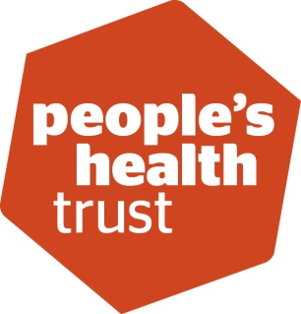
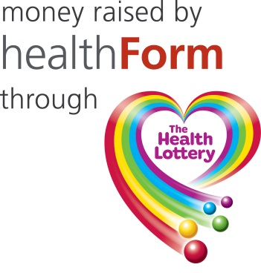

Looking for local funding?
Local groups and organisations with great ideas to make their communities even better places to live are now invited to apply for funding to turn their ideas into reality.

Using money raised by society lotteries through The Health Lottery, People's Health Trust has opened Active Communities in HealthForm - Manchester.

Active Communities is a funding programme for community groups and not-for-profit organisations, with an income of less than £350,000 a year or an average of £350,000 over two years, seeking investment of between £5,000 and £50,000 for projects lasting up to two years. We're looking for small and local projects, genuinely designed and run by local people. By small, we mean just a small group of people on an estate, in a few streets or villages.

We're also looking for great ideas from communities of interest. By this we mean a group of people who have things in common and wish to come together to address something that is important to them. These ideas could be based in one neighbourhood, or cover a wider area.
We run a two stage application process over a six week period that begins with a short online form.

Forever Manchester are supporting groups in Manchester to develop their funding idea and submit the first stage application. Ideally, these applications need to be submitted by Wednesday 22nd April, as if your first stage application is successful you will need to complete the second stage application by 6th May.

If you are thinking of applying, please do contact us first as we can give you one-to-one support and guidance. For further information please contact a member of the awards team on 0161 2140940, email awards@forevermanchester.com

We look forward to hearing from you.

