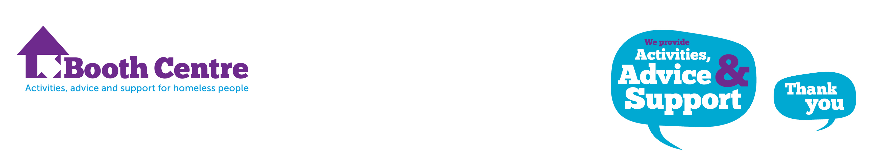

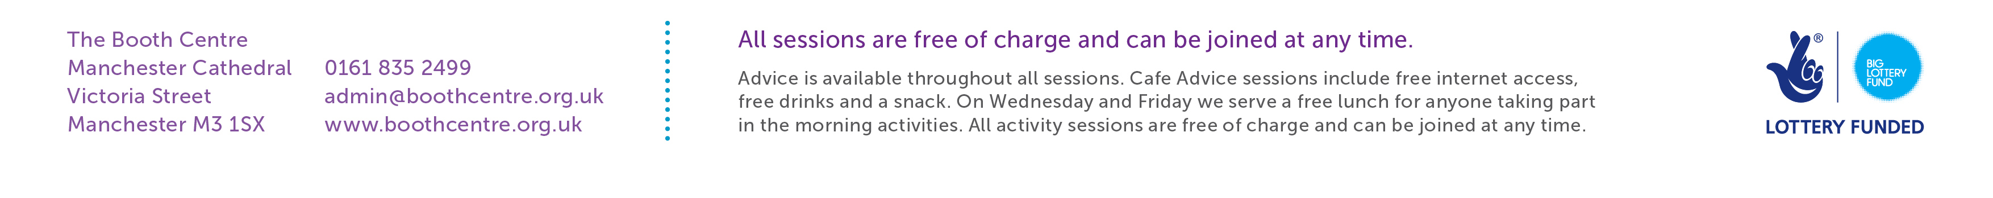
Opening times; Monday to Friday
9 – 10 am Free Breakfast Café
9 – 12 noon Monday to Friday – Advice Service
10 – 12 noon Activities/Job Club/ Training followed by Lunch
1 – 3pm Work Placements

Activities Timetable – 1st April – 30th June 2014
Monday  10am– 12noon | Tuesday  10am– 12noon | Wednesday  10am– 12noon | Thursday  10am– 12noon | Friday  10am– 12noon
Boules | Construction Skills | Singing and Drama | Learning Circle | Drama
Job Club | Job Club | Work Club | Work related Training course | English Class

