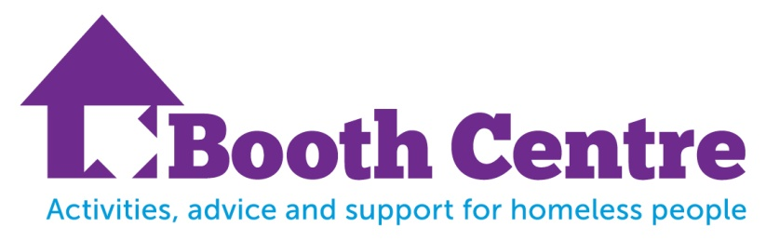
Are you homeless, living in a hostel or B+B or at risk of homelessness?

We could help with;
Free Breakfast Café Monday to Friday 9 am – 10 am
Advice Service Monday to Friday 9 am to 12 noon
Support to register with local Doctors, Dentists and other health services
Education and Training workshops to increase your skills
Drama, music, gardening and other recreational activities
Job Club and support to get back into work
Volunteering and work placements

No referral needed, just come along and see how we can help.

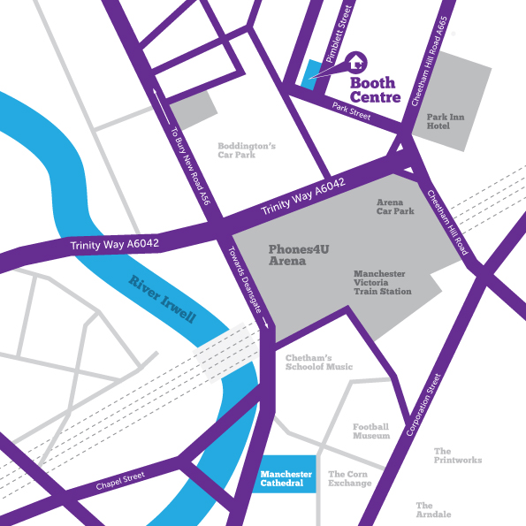

The Booth Centre, Edward Holt House, Pimblett Street, Manchester, M3 1FU
0161 835 2499 admin@boothcentre.org.uk www.boothcentre.org.uk

