Dear Voluntary Youth Organisation

I am writing to tell you about a project run by National Youth Agency, funded by the Local Government Association, working with VCS groups in Manchester and Manchester City Council to: Support the youth sector in Manchester to build constructive and productive relationships with business.

The key outcomes of this project are to:

- Develop a long term Manchester strategy for building engagement between VCS and business
- Develop guides and tips for VCS and business, working with MACC and United Futures programme
- Undertake local capacity building events – Sep – Oct 2012
- Hold a speed dating event – November 2012
- Develop tools for measuring impact and future sustainability

To kick start the process there will be a speed dating event. In order to prepare for the speed dating event that will attended by around 100 Manchester based businesses, taking place at the end of November 2012 we are running a series of capacity building workshops. These are being arranged and delivered in 5 area clusters and one city wide event. The intention is that the people who attend these events will identify 2 representatives from their group to attend on their behalf. This will be the start of a process that is planned to become a long term Manchester strategy.
Please could you return the attached reply form stating the name of your organisation and which one of the events you will be attending.

Dave Packwood
07837035477
dave.packwood@sky.com

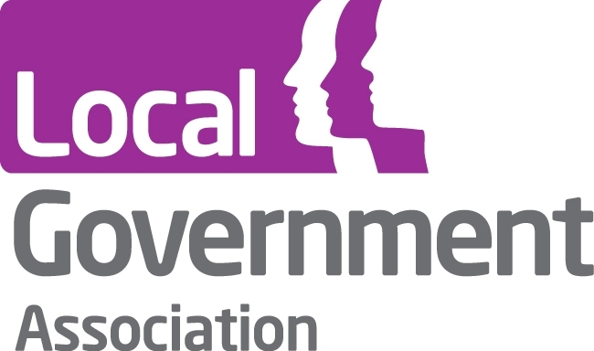


Working with business capacity building event

Name of attendee …………………………………

Name of organisation……………………………..

I will be attending on: Please tick

Monday 8th October 1 - 4.30 PM – East event - 4CT The Grange/Pilgrim Dr, Manchester M11 3TQ - 0161 230 1422

Tuesday 9th October 1 - 4.30 PM – North event – Whitemoss Youth Centre Elliot House, Southdown Crescent, Blackley, Manchester, M9 7DQ

Thursday 11th October 1 - 4.30 PM – Central Event – Hideaway Youth Project The Armani Centre Quinney Cresent, Shoreham Close, Manchester, M16 7DG, 0161 226 7325

Monday 15th October 1 - 4.30 PM – Wythenshawe – Willow Park Housing, 8 Poundswick Lane Manchester, Greater Manchester M22 9TA
0800 633 5500

Friday 19th October 1 - 4.30 PM – City wide event – 42nd St The SPACE
87-91 Great Ancoats Street, Manchester, M4 5AG

Wednesday 24th October 1 - 4.30 PM – South event - Ladybarn Centre Royle Street, Manchester, M14 6RN

Please complete and email to:
dave.packwood@sky.com

