We’re offering a FREE series of visits to co-operatives and social enterprises to celebrate Co-operatives Fortnight! Find out more about co-operative and enterprising ways of working in diverse sectors – including the arts, food, environment, retail and workspaces. Be inspired by positive, practical solutions, gain knowledge, meet the hosts and show your support for the local economy!

Tuesday 25 June, 2-4pm, Leigh, Wigan
Learn where your food comes from, talk about the impacts of farming, and why food choices are important – for us and the planet. Bring your wellies and take a tour around the site, looking closely at plants and wildlife, and seeing our work in action: www.mossbrookgrowers.co.uk


Wednesday 26 June, 2-4pm, Manchester: On the Eighth Day is a vegetarian wholefood shop and café, providing a huge range of ethical products and GM free goods. Established in 1970’s, the co-op has grown and is now one of the city’s most vibrant workers’ co-operatives. Visit us to learn more…http://eighth-day.co.uk/


Thursday 27 June, 2-4pm, Bolton
We’re a community cafe (Lakamka Workers Co-operative) which creates simple, wholesome food at affordable prices. With experience of growing, cooking and teaching, we’re also an inspiring centre which aims to generate interest and participation in local food activities. We look forward to welcoming you: http://thekitchen.coop/


Friday 28 June, 2-4pm, Manchester
Hulme Community Garden Centre is an inner-city horticultural project. We bring the community together through gardening, encourage people to grow food, green their neighbourhoods and lead healthier lives. See the Garden Centre Nursery, find out about our volunteer, education and training programs and Manchester’s first public green roof and strawbale eco-classroom! www.hulmegardencentre.org.uk


Monday 1 July, 2-4pm, Manchester: OpenSpace is a members' co-op managing our own office space. We created an affordable, attractive workplace, where different organisations and freelancers undertake creative and socially conscious work. Join us on the visit to find out more: www.openspace.coop


Tuesday 2 July, 2-4pm, Manchester
Our products are made from locally sourced, essential treework and woodland operations. We promote the social, environmental and economic benefits of using wood and provide landscaping services, forest management, consultancy and home delivery of biomass fuels. Come and meet our amazing team! www.treestation.co.uk


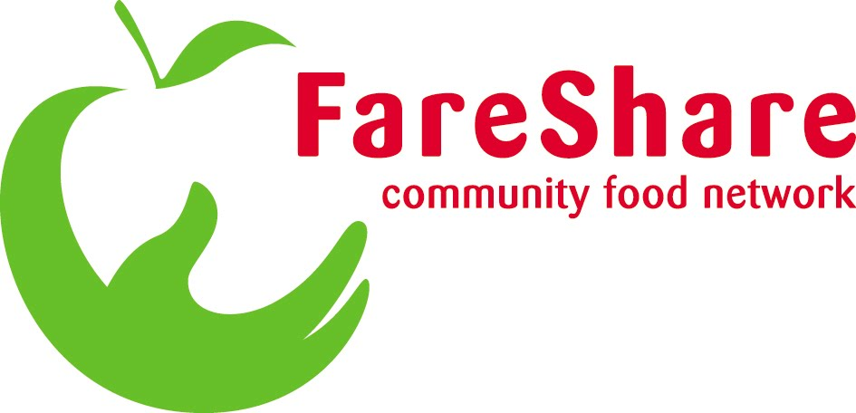

Wednesday 3 July, 2-4pm, Manchester
EMERGE collects waste for reuse/recycling and promotes the 3Rs (Reduce, Reuse, Recycle). We deliver recycling services to businesses and schools, and run education and volunteering programs for the wider community. In addition, corporate food donors deliver 200 tonnes of waste food to our FareShare NW depot each year. The food is sorted and matched to the needs of our 65 community food members, who use it to provide meals and food parcels to hundreds of people experiencing hardship in Manchester. Visit our busy depot to meet us, take the tour and find out more. www.emergemanchester.co.uk

Friday 5 July, 2-4pm, Manchester: As a co-op of 30 Artists, working across a range of disciplines (painting, textiles, photography, installation, sculpture, ceramics), we created a low cost, shared studio and gallery space. Come look around, talk with us and meet the artists. www.bankley.org.uk

-------------------------------------------------------------------------------------------------------------------------------------
HOW TO BOOK YOUR PLACE…

Name:____________________________ Organisation: __________________________________
Email: ___________________________________________ Telephone: _____________________
Number of visitors if booking for a group: ________________
Spaces are limited and offered on a first come, first served basis

I wish to attend the following visit/s….
- Moss Brook Growers: Tuesday 25 June, 2-4pm
- The Kitchen on the Moor: Thursday 27 June, 2-4pm
- Hulme Community Garden Centre, Friday 28 June, time
- OpenSpace: Monday 1 July, 2-4pm
- TreeStation: Tuesday 2 July, 2-4pm
- EMERGE/Fareshare NW: Wednesday 3 July, 2-4pm
- Bankley Studios & Gallery (NB. no disabled access to top floors): Friday 5 July, 2-4pm

Travel costs…
- YES I will claim travel costs (show your receipts on the day: max £10 per visit)
- NO I will not be claiming my travel costs
Please email your completed form as soon as possible to: cooperatives2020@gmail.com
Deadline Monday 17 June. An invite (with full details) will then be emailed to you.

If you need more information or have any questions, please contact Joanna Huddart:
0161 4480788
cooperatives2020@gmail.com

