Urgent Appeal
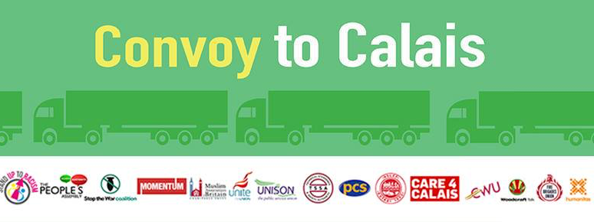
Manchester Women's Aid together with Independent Choices Greater Manchester are jointing the Convoy to Calais on Saturday 18th June.

We aim
a) to collect aid items for women and deliver them to Calais Refugee Camp; please deliver any aid items you wish to donate to The Pankhurst by Friday 17th June 2pm
List of items needed for Women:
Boots/ shoes up to size 39 (no heels!);
Smaller cup size bras (up to 36C);
Socks & Underwear;
Warm, waterproof coats (s&m);
Waterproof trousers; Trousers jeans and tracksuit bottoms (S, M, L);
Long-sleeved tops, jumpers and hoodies (S, M).

and

b) to raise awareness of the issues affecting refugee women in camps around the word
UNHCR research found that women and girls are less likely than refugee men and boys to have access to the most fundamental of their rights, including right to food, health care, shelter, nationality etc. Amnesty International research shows that women and girl refugees face violence, assault, exploitation and sexual harassment at every stage of their journey, including on European soil. There are cases of women being raped by smugglers, security guards and refugee men or forced to ‘exchange’ sex for passage to safety to the UK. There are approximately 300 women who make up around 10% of the Calais camp’s population. The 100 beds in the women’s centre of the camp have been filled up long ago. This means that others must now use the main camp, which has no security or street lighting, let alone dedicated toilets or bathrooms for women. ‘Women are more vulnerable to harassment and they need to find ways to protect themselves, but no protection comes for free’ said a volunteer at the camp. A 24 year old woman, 5 months’ pregnant who can’t remember the last time she had a shower, let alone a medical check-up trekked through eight countries, her belly growing all the time, before ending up at Calais.

