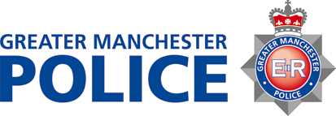

English Defence League

BACKGROUND

The EDL is planning to hold a demonstration in Manchester on Saturday 2nd March 2013.

Manchester City Council and Greater Manchester Police are working in partnership to ensure that this event causes the minimum of disruption to all members of the community.

ADVICE FOR RESIDENTS FROM GREATER MANCHESTER POLICE AND MANCHESTER CITY COUNCIL

- The city is open for business as usual, although we do accept that there could be some disruption to traffic in the Albert Square area.
- We urge you to ignore all elements of this protest.
- We would reassure you that violence will not be tolerated and action will be taken against anyone who breaks the law
- The police are there to prevent disorder and ensure everyone in our community is protected.
- We urge the community not to take the law into their own hands.
- Anyone who is subjected to any kind of abuse or violence should report it to police immediately.

In an emergency, always dial 999. If you want to report something to police, such as a hate crime, but it is not an emergency, call 101. You can also report hate crime online at gmp.police.uk/hatecrime.

