Innovation and Empathy Retreat
For purpose-led leaders https://www.brilliantthing.co.uk/innovation-retreats
Wednesday 20th to Friday 22nd July 2022, Manchester | £750
Non-profit organisations, public sector teams and social purpose projects are rebuilding from the pandemic, and responding to escalating need. Our retreats offer space to reflect, think creatively and deepen innovation skills for thoughtful, impactful leadership.
Join this retreat, spending time with up to 8 other non-profit leaders in a beautiful, contemporary venue in Withington, Manchester. Each day will begin with a reflective group coaching session, followed by a practical afternoon skills workshop exploring design-thinking, reflective practice, creative teambuilding and collaborative leadership. ⚡️Nurturing Extras⚡️ there will be daily nurturing extras for guests - think gorgeous food, wellbeing and sensory experiences.
You will leave energised and with the ideas, tools and confidence to apply design-thinking practices within your own organisation. Post-retreat you will be invited to a 1hr online coaching call, to support you to apply your learning at work.
What’s included? For an investment of £750 per person (or 4 payments of £190, made between June-August) you will enjoy:
• Pre-retreat welcome call and workbook
• A private double room in comfortable accommodation
• A swim/leisure pass for nearby Withington Works, a coworking space where we will also hold our first and last sessions
• Breakfast and lunch, and optional evening group meals
• X3 Group Coaching sessions
• X3 Innovation workshops
• Post-retreat, online coaching session

Tickets are now available! Book here
(If you’d like to have a conversation first or discuss a payment plan please email abrilliantthing@gmail.com)
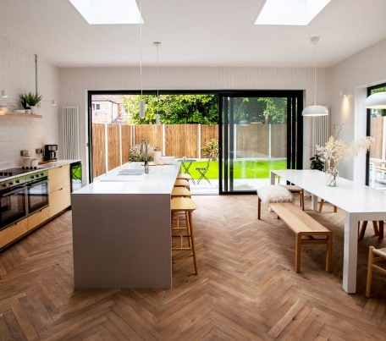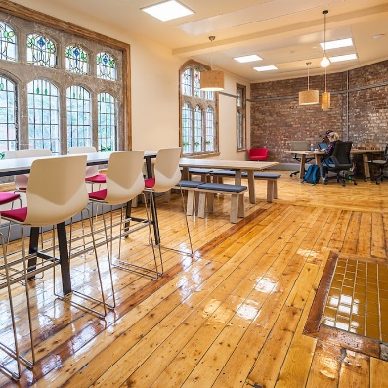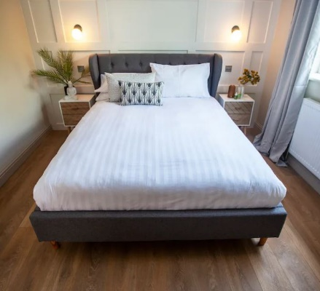
Scroll down for programme!

Innovation and Empathy Retreat Programme
Each day is a combination of coaching and skills workshops with daily optional extras to nurture you

Nourish
Day 1 nourishes your mind with innovative thinking
AM – Connection session at Withington Works
PM- Design Thinking for fresh solutions to work challenges

Nurturing extras:
Swim/leisure pass for Withington Works
Evening supper club experience

Reflect
Day 2 focuses on reflection, communication and impact
AM- Reflective Practice, exploring our value and impact at work
PM- Designing impact plans that make a difference at work

Nurturing extras:
Lunchtime talk on ‘Compassionate Communication’ by Kate from Calm at Work.
Optional, individual seated acupressure sessions throughout the afternoon to revitalise mind and body

Captivate
Day 3 is about creating captivating work, that engages funders, partners and beneficiaries
AM- Creative team cultures
PM- Collaborative leaders

Nurturing extras:
Early morning, silent sensory walk around Old Moat Park, connecting to our senses and beginning the day with renewed vitality

https://www.brilliantthing.co.uk/innovation-retreats

