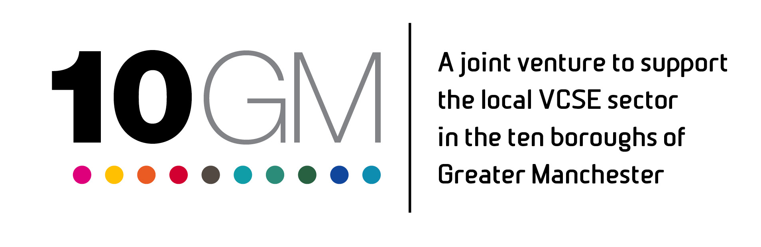
FASD Peer Support Small Grant Fund – Guidance Notes

We want to work with voluntary, community and social enterprise (VCSE) groups and organisations in all of the local authority areas of Greater Manchester to provide peer support opportunities for parents, carers and families of children with suspected or diagnosed Foetal Alcohol Spectrum Disorder (FASD). FASD is an umbrella term used to describe the range of lifelong disabilities that can occur as a result of drinking alcohol during pregnancy. FASD causes physical, mental, behavioural and learning impairments and is reported to potentially affect up to 17% of children across the UK. More information on FASD can be found at www.nofas-uk.org and at www.drymester.org.uk
10GM is inviting local VCSE groups to apply for one of our FASD Peer Support Small Grants to support monthly activities to take place from February 2020 until September 2020. There will be the opportunity for continued grant funding beyond this point based on the learning from the work undertaken. Grants of up to £1000 are available and applications must:
- Deliver a peer support activity or event that will take place at least once a month
- Be prepared to learn from those taking part and let them design and shape developing activities and events, and demonstrate how this is being done
- Take part in shared learning, mainly via email and phone, with the other projects funded including two meetings with other coordinators over the 6 months of the initial work
We are interested in creative approaches. Our conversations with those with experience of FASD peer support recommend an approach based on the following options:
- A daytime social space for parents, carers and family while children are at school e.g. a drop-in coffee morning
- A late afternoon or early evening activity for children and parents/carers together with provision for children’s activities e.g. after school sole use of a play centre space or an inclusive, structured setting for older children
- Informal learning and training opportunities are of interest with options of formal training but accessibly provided
- Take a flexible approach that is ready to learn from the parents, carers and families of children with FASD and let them design and shape activities and events
We will be particularly interested in funding applications that respond to at least one of the above recommendations.
Successful grant applicants may receive a visit to their event/activity by a member staff.
Closing Date: 12 noon Friday 10 January 2020
Decision date: Wednesday 15 January 2020
Eligible Costs:
The below items are anticipated as potentially being included in applications and will be eligible for funding:

- Venue hire
- Refreshments
- Promotional, marketing and publicity costs
- Entertainment / activity costs
- Training materials and costs
- Other costs related clearly to activities detailed

The items below are not eligible for funding:
- Merchandise
- Costs for physical items such as laptops or for building upkeep
For support with your application, please contact: Hayley.Tomlinson@actiontogether.org.uk
FASD Peer Support Small Grant Fund - Application Form

SECTION ONE: ELIGIBILITY
Our VCSE group/organisation is based in: (please circle)
Bolton | Bury | Manchester | Oldham | Rochdale | Salford | Stockport | Tameside | Trafford | Wigan
Please note that organisations can only apply once for this grant

SECTION TWO: CONTACT DETAILS
Organisation Name:
Main Contact Name:
Telephone Number/s:
Email address:
Website and/or social media:

SECTION THREE: YOUR EVENT OR ACTIVITY

Please describe your proposed event or activity to provide peer support for parents, carers and families of children with FASD? (500 words max)

How will you learn from those taking part and let them design and shape the development of your activities and events? (200 words max)
How will you know if your events or activities are successful? (200 words max)
How will you promote your events or activities to attract parents, carers and families of children with FASD?
What experience do you have of successful promotion of such activities in the past?
(200 words max)
Approximately how many people will benefit from your events or activities?

Where and when will the events or activities take place? (if known)
Town | Venue including address (if known) | Date/s | Time/s

SECTION FOUR: THE BUDGET

Please indicate how much money you need and provide a detailed breakdown of your planned expenditure and details of how the costs have been worked out. For example if ‘Venue Hire’ applies please state how many hours you need to hire the venue and how much it will cost per hour – ‘Hall hire, 3 days for 4 hours per day @ £15 per hour - £15 x 4 x 3 = £180.00’.

Item of expenditure | Please describe & show calculations below | Item Cost | Amount Requested
 |  | £ | £
 |  | £ | £
 |  | £ | £
 |  | £ | £
 |  | £ | £
 |  | £ | £
Total cost of your event or activity |  | £
Total amount requested from the FASD Small Grant Fund (Maximum £1000) |  |  | £

SECTION FOUR: BANK DETAILS
Account name
Sort Code
Account Number

SECTION FIVE: DECLARATION

- All the information supplied is correct to the best of our knowledge and I am duly authorised to submit this application on behalf of our organisation.
- If successful I will be able to attend a workshop on Monday 20 January, 10am-2pm in central Manchester (please keep this time and date free)
- I agree to a visit from a staff member at one of our events / activities and for a photograph of the activity / event to be taken to document the event / activity with the permission of those in the photograph.
- I commit to taking part in shared learning with the other projects funded including two meetings with other coordinators over the 6 months of the initial work.
Name: |  | Role:

Please send your completed application form by 12 noon Friday 10 January 2020 by email to Hayley.Tomlinson@actiontogether.org.uk (WORD or PDF only – no scanned PDFs).

