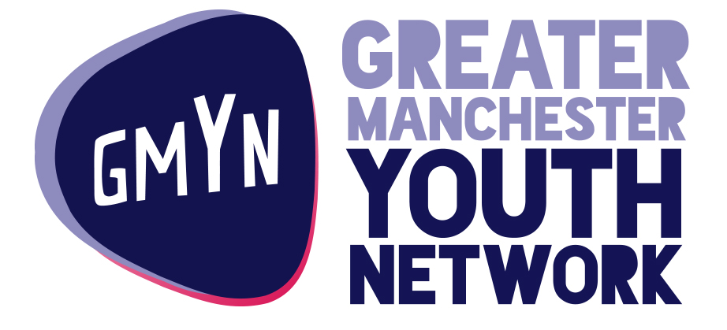

Help Us Get Manchester Young People Running Businesses in the Heart of Their Communities
GMYN has made it through the last stage of the RBS Inspiring Enterprise application process and the shortlisted applications are now being put to a public vote, including GMYN’s application for our innovative “Trade Up” project.
Working in partnership with Manchester Markets, we will support disabled young people to work as groups to set up and run their own temporary market-based businesses. We will then provide mentoring and practical start up support to 16 young people to enable them to run their own market stalls.
Your vote will help enable to deliver the support that will transform young lives and support our local markets by creating the next generation of market traders. Voting for us is easy. You can place your vote online.
Click on the link below and 10 seconds of your time can make a lifetime’s worth of difference to some Manchester young people.
http://www.inspiringenterprise.rbs.com/inspiring-youth/grant-funding/public-voting/trade?vnc=DuqAn3FmtAMcykiA0eTrnzXqgbCwkCQmlen0C9gyiX0&vnp=20
THANK YOU!
Greater Manchester Youth Network

