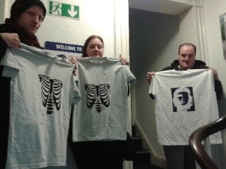
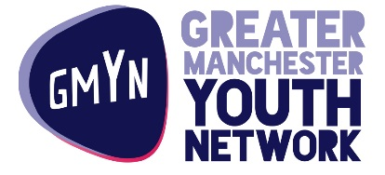

Greater Manchester Youth Network are currently looking for young people 16 – 24 to join our friendly, fun, and creative Manchester Not Just a Group. The group have been learning about ethical trade and screen printing for the past 6 months and producing images/posters and T shirts.
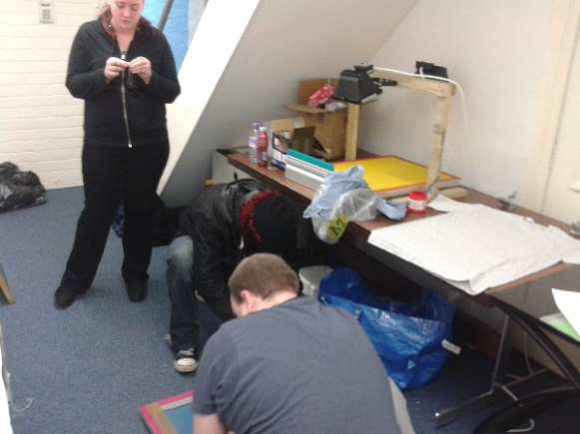
At present the young people on the programme, are expanding their products range further, producing their own brand of tea, whilst continuing to grow their T shirt and poster/image range. All the products they are producing are either ethically sourced or Fair Trade.

We have limited places available on the programme and would be able to accommodate two new recruits. The new recruits would have the opportunity to learn these skills and to contribute to further development of this exciting project.

The group currently meet at GMYN’s Offices in Ardwick on a Tuesday from 10am – 1pm. We are therefore looking for young people who are available at this time, who would enjoy being creative, learning more about ethical trade, and running a business.
