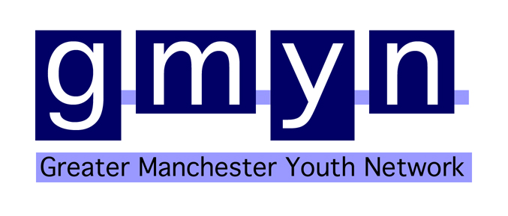

Trustee - Greater Manchester Youth Network

Greater Manchester Youth Network (GMYN) supports young people and youth involving organisations to participate, develop and achieve; with a focus on volunteering and social action. The organisation is part-way through the process of becoming a registered charity, which has included the stepping down of three executive board members. This has opened up the exciting opportunity to join the Board of Trustees, who oversee the development and running of GMYN.

We want board members who believe in GMYN's cause and are able to give enough time to the role. No previous experience of board membership is needed. We welcome applications from people of all ages and backgrounds. Enthusiasm and commitment are the most important things!
As a board member you would have the option of getting involved with a number of different activities, besides from regular board meetings, including staff recruitment, strategic away days, campaigning, team building, quality standards, fundraising events, etc.

We are particularly interested in people who have experience in finance, fundraising and/or campaigning; knowledge/experience of the private sector would also be an advantage but please don't allow a lack of this type of experience/knowledge to stop you from applying.
The amount of involvement is up to the individual but, as a minimum, you must be able to commit to being available once every six weeks for board meetings and be happy to complete small actions in-between meetings.
Board meetings usually take place late afternoon/early evening and are held at GMYN's office in Ardwick, Manchester, which is around one mile south of the city centre and easy to get to by public transport.

This is an unpaid voluntary role but a great opportunity for personal and career development.

If you would like to speak to an existing board member or a member of GMYN staff about the organisation or the opportunity to join the board, please initially contact our Managing Director, Alex Fairweather on 0161 274 3377 / alex.fairweather@gmyn.co.uk

Further information and relevant downloads can be found at www.gmyn.co.uk/cm/support-gmyn/volunteer/join-the-board.html

Deadline for applications: Tuesday 30th April

