Greater Manchester Law Centre
Annual General Meeting
Tuesday 8th September 6.30pm
Mechanics Institute, 103 Princess St. M1 6DD

- Please come to the first AGM and help make the Law Centre a reality.
- We had a public meeting where the idea was endorsed and people volunteered to help.
- We have a constitution which is being submitted to the Charity Commission and Companies House.
- Now we need to get the word out, raise the money and interest to make it happen.
- Through legal and social means we can help people improve their lives and work for social change for the better
- The law centre will provide free legal advice and representation and ensure access to justice for people in Greater Manchester who would not otherwise afford it.
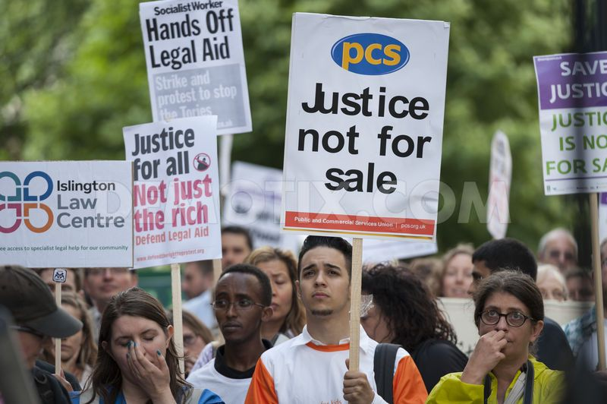
We are developing partnerships with trades unions and other campaigns.

We will involve community activists in the development of the project.

We will work alongside other providers of advice and legal services.

'It’s the only way ordinary people will get access to justice despite having limited means, and the only way they can defend themselves from attacks by the state’

We expect to provide advice initially in employment and welfare benefits. Over time we want to expand provision and to support campaigns in public law and human rights.

We aim to identify premises and launch a pilot law centre casework service

Volunteers will be the backbone of the law centre.

For more information contact: Paul Im Thurn or John Nicholson Kenworthys Chambers
p.imthurn@kenworthysbarristers.co.uk / j.nicholson@kenworthysbarristers.co.uk

