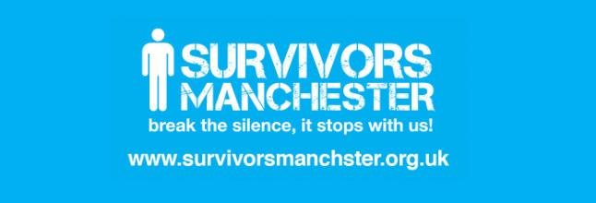
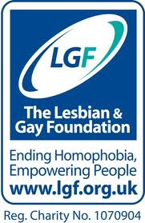

Therapy Group for Gay and Bisexual Male Survivors of Childhood Sexual Abuse (CSA) in Greater Manchester.

Survivors Manchester and The Lesbian & Gay Foundation (LGF) are launching a new therapy group for adult male survivors of childhood sexual abuse, who also identify as gay, bisexual or questioning. We also welcome applications from trans* men, who identify as gay, bisexual or questioning.
What can I expect from the group?
This group will be the first of its kind within the North West of the UK, and will build upon the learning taken from existing psychotherapy groups, led by Survivors Manchester, along with The LGF’s expertise in supporting gay, bisexual and questioning men.

The first ten sessions will focus on awareness and understanding of the common symptoms and experiences associated with childhood sexual abuse (CSA). The aim of these sessions is to help focus and empower group members, so they feel more able to manage these symptoms and issues in an effective and helpful way.
Sessions even to twenty will be unstructured, with an aim to encourage members of the group to take ownership of their space. The safe space we will work together to create, offers the opportunity for group members to raise and explore issues related to their individual experience and recovery journey.
Who can apply?
Survivors of childhood sexual abuse – (took place under 16 years of age) who:
- are aged 25 years and above
- identify themselves as male (including trans* men)
- identify as gay, bisexual or questioning
- live in Greater Manchester (Please note: trauma does not have to have occurred within Greater Manchester)
- feel sufficiently motivated and at a stage in their individual recovery to promote positive change

Some practicalities:
- The group is free and refreshments will be available at the venue.
- This is a closed group, which means that no new members will join, once the group has met for the first time.
- All applicants will be required to have an initial assessment with one of our group facilitators, to ensure the group is suitable for them.
- The group will meet on a Wednesday evening in a safe location based Manchester City Centre.
- We ask people to consider their ability to attend all 20 sessions before applying.
- There will be a maximum of 12 people in the group, plus two facilitators.

How can I apply?
Please contact one of our project team, who will then complete a short application form with you over the phone:

Tom Taylor – Clinical Lead at Survivors Manchester on:
tom@survivorsmanchester.org.uk
Or alternatively contact the Survivors Manchester Helpline on: 0161 236 2182

Rossella Nicosia, Mental Health Co-ordinator at The Lesbian & Gay Foundation on:
counselling@lgf.org.uk
Or alternatively contact The LGF Helpline on 0845 3 30 30 30

