Please find details below of an exciting new and free surplus food scheme. If you are interested in getting involved you can register here.
What’s new?

FareShare FoodCloud is a new scheme which helps charities and community groups like you to access the free, unsold, surplus food from a day’s sales at your local Tesco supermarket. Using the simple mobile technology FoodCloud, we have already helped 60 UK charity groups to access over 20 tonnes of fresh, good quality, free food. We want you to benefit too.

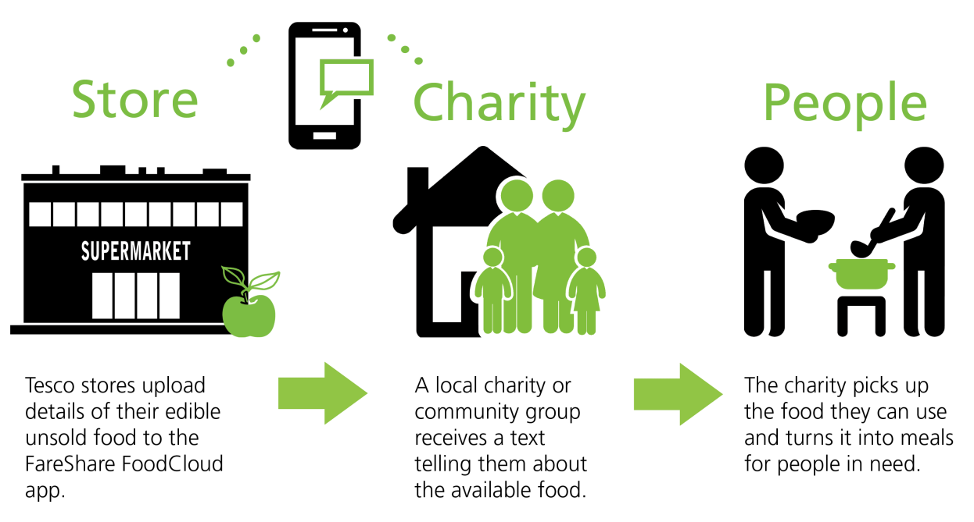
How it works?

1. You nominate one or more evenings per week you are available to collect surplus food from your local Tesco Extra or Superstore.
2. On those evenings at 7:30pm, you will be notified via text that your donation is available for collection.
3. The fresh surplus food will be packaged and available for collection from the store from 8:30pm.
4. We are happy to say, this will always be a free of charge service to our charity partners.

FareShare currently redistributes surplus food to over 2,000 charities like you, together serving over 19 million meals last year. We want to work with you on this new project to make an even bigger difference to vulnerable people across the UK.
If you want to benefit from additional fresh surplus food please register here.

