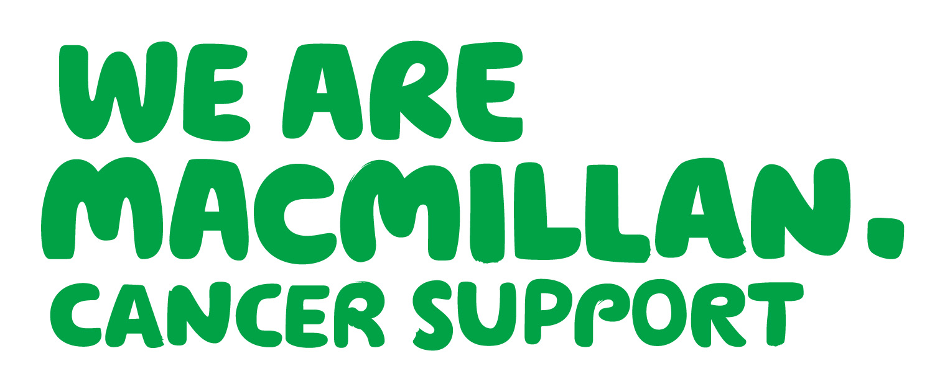


Living
with
& beyond
cancer?

Join our
friendly
support
group

It’s a morale boost. You recognise that you have moved forward.

I realise I’m not alone with cancer and can draw inspiration from others in the group.
It’s good to share and reflect with other people. You learn new things.

The Living With & Beyond Cancer group meets every two months at the Post Graduate Centre,
North Manchester General Hospital.

Everyone in the group has had cancer or is living with the condition.
Each time there is an informal chat around a different theme, with a Macmillan Professional.
New members are always welcome.

Dates for 2016:
Thursday 11th February
Thursday 14th April
Thursday 9th June
Thursday 11th August
Thursday 13th October
Thursday 8th December

Meetings are 10am – 12 noon.

To find out more or help you decide if you would like to give it a try, contact Ali Davenport,
Macmillan Community Outreach Officer: 227 3727 or 07767 663 099, a.davenport1@manchester.gov.uk

