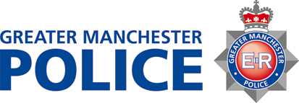

PROTESTS AROUND THE CONFLICT IN ISRAEL AND GAZA

Manchester City Council and Greater Manchester Police understand the strength of feeling on issues arising from the conflict in and around Israel and Gaza. We recognise that residents in our city maybe personally affected by what is happening and people want to do their utmost to avoid further injury and loss of innocent life.

Manchester has a long legacy of different communities living and working with each other, which makes this city a great place to be. We respect the right of individuals and groups who wish to participate in peaceful protest and will facilitate this as far as possible. However, we will not support protests that interfere with the lawful activity and lives of shop workers and businesses in our city or people who live or want to shop here.

We request all our residents who engage in political debates, whether about domestic or foreign matters, to do so with respect and dignity.

ADVICE FOR RESIDENTS FROM MANCHESTER CITY COUNCIL AND GREATER MANCHESTER POLICE

- We understand the strength of feeling amongst our communities in relation to the conflict in Israel and Gaza
- We respect freedom of speech and the legal rights to peacefully protest
- We urge individuals and groups when engaging in political issues and debates, to do so with respect and dignity for others
- We will not tolerate any unlawful behaviour and action will be taken against anyone who breaks the law
- We will not tolerate individuals or groups who threaten and attempt to divide communities or obstruct people going about their daily business
- We encourage communities to express their support for an end to the conflict through petitions, supporting those charities that are delivering peace initiatives and contacting their MP.

In an emergency, always dial 999. If you want to report something to the police but it is not an emergency call 101.

