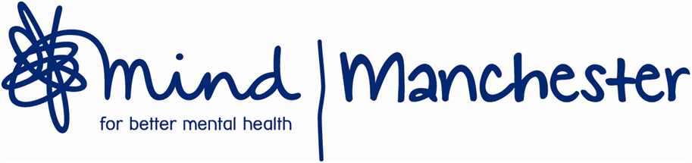

Invitation to tender for a time-limited evaluation of the
Manchester Volunteer Advice Partnership

Manchester Mind is the lead partner in this strong partnership project and is working with 4 other Manchester-based partners (Cheetham Hill Advice Centre, Manchester Refugee Support Network, Greater Manchester Immigration Aid Unit and Young Peoples Support Foundation) to deliver an exciting, two-year project providing excellent-quality volunteering opportunities in advice activities across all our organisations.

Provision of well-organised, good quality recruitment, training and support is a key factor in this project, which provides opportunities for people to volunteer in advice activities whilst enabling our organisations to meet increasing demand for advice. This project has been funded by Big Lottery Reaching Communities. We are now 15 months into the project and are looking to recruit someone to evaluate the project and produce a report.

If you would like to speak to someone about this please contact info@manchestermind.org. For more information on the evaluation please download the evaluation briefing from our website, www.manchestermind.org, email us on info@manchestermind.org or ring on 0161 226 9907.

Closing date for bids is 6pm, Monday 23rd March 2015. We will be hoping to hold interviews during the week beginning the 30rd March 2015.

Manchester Mind is striving to be an equal opportunities employer and welcomes applications from all sections of the community. Manchester Mind sees it as a positive advantage if you have experience of mental health issues and/or have used mental health services.

