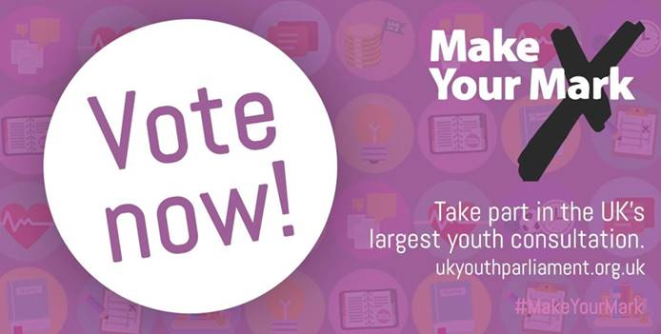
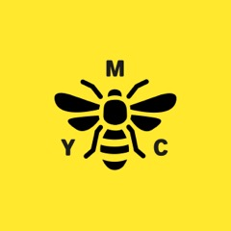

Hello

Samuel Remi Akinwale and Vanessa Attipoe, elected Members of the UK Youth Parliament (MYP) from Manchester in partnership with Manchester Youth Council, are taking part in the annual Make Your Mark ballot, the largest consultation of young people in the country.

In a ballot beginning 12th August and running till 5th October, young people across the country will be asked what issues matter most to them, in order to determine what is debated by the UK Youth Parliament in the House of Commons on 11th November. Voting takes places both online and through ballot papers issues in schools, colleges and youth centres.

Ten topics will be available to choose from on the initial Make Your Mark ballot paper, with the five most popular topics among young people going on to be discussed by MYP’s in their November debate, chaired by the Speaker of the House of Commons Rt. Hon. John Bercow MP and broadcast live on BBC Parliament.

Last year, the Make Your Mark ballot surveyed the opinions of over 970,000 young people, making it the largest youth consultation of its kind in the UK.
In Manchester 22.639 young people aged 11- 18 took part in the ballot.
In 2015 Manchester had a 57.41% turnout, and came 4th in the UK on the National League Table for Make Your Mark turnout. Manchester came 2nd in the UK for the number of votes collected by a local authority.
MYP for Manchester Ali Drabu campaigned for tackling Racism to be on the ballot paper. He was successful and was voted at UK Youth Parliament to be one of the main campaigns for 2015 alongside Mental Health
The “Don’t Hate Educate Campaign” is now in its first year as a national campaign and it all began in Manchester.

This year, Samuel Remi Akinwale and Vanessa Attipoe, 16 year-old MYP’s will be running the Make Your Mark campaign with Manchester Youth Council.

“This year we want to get the most ballots for Manchester, and be the best in the North West and the UK. We know that young people in Manchester want their voices to be heard and this ballot is the best way for young people to have their say and make a change for Manchester.”

“Manchester’s young people are passionate about their future, they want Manchester to be the best city to grow up and live in. Manchester Youth Council are working with leaders to make Manchester the best city for young people.
Last year 22,939 young people took part, this year we hope that every young person aged 11- 18 in Manchester will take part and have their say.
We are proud of our city and by taking part in the ballot, young people can tell leaders how they can make Manchester even better!”

We are asking all schools, academies, colleges and youth groups to support Manchester with the Make Your Mark ballot.

We have enclosed information with this pack to enable you to share this information with your young people and encourage them to take part.

We hope that you will support Manchester Youth Council to be the best in the country and help us to empower young people in the city to have their say.

For more information please go to:

For More information on the Make Your mark Campaign go to
http://www.ukyouthparliament.org.uk

For More information on Manchester Youth Council go to
http:// www.manchesteryouthcouncil.co.uk
Follow us: Face book - Manchester Youth Council Twitter: @mycthehive

If you require ballots or information please contact

Joanne Aungier – Engagement Coordinator

Email: Joanne.aungier@manchester.gov.uk

