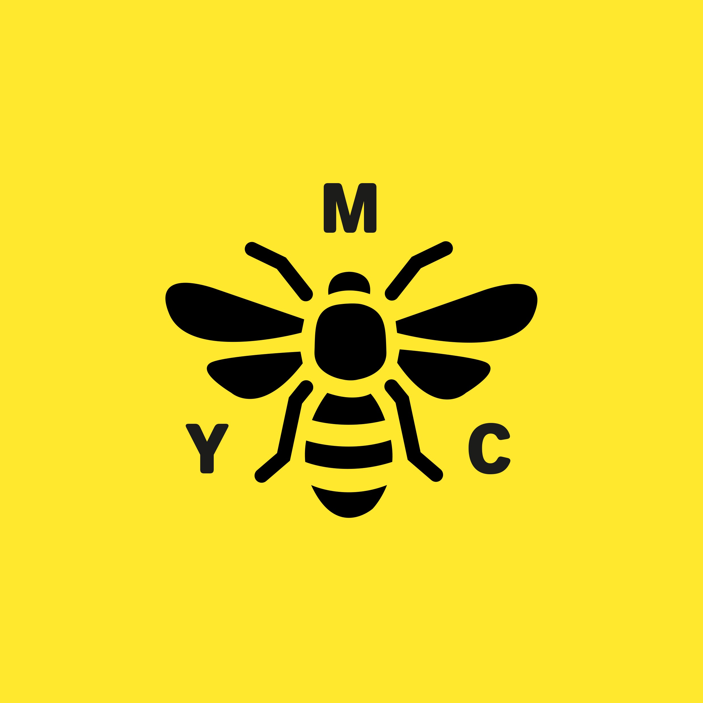
Manchester Youth Council
Room 137
Town Hall,
Manchester
M60 2LA

Dear Group,

I am writing to you as Chair of the Manchester Youth Council to let you know about the new Youth Council model that we are going to launch on January 29th 2016

The new model will reach more young people by building stronger links with School and College Councils and Youth Groups through a wider membership scheme.

This approach will hopefully result in young people having a stronger voice informing and influencing the decisions that impact on their lives.

We would like to invite your group to join the Manchester Youth Council(MYC) so we can connect with the work that your young people are leading on and in return create opportunities for them to link with city wide campaigns and activities that MYC are involved in. These opportunities will include:-

- Attending MYC sittings in the Council Chambers
- Taking part in local and city wide consultations
- Training, support and resources to support the work of your group
- Receiving and sharing information via our web site and social media platforms
- Meeting elected members and other decision makers
- Putting forward nominations to become members of regional and national youth council structure.

If your group joins the MYC then each of your young people will automatically become MYC members and will receive a joining pack and badge.
Members will receive regular communications keeping them up to date with MYC news and ways they can participate and influence the work of their Youth Council.

If your group is interested in finding out more then please can you pass on the registration form to the member of staff responsible for supporting your young people, so we can contact them directly with an introductory pack or to provide them with more information.

I do hope that your group will support the MYC and join us so together we can make a difference.

Yours Sincerely

Michelle Saidi

(Chair Manchester Youth Council)

Manchester Youth Council
Room 137
Town Hall,
Manchester
M60 2LA

Manchester Youth Council Registration Form

I would like my Youth Group / Leadership Programme, to join with Manchester Youth Council

Name of Organisation

………………………………………………………………………………………………

Name of Contact

………………………………………………………………………………………………

Email address

………………………………………………………………………………………………

Contact Phone number

………………………………………………………………………………………………

Address
………………………………………………………………………………………………

………………………………………………………………………………………………

………………………………………………………………………………………………

Email your completed registration form to: Joanne Aungier – Engagement Coordinator
Joanne.aungier@manchester.gov.uk

Or return to:
Manchester Youth Council, Room 137, Manchester Town Hall, M25DB

