Manchester Day: Game On!
Sunday 14 June 2015
Call for applications to participate
Deadline for applications: Monday 2 February 2015

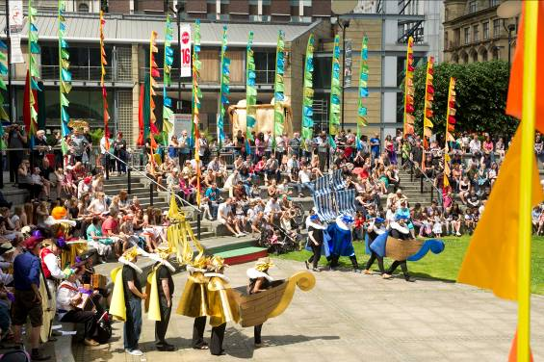
Game On! – join us to celebrate leisure, play, and Manchester’s place in a global gaming world: Sunday 14 June will be playtime in the city.
From contemporary games technology to traditional street games, let’s make our city a colourful playground of music, outdoor theatre and procession.
Do you want to take part in the Parade or bring one of the squares to life?
Your group could be part of one of the North West’s best community celebrations…or sign up as an individual to make costumes, build floats or volunteer on the day.
Artists will work with groups to turn your ideas into reality.

What does Game On! mean to you?
- Manchester in the 21st century - once again emerging as a global leader in gaming, and technological research and development - home of the National Graphene Institute, and the Sharp Project.

- Manchester – one of the first cities to embrace modern leisure pursuits with pleasure gardens at Pomona and Belle Vue.

- Manchester - World leader, world beater and national centre in sport!

We will transform some of Manchester’s city squares into mega parties of amazing décor, mouthwatering food and drink, and vibrant performance, alongside another wonderful parade celebrating the city of Manchester and what it means to be Mancunian.
Let’s unlock a whole new level of fun in the city. Manchester Day: Game On!

Photo: Mark Waugh

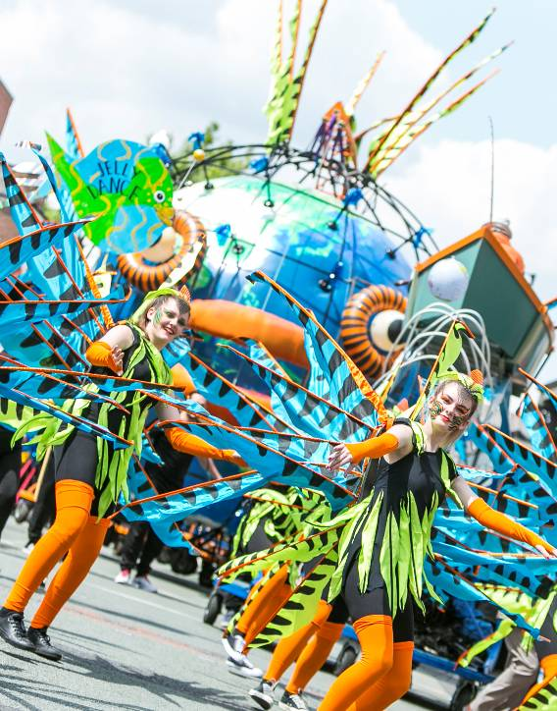

Photo: Rich Kenworthy

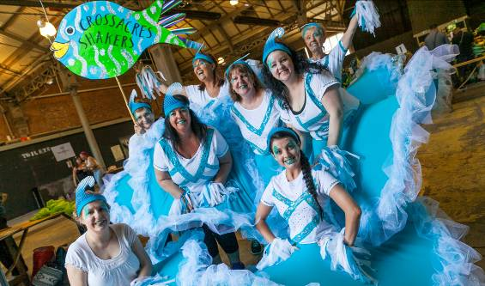

Photo: Rich Kenworthy

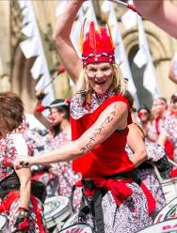

Get involved…
- Groups can work together in advance to develop creative ideas inspired by the theme to decorate, animate and perform in the Manchester Day squares or design a float or image, make costumes, or play music as part of the parade.
- Walk the Plank will give you professional support from an artist and a co-ordinator to develop your creative idea.
- Some groups may play music, or already have costumes or a float that fit with the theme.
- Some groups come together to create décor for the squares or a section of the parade co-ordinated by Walk the Plank.
- Individuals, small groups, families or anyone else who wants to take part can join larger groups, volunteer on the day or help out at Manchester Day’s creative hub: the WOW Workshop.
We want to encourage as many people as possible across the city to take part. However entry into Manchester Day is subject to a selection process and cannot be guaranteed: resources are limited and we have to say no to some groups.
If the event is oversubscribed as in all previous years, priority will be given to:
- Groups who the steering group feel have put forward the most exciting creative ideas.
- Groups who can demonstrate both a commitment in time
(e.g. workshops of 2-3 hours per week for 4 weeks) and the ability to deliver a quality project.
- Groups who are able to bring some funding or resources to Manchester Day.
Manchester Day is a GREEN event….
The use of vehicles or diesel-powered generators is discouraged. Within the parade itself we actively embrace structures which can be walked, pushed, pulled or wheeled.
How to apply
If you want to apply to be part of Manchester Day 2015 please fill in the form or apply online at:
www.manchesterday.co.uk/participate-perform/

Photo: Rich Kenworthy
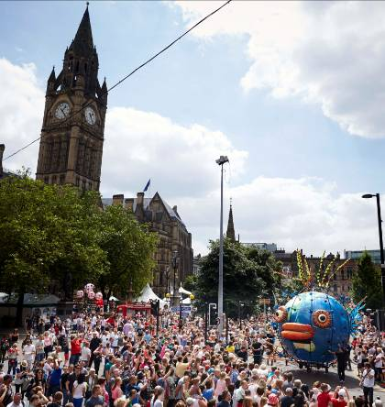

Photo: Mark Waugh

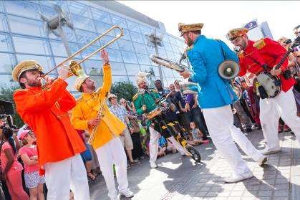

Photo: Rich Kenworthy
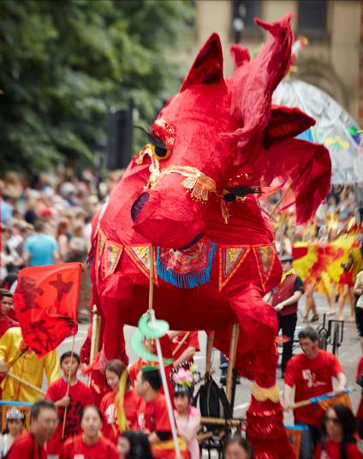

Photo: Mark Waugh

First name: | Last name:
Address line 1:
Address line 2: | Postcode:
Daytime phone: | Mobile phone:
Email address: | Are you applying as a group? if no go to *  Yes No
Group name: | How big is your group?
Age range: | How often do you meet?
Name of group leader:
Where does your group do its activities?

Application to participate in Manchester Day 2015. Deadline Monday 2 February 2015

City of Manchester (please tick one or more boxes)
Ancoats & Clayton Chorlton Gorton South Moston
Ardwick Chorlton Park Harpurhey Northenden
Baguley City Centre Higher Blackley Old Moat
Bradford Crumpsall Hulme Rusholme
Brooklands Didsbury East Levenshulme Sharston
Burnage Didsbury West Longsight Whalley Range
Charlestown Fallowfield M.Platting & N. Heath Withington Cheetham Gorton North Moss Side Woodhouse Park
City Wide (across majority of wards)
Other Greater Manchester Area (please specify):
Are your group able to attend 3-4 workshops (2-3 hours per workshop) to help create and make your section in Manchester Day? Yes No
* Are you applying as an individual? Yes No
Please describe your creative idea for Manchester Day: Game On! Or tell us how your group would like to get involved:

Please tick below how you would like to be involved in Manchester Day: Game On!
- Work with other groups and an artist to create amazing decoration, costumes,
performance or a structure for Manchester Day
- Work as an individual group with support from an artist to realise your own idea
- Bring your own costumes, float, music to Manchester Day
- As a volunteer in the lead up and making of Manchester Day
- As a volunteer on the day
Are you able to bring any resources to Manchester Day?
- Funding – approximate amount
- Resources: staff/volunteer time (please give
a brief outline of numbers and time available)
- Other
Any other information / notes you would like to add?

I would like to receive Manchester City Council’s ebulletin and receive information Yes No
about major events straight to my in box
I would like to receive Walk the Plank’s enews letter Yes No

Please fill in and return to: Ellie Turner, Producer – Manchester Day 2015, Walk the Plank, 72 Broad Street, Salford M6 5BZ or email to info@walktheplank.co.uk
Thank you for applying to take part in Manchester Day 2015. The application process closes on Monday 9 February 2015 and we will confirm successful applicants by 13 March 2015.

