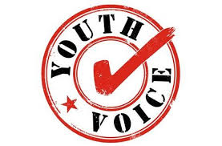

Manchester Youth Council Needs You!
We are the Voice of Young People in Manchester!

We are running a campaign to change the negative perception of young people
This competition will showcase your ideas to change the negative perceptions of young people

The competition open to Young People aged 13-25 years old

We want you to
Design a poster, write a poem, rap or song that promotes the positive image of young people

The Poster must be designed on size A4 Paper and must promote youth in a positive way
The poem or rap must be 250 words or less and can be sent be sent to the Youth Council in a word document

Closing date for all entries is Monday 12th August

The Manchester Youth Council will vote for the winning entries

Winners will be invited to an award ceremony
At The Manchester Youth Council Meeting
9th September 2013
Manchester Town Hall

There will be a £20 gift voucher for each winning entry
Winning entries will be shown on our website and face book page

Please send your entries to:
Joanne Aungier
Manchester Youth Council
Level 4
Town Hall Extension
Po Box 532, Town Hall, Manchester
M60 2LA
Or
e-mail: joanne.aungier@manchester.gov.uk Please title e-mails competition entry

