Mustard Tree: Combatting Poverty – Preventing Homelessness
Mustard Tree creates opportunities for people in poverty or facing homelessness to help themselves through the provision of immediate help and support for long‑term change. We believe that:

- Everyone needs an opportunity to earn an income
- Everyone needs a home
- Everyone will face trouble at some point in their lives

The charity blends immediate provision (Food Clubs & Community Shops, furniture/white goods, toiletries) with progression (Freedom Project life-skills & employability, classes & clubs, 1‑to‑1 coaching) across hubs in Ancoats, Eccles and Little Hulton.

Our values underpin all we do. By empowering ourselves and others through Belief, Dignity, Opportunity, Diversity and Partnership, we commit to open access, consistent welcome and progression for all.

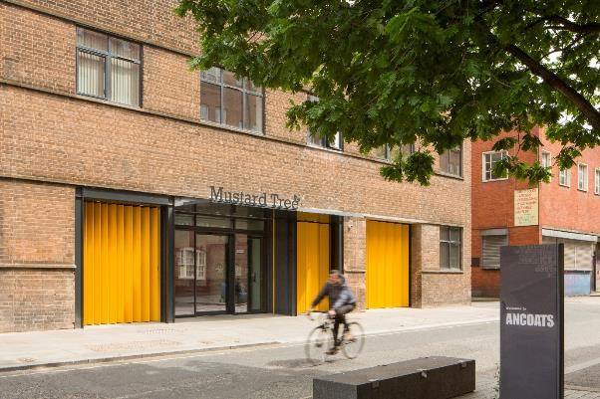

Currently, Mustard Tree supports nearly 11,000 people per annum and has over 10,000 visits a month across its three hubs. Mustard Tree has received awards for Most Loved Charity; Charity of the Year and publicly promotes case studies and opportunities for all.

The charity partners with over 100 corporate organisations through our ‘Charity of the Year’ work placement and donation programmes. Businesses and our local supporters help us stock our shops with furniture and white goods to enable 40% gifting of essential items to those most in need. Mustard Tree partners with Voluntary organisations as well as Local Authorities, who bring expertise and reach to our services and help maximise impact.

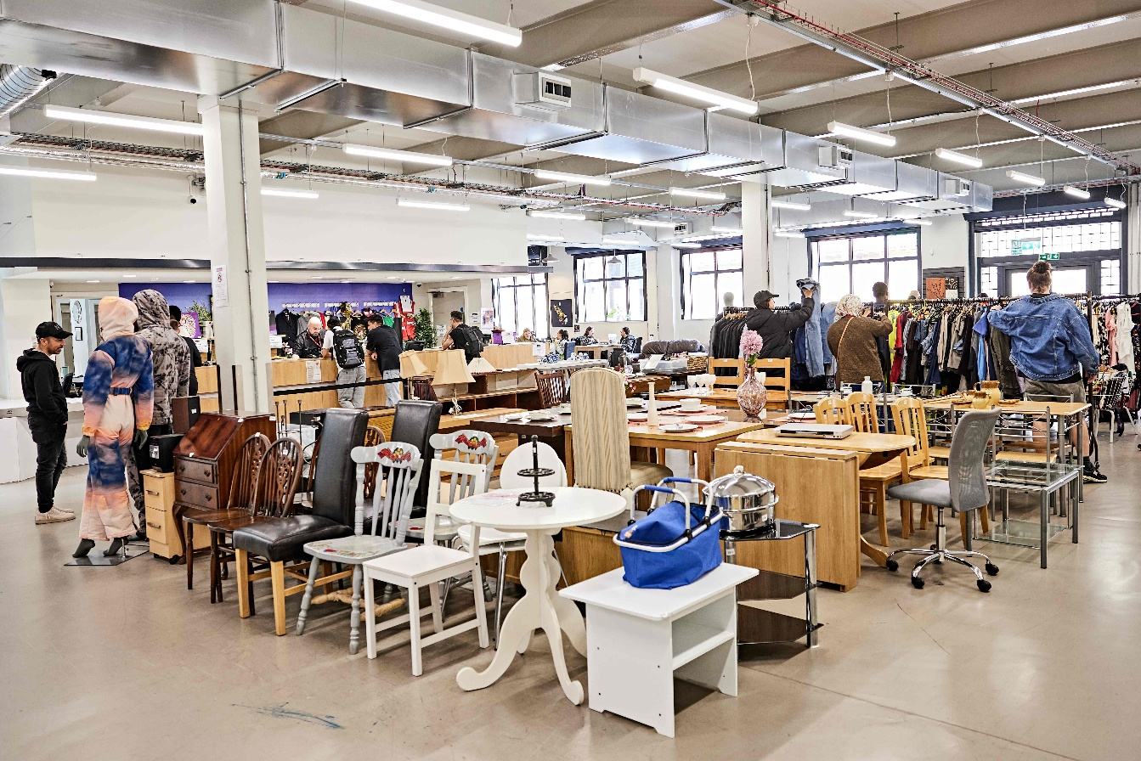

What’s New?
Mustard Tree has recently extended its opening times to make the hubs more accessible during the week and on Saturdays. The most updated opening times are available via the charity’s contact page.

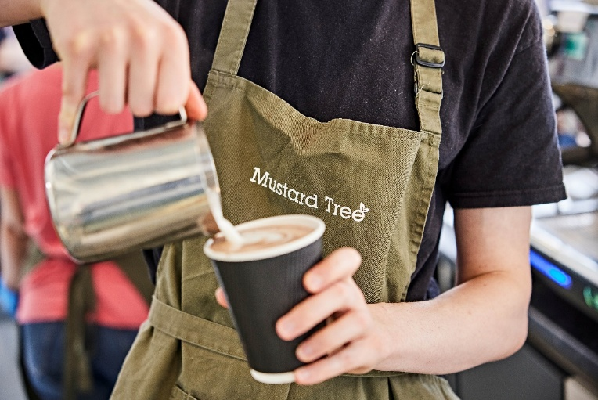
The charity has also recently had its Ancoats Coffee Shop refurbished and is now open 6-days a week – Monday to Saturday – for breakfast, lunch, tea, coffee and pastries.

For more information about Mustard Tree, visit www.mustardtree.org.uk or follow the charity on Instagram @MustardTreeMCR.

Thank you for your support!



Credit to Jack Barton.
Head of Communications and Impact | Mustard Tree

