
Free Homeless Sector PIE Training, Online - Spring 2026
By GMMH NHS Foundation Trust,

Psychologically Informed Environment (PIE) Training is designed to increase the learner's knowledge of homeless people, understand their narratives and respond effectively.
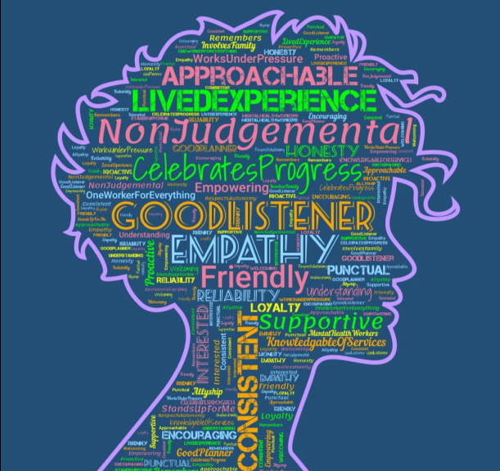
FREE Autumn 2026 Homeless Sector PIE Online Training Course Application form – Fill in form

Dates and times – 4 consecutive Tuesdays 1-4pm (12 hours total)

Tue, 1th, 22nd, 29th September and 6th October 2026
Microsoft Teams

To attend, please fill the form to reserve your place

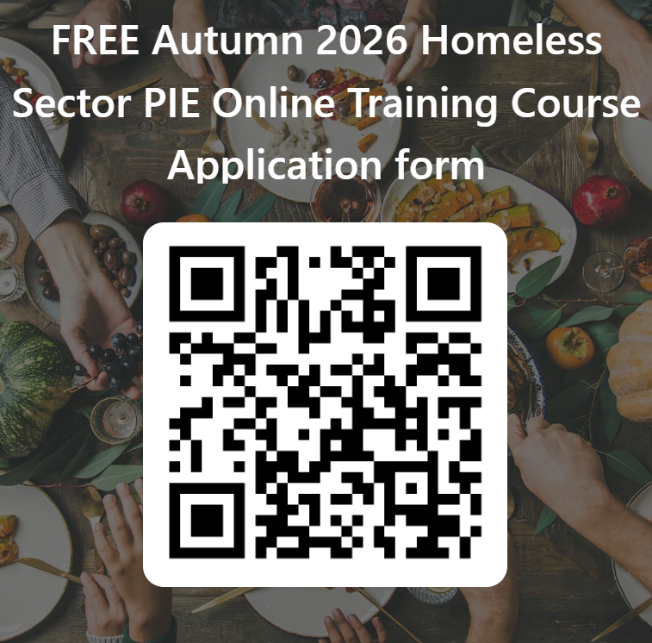

About this event
This is a 4-session course, run by mental health professionals. It is open to anyone working in the Homeless Sector, particularly in the Greater Manchester Area. The training session will run on consecutive Tuesday afternoons 1pm - 4pm on Microsoft Teams.

- Tuesday 15th September 1pm - 4pm
Introduction to Psychologically Informed Environments in Homelessness. How the approach enables organisations to understand and support homeless people who have had challenging experiences in life.
- Tuesday 22nd September 1pm - 4pm
Becoming Trauma Informed - Early life experiences and their impact on adult relationships and mental health.

- Tuesday 29th September 1pm - 4pm
Substance Use and Managing Dysregulation - Understanding and working with substance use difficulties. Trauma’s impact on personality development and a focus on dealing with intense emotion in ourselves and others.

- Tuesday 6th October 1pm - 4pm
Trauma Informed Approaches to Change - Practical ideas about how to approach the subject of change, using supportive conversations.

If you want to reserve a place, please complete the application form
(see link below)
Frequent Questions about the course

Can I attend just one session?
The course is made up of four sessions which fit together as a whole. Themes run
through the course and references are made to other sessions which would make little sense out of context. Further courses will be held, when planning them we consider people’s circumstances. If there is a reason attendance is difficult you think we might be able to help with, please let us know.

When is the Microsoft Teams link being sent out?
After you complete the application form the link will be emailed to you a few days before the first session.
Please check your junk mail and contact homelessPIE@gmmh.nhs.uk if you have not received it the day before the session. It is the same link for every session.

I have a disability or health condition which makes it difficult for me to fully participate.
Please let us know what you need prior to the course and we will aim to make it more accessible for you. We aim to use high contrast and there is an option to select subtitles. There will be two comfort breaks in each session and a variety of media and exercises are used. Please contact us if you need anything else homelessPIE@gmmh.nhs.uk

I would like to go on the training, but I don't have a suitable device or stable internet access.
We aim to put on a face-to-face course near the centre of Manchester in June 2026

I don't work in Greater Manchester. Can I still attend?
Of course. All are welcome.

I am volunteering in a homeless charity. Will it be relevant to me?
It will be relevant to anyone working in homelessness. We aim to keep the courses accessible for people with all levels of previous knowledge. We try to use plenty of examples from practice and use a range of different teaching styles. The contribution of attendees with different backgrounds is central and valuable. Please let us know whether you agree in the feedback after the course.

I am a manager / CEO. Will this training be relevant to me?
PIE is a systemic approach, understanding the principles of trauma informed care and knowledge of the complexity of the support required is relevant to KPIs you may write, stipulating achievable outcomes for a project you are funding.
Email us for more info homelessPIE@gmmh.nhs.uk

Do we get the slides?
We will send the slides out to the address you have registered with us after each session. Please let us know if you do not receive the slides.

