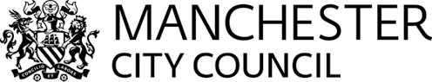

Public Health Manchester
Manchester Town Hall
Manchester
M60 2LA

Tel: 0161 234 3576
email: d.regan@manchester.gov.uk

26 September 2013

Dear Sir / Madam,

Pharmaceutical Needs Assessments

During the reorganisation of the NHS the responsibility for production of the Pharmaceutical Needs Assessments (PNAs) transferred to the Health and Wellbeing Boards (HWB) which are hosted by the local authorities.

Manchester HWB and local authority have produced their first draft of the PNA in collaboration with the Greater Manchester Commissioning Support Unit (CSU).
As part of the legislation the draft PNA must be available for local health partners to comment on the contents of the assessment before it is finalised and published.

The key outcomes for this consultation are:

- To encourage constructive feedback from a variety of stakeholders between 1st October and 6th December 2013
- To ensure a wide range of primary care health professionals provide opinions and views on what is contained within the PNA
To facilitate this we have uploaded the draft PNA onto Manchester City Council website and it can be found by accessing this link: www.manchester.gov.uk/pna

To allow comment and feedback there is also a short survey form to complete; a link to which can be found on the same page.

Manchester City Council has used this method of consultation to reduce amount of paper sent out and limit the environmental impact. However If you require a paper version of the PNA please contact Barry Gillespie at the above address (or email: b.gillespie@manchester.gov.uk) and a copy will be sent to you within 14 days.

All feedback will be considered and the HWB will decide which sections of the PNA need amending so that it will be ready for final publication from March 31st 2014.

Yours sincerely

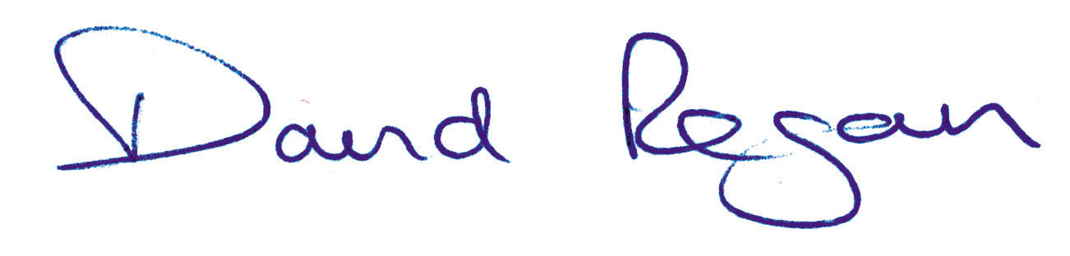

David Regan
Director of Public Health for Manchester
On behalf of
Manchester Health and Wellbeing Board

