RADEQUAL

VCS GRANT
EXPRESSION OF INTEREST
2020 – 21

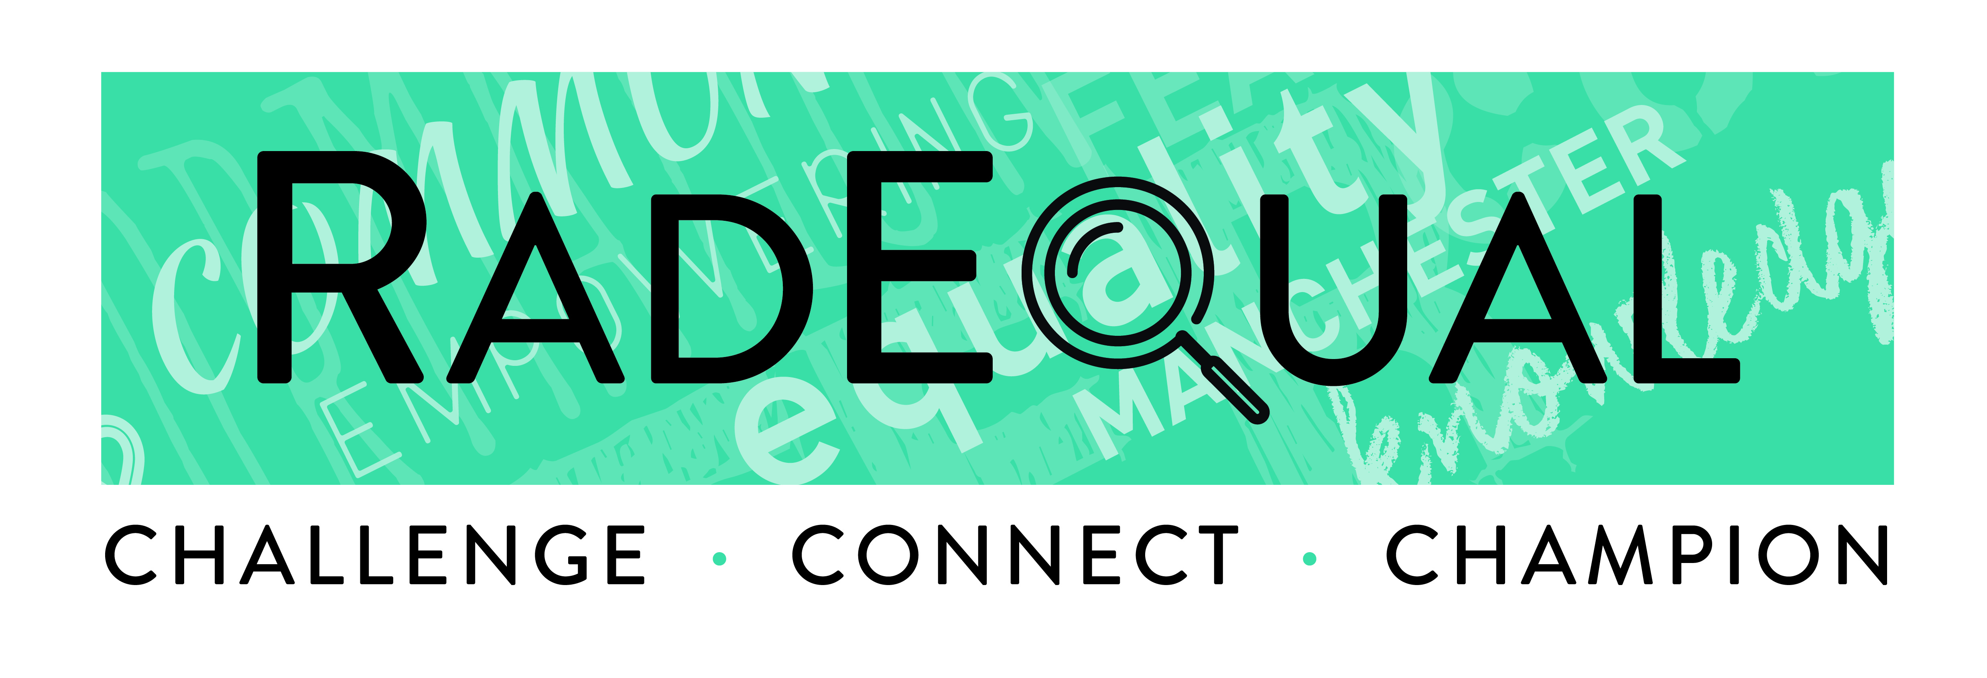

THE RADEQUAL CAMPAIGN

The Rethinking Radicalisation programme of community engagement started back in 2015 and recognised the challenges faced today relating to our collective understanding of radicalisation and extremism are far too complex for laws and powers to provide the sole solutions. It recognised that there are a range of factors that come together and play out in communities and neighbourhoods, which if tackled earlier would improve the lives of residents and increase opportunities for people to contribute towards how we build a safer and more resilient Manchester.

RADEQUAL is aimed at getting into communities and neighbourhoods early, having honest and often difficult conversations and working together to address and prevent some of the factors that could lead individuals to engage in extremism.

RADEQUAL is Manchester’s campaign to build community resilience. It was co-designed with communities, for communities and has three key principles referred to as the three C’s, which build on the Our Manchester approach:

1 CHALLENGE - Identifying and understanding the concerns and challenges across and within communities that could create divisions and tensions – not just the stats and research, but also the less obvious causes of tension, such as events and incidents and people's attitudes and behaviours.

2 CONNECT- Connecting communities, groups and organisations, and building relationships to create a network of credible voices -– not just those who are new to the community, but also long-standing residents who are willing to come and make a difference together.

3 CHAMPION - Championing Manchester’s radical reputation for campaigning for equality and inclusion and celebrating diversity – not just by focusing on what we have in common, but by preparing people for difficult debates, and asking the tough questions that help to build critical thinking and resilience in communities against all forms of extremism and safeguard those most vulnerable.

EXPRESSION OF INTEREST
GUIDANCE

PLEASE READ BEFORE COMPLETING AND SUBMITTING YOUR EXPRESSION OF INTEREST

The RADEQUAL Grant receives funding from the Community Safety Partnership in Manchester. This partnership is made of representatives from across key stakeholders and partners, including the voluntary and community sector in the city and is responsible for the delivery of the Community Safety Strategy for 2018-2021. This strategy was developed in consultation with Manchester residents, people who work and visit the city.

One of the priorities set out with work delivered through the strategy is aimed at safeguarding people from serious harm. This includes the RADEQUAL Campaign to build community resilience against prejudice, hate and extremism.

This year (2020-2021) marks the fifth year of Community Safety Partnership funding being allocated to the RADEQUAL campaign. Over the last two years, this funding has been used to work with the following five voluntary and community sector partners to develop and test approaches and models of community engagement to build community resilience:

- Community On Solid Ground
- Greater Manchester BME Network
- Manchester Young Lives
- Manchester Youth Zone
- Odd Arts

In line with the priorities of the Community Safety Strategy and CSP funding, we have reviewed the activities and outcomes delivered through the RADEQUAL campaign. We recognise that we have come a long way in building awareness about the campaign, established good networks to learn from one another and tried and tested models of community engagement and delivery which have helped to reach and connect with individuals and communities who normally might not engage. This is something that we are really proud of.

For 2020-21, we want to build on the skills and capacity that exist within the RADEQUAL Network and across the wider voluntary and community sector in Manchester. At the same time, we want to make sure that the campaign is current and is reaching and tackling the issues that are of most importance and affecting our communities.

Based on this, the focus of the RADEQUAL Grant funding for 2020-21 is ‘Building Community Resilience to Hateful Extremism’. We define hateful extremism as ideas, attitudes and behaviours that are hateful towards specific ‘others’ and designed to undermine social cohesion.
For more information see the A Shared Future report from the Greater Manchester Preventing Hateful Extremism and Promoting Social Cohesion Commission: https://www.greatermanchester-ca.gov.uk/media/1170/preventing-hateful-extremism-and-promoting-social-cohesion-report.pdf

Who can apply?

Voluntary and community sector and not for profit organisations and groups across the city of Manchester. We would welcome expressions of interest from community organisations, registered social landlords, charities, groups working with young people, media and creative arts groups etc. We also encourage joint bids which demonstrate collaborative working.

What we will consider when assessing your expression of interest

Applicants will be expected to:
- Respond to the 2020-21 RADEQUAL theme of Building Community Resilience to Hateful Extremism
- Delivery of activities against the five areas identified on page 6 of this document
- Deliver activities in the 10 wards identified by the Community Safety Team on page 9 of this document
- Work with as many of the target audiences identified on page 9 of this document
- Demonstrate collaborative working across different communities, organisations and neighbourhoods (including members of the RADEQUAL Network
- Utilise community assets and promote positive local role models.
- Demonstrate commitment to equality of opportunity and inclusion
- Demonstrate value for money
- Promote the RADEQUAL campaign – online and in communities
- Demonstrate innovation along with a proven track record and evidence of working against a set of agreed objectives, outcomes and spend profile.

We will not consider expressions of interest for
- Activities that do not directly benefit Manchester residents or do not have open access for membership
- Individuals
- Staff salaries and ongoing costs of established projects
- Fundraising activities
- Activities to raise awareness of hate crime and celebrating diversity
- Purchase of alcohol or gambling activities
- Trips or activities outside of Manchester
- Activities of a religious or political nature
- Groups in which individual members will benefit financially from a grant
- Venue hire costs held for events taking place within premises you already own/rent
- Costs which do not directly contribute towards the delivery of the activities for RADEQUAL

WHAT YOU NEED TO DO TO APPLY
You must complete every section of the expression of interest and submit by email to radequal@manchester.gov.uk no later than 5.00 p.m. on Friday 7 February 2020. Please note that expressions of interest received after this date and time will not be considered.

Your expression of interest will be considered by a panel and a decision on your bid will be communicated by the end of April 2020. You should be in a position to deliver your activities in the period between 1 May 2020 – 19 March 2021

RADEQUAL Grant Activities – 2020/21

RADEQUAL is looking for activities that: -
- Build awareness of all forms of hateful extremism (in line with the definition provided)
- Facilitate conversations about hateful extremism, what it looks like and the harms that it can cause at a community level.
- Promote critical thinking to help communities (women, asylum seekers / refugees, parents and families, faith organisations, young people, new communities and schools and colleges) to identify and challenge extremist propaganda (online and face to face between communities).
- Build community resilience to hateful extremism
- Establish resources that can be accessed by the RADEQUAL Network

Grants of £1,000 and £10,000

We are providing local community groups and organisations with the opportunity to submit an expression of interest for either a small £1,000 grant or £10,000 grant so that we can continue to raise awareness of the RADEQUAL campaign and help smaller groups get involved. It is important that you make sure that you demonstrate the level of detail and delivery needed for each grant funding amount.

Help and Support

If you are unsure about any section of the expression of interest, please contact Gemma Walsh of the Community Safety Team on 0161 234 3923 or email g.walsh1@manchester.gov.uk

Hate Crime

Throughout the year, the Community Safety Partnership also provides opportunities for voluntary and community sector groups and organisations to apply for funding to hold events or put on activities to raise awareness of hate crime and celebrate diversity in our communities. Therefore, the RADEQUAL grant 2020-21 will not fund activities that focus on prejudice and hate. If you would like details about hate crime funding opportunities, please email hcaw@manchester.gov.uk

Please note that any bids that have not been fully completed, submitted by the deadline or do not meet the criteria for the funding priorities will not be submitted for a panel decision.

Therefore, it is really important that you allow enough time to think about the activities you would like to deliver, the outputs and outcomes and breakdown of costs and fully complete the application form before you submit.

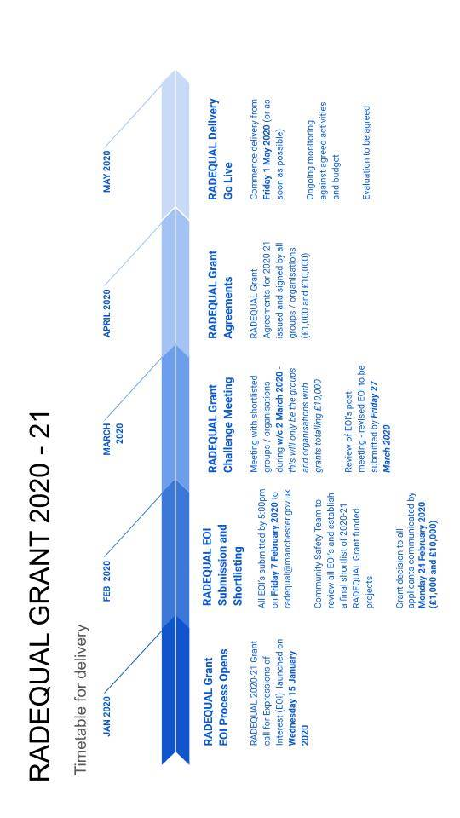

Section 1: ABOUT YOU AND YOUR GROUP

Name of Group(s)

Charity or Company Number (explain if not registered)  ***Note: any third parties to be used must be approved by the Community Safety Team in advance and identified in this EOI*** | Charity No:  Company No:
Lead Contact(s) Name

Contact Address

Contact telephone

E-mail

If your group has a website please provide the address

Have you previously had a grant from Manchester City Council? | Y / N  If yes, please provide details of the year, amount and department that gave the grant :

Section 2: ABOUT YOUR PROPOSED PROJECT

Name of proposed RADEQUAL project
Amount Requested (please only select ONE ) | □ £1,000 □ £10,000

Aims and Objectives: Tell us about your proposed activities. (200 words maximum) What are you applying for funding for? Tell us all about your proposed funded activity, why it is needed and how it’s going to make a difference?
What do you plan to do, who with and how? Please explain your main activities adding as much detail as you can about what the activities will involve and how you intend to deliver the activities (workshop/ discussion group/ Q&A panel). Tell us how your activity will focus on Building Community Resilience to Hateful Extremism.

Delivery Neighbourhoods: This year the CSP has requested for the RADEQUAL Grant funding to be delivered in the following areas (for £1,000 grants please select a minimum of two wards and for £10,000 grants please select a minimum of four)
□Ardwick □Burnage □Cheetham □Crumpsall □Fallowfield □ Levenshulme □Longsight □Moss Side □Rusholme □ Whalley Range □Other- Please provide rationale:

Target audience: Please tick as many as apply
□Women □Asylum seekers and refugees □Parents and families □Faith organisations
□Young People (specify age range___________________________________)
□New Communities (specify________________________________________)
□Clusters of schools or colleges (specify_______________________________)
□Other- Please provide rationale:____________________________________

RADEQUAL Grant Activities: Indicate which of the grant priorities below your proposed activity will meet

(Remember – strong expressions of interest will cover a number of the priority areas)

Grant Priorities (tick to select all that apply) | Please provide details of the activities that the grant will be used to deliver and how these will demonstrate the priorities
□ Build awareness of all forms of hateful extremism (in line with the definition; ideas, attitudes and behaviours that are hateful towards specific ‘others’ and designed to undermine social cohesion)

e.g.

Delivering critical thinking and conflict resolution training

Delivering dialogue events aimed at building awareness

Creating events / opportunities to interact with individuals who may not necessarily participate in mainstream activities

Using creative arts to explore and challenge extremism and intolerance - monologues, dramas, exhibitions etc.

□ Facilitate conversations about hateful extremism, what it looks like and the harms that it can cause at a community level

e.g.

Delivering constructive dialogue sessions led by experienced and credible individuals who have first-hand experience of understanding and tackling extremism

Inviting local speakers to debate about current topics and the issues relating to extremism that affect communities

□ Promote critical thinking to help communities to identify and challenge extremist propaganda (online and face to face)

(women, asylum seekers / refugees, parents and families, faith organisations, young people, new communities and schools and colleges)

e.g.

Delivering a social media campaign aimed at challenging extremist narratives and ideologies and building better relationships across and within groups in the city

Delivering intergenerational activities and bringing families together to raise awareness and understanding about hateful extremism

Talking about the impacts of conflict on people across the world and promoting positive and peaceful messaging and opportunities to volunteer, support or campaign locally

□ Build community resilience to hateful extremism

e.g.

Delivering creative community based events and activities that bring people together from different backgrounds and neighbourhoods to showcase the contributions of all communities

Producing community friendly information leaflets with creative ways of disseminating information

Developing local problem solving community networks which feed into the RADEQUAL Community Network

□ Establish resources that can be accessed by the RADEQUAL Network

e.g.

Working with different groups to develop myth busting material to share with communities

Developing session plans for young people identifying and exploring ‘them and us’ ideologies

GRANT BIDS WILL ONLY BE CONSIDERED IF THEY MEET ONE OR MORE OF THE PRIORITIES ABOVE.

THE EXAMPLES SHOULD BE USED AS A GUIDE FOR THE TYPES OF ACTIVITY THE PANEL WILL BE LOOKING FOR.

Section 3: PROJECT DELIVERY

Details of delivery: E.g. number of events, number of training sessions, clear outputs and number of participants etc.
Output / Activity | Quantity / dates | Target No of Participants

Section 4: PROJECT COSTS

Expenditure (please itemise) | Amount
TOTAL Cost | £
Amount Applied for | £
If the cost of your activity is more than you have applied for, have you secured the rest of the funding you need? | Y/N
If yes to the above, please indicate the amount you have secured | £

PAYMENT SCHEDULE
To be agreed in line with Grant Agreement

DECLARATION

I declare that the information given on this application form is accurate to the best of my knowledge and that I am authorised to submit this application.

I understand that I must notify Manchester City Council of any significant changes to the application and that misleading information can invalidate this application.

Manchester City Council is listed as a public authority under the Freedom of Information Act 2000. By law, we may have to provide your application documents and information about our assessment to any member of the public who asks for them under the Freedom of Information Act 2000.

This application form contains information that is personal data for the purposes of the Data Protection Act 1998. The Council's Data Protection policy is available from the website at http://www.manchester.gov.uk/downloads/file/8753/councils_data_protection_policy. The personal data that you have provided will be used by the Council for the purpose of processing your application and will not be disclosed to any other organisation for any other purpose other than in relation to cases of suspected fraud or where there is a statutory requirement for disclosure.

Please tick to confirm that you will use the RADEQUAL logo on all materials funded through the grant and seek approval of communications material before publication □

Signatory
This must be the main contact named above.

I understand you may contact me during assessment and I confirm I am authorised by the organisation for this purpose and that you may rely on any further information supplied by me.

Title (Mr, Mrs, Ms, Miss)

Forename/s

Last name

Signature

Date

Before sending us this form please check

You have answered every question

You have signed and dated the form

Good Luck with your application.

