RIGHT TO
CONTROL

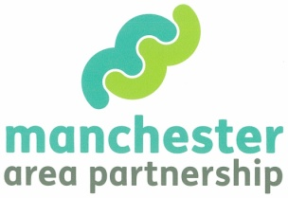

Developing the Skills of Disabled People and their organisations to provide Whole Life Planning and Peer Support to Disabled People.

From the end of August through till the end of November the Manchester Area Partnership will be providing:-

FREE Knowledge sharing opportunities, briefings, training events and 1:1 business coaching.

These events will enable Disabled Peoples Organisations (DPOs) and disabled people in the Manchester Area Partnership (MAP*) area develop the skills to support customers and families to best utilise personalisation opportunities such as Right to Control (RTC) and Personal Health Budgets provider market.
*MAP Area = Bury, Manchester, Stockport and Trafford
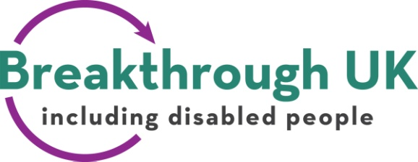

MAP & Breakthrough UK will be co-ordinating a programme of FREE events and opportunities which aim to:-

- Ensure we all understand and evaluate current policy, legislative environment and the personalisation environment and the implications for our organisations and disabled people.

- Support Disabled Peoples Organisations and disabled people to develop skills and knowledge to deliver services, which will support disabled people to access opportunities through RTC and other Personalisation initiatives such as Personal Health Budgets.

All events are FREE for Disabled Peoples Organisations and disabled people from the RTC MAP area. Some events or training courses will have a restriction on numbers and some are restricted to representatives from disabled people’s organisations.

The first group of events will be

27th August 2013 at BEVC – Breakthrough UK, Manchester
What are the current BIG National Policy Issues affecting Personalisation?
A one day event of seminars and discussions with lunch which will cover the White Paper “Caring for Our Community” and the subsequent Care Bill and the Office for Disability Issues Disability Strategy - ‘Fulfilling Potential’.
(Code RTC 2/1)

29th August 2013 at BEVC – Breakthrough UK, Manchester
What are the Health Reforms, Personal Health Budgets? What is Think Local Act Personal – and what’s happening in my area?
A one day event of seminars and discussions with lunch.
(Code RTC 2/2)

12th and 18th September 2013 at BEVC – Breakthrough UK, Manchester
An in depth day which explores the Social Model and the concept of Independent Living in the current policy climate and the barriers disabled people are currently facing to achieving a 24-7 life.
A one day training event with lunch (one day repeated twice)
(Code RTC 2/3a or b)

19th September 2013 at BEVC – Breakthrough UK, Manchester
What is Personalisation, What does it mean? What are the core values and principles, What does it mean for disabled people at the moment?
A one day training event with lunch
(Code RTC 2/4)
Detailed times will be confirmed – a full day is likely to be 10-4pm

All events are fully accessible (please identify access requirements at the time of booking), all events are free, reasonable travel expenses can be covered with prior agreement.

All these events are open to representatives of disabled
peoples organisations and disabled people in the RTC
Trailblazer areas of Bury, Manchester, Stockport and
Trafford.

To book your place e-mail
admin@breakthrough-uk.co.uk and
quote RTC DPULO Development and
the booking code. You will then receive
a booking form.

Some are also open to disabled people and to
representatives of disabled people’s organisations
across Greater Manchester.
However, in the case of over booking priority will
be given to the RTC areas.

Coming Soon….
Peer Support – what is it? and what are the skills needed?
Support Planning, Brokerage, Developing Circles of Support and much more.

And specifically for disabled people’s organisations, there will be a one off opportunity for a funded place on a NVQ Level 3 in Advice and Guidance and 1:1 Business Support and coaching to develop your business plan in this market.

So get involved and register now!
