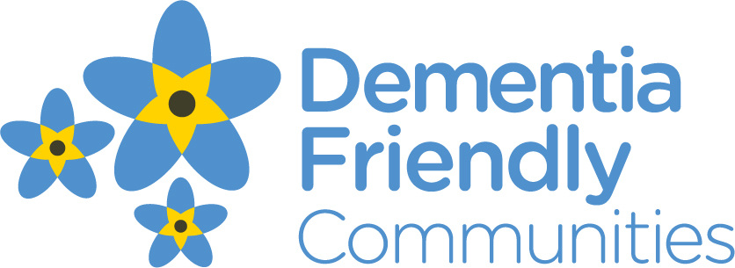

Date: Thursday 7 May 2015
Contact: Helen Morris 07740 178310


LOCAL ORGANISATIONS SUPPORT NEW DEMENTIA FRIENDLY HULME INFORMATION PROGRAMME

Dementia Friendly Hulme is working in partnership with experts from local Manchester companies and services to run their first SHARED programme for people living with dementia and their partners/family carers.

This free programme runs for 6 consecutive weeks every Wednesday from 20th May starting at 10.00am and finishing at 2.30pm at the Amani Centre, Moss Lane East, Moss Side, Manchester M16 7DG (on the Hulme / Moss Side border) and includes lunch.

The programme is designed for 8-10 couples (spouses, partners, siblings, parents with their children) and has 18 separate sessions across the 6 weeks, many of which are co-run with experts in their field.

The group meets to gather information and share experiences across a range of topics, from learning more about dementia and future planning through to keeping fit and communicating well.

Helen Morris, Services Manager of the team said “We were delighted by the response and to see how organisations are starting to reach out to residents of Manchester who are living with dementia.

It’s great to think we can combine our expertise in dementia with the specialist knowledge of solicitors, fire and police officers, researchers and pharmacists to name but a few, to deliver a rounded information programme for people living with dementia and their carers.
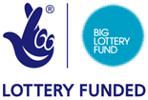

“It’s fun too with a social lunch and afternoon sessions covering a variety of areas like movement, relaxation, singing, taking part in research and getting started with life story work.”

To guarantee a place on SHARED (Support, Help, Access to Resources and Engagement with Dementia) call 0161 962 4788, post to Alzheimer's Society, Dunham House, 85-89 Cross Street M33 7HH or email DFCGM@alzheimers.org.uk.

ENDS

Notes to editor:

- Building dementia-friendly communities: A priority for everyone explores new evidence from people with dementia: their experiences of living in their community and the changes that they would like to see in place.
- 510 people with dementia and carers responded to a survey that was distributed via Alzheimer’s Society staff including dementia support workers and Dementia Advisers in England, Wales and Northern Ireland
- Survey findings from Alzheimer’s Society (2013) have been applied to prevalence estimates from Alzheimer’s Society Dementia UK (2007) report. This provides an estimate of 184,800 people
- YouGov survey Total UK sample size was 2,287. Fieldwork was undertaken in January 2013. The figures have been weighted and are representative of all UK adults (aged 18+)
- Alzheimer’s Society’s report ‘Economic Case for Building Dementia Friendly Communities’ was produced by Crystal Blue Consulting Ltd. A saving of £11,296 per year is calculated by comparing the costs of residential and community care for a person with dementia. This looked at each element of the individual care pathway, including costs associated with the initial presentation, diagnosis, case management through to actions in the home, residential and hospital care setting.
- If Dementia Friendly Communities reduce 5% of admissions to residential care for people with dementia for one year, the net saving would be £55 million per annum
- Alzheimer’s Society provides a National Dementia Helpline, the number is 0300 222 1122 or visit alzheimers.org.uk
- You can find out more about Alzheimer’s Society through their website alzheimers.org.uk
- Dementia Friends is part of Alzheimer’s Society’s Dementia Friendly Communities programme. This programme focuses on improving inclusion and quality of life for people with dementia.

