
Free Homeless Sector PIE Training Face to Face course - Summer 2026 in Central Manchester

Psychologically Informed Environment (PIE) Training is designed to increase the learner's knowledge of homeless people, understand their narratives and respond effectively.

Please be available to attend both days:
Day 1 – Monday 6th July 10am-4pm
Day 2 – Friday 10th July 10am-4pm

To book your place, please complete the form:

Free Summer 2026 Homeless PIE Training. Face to Face Manchester City Centre Location – Fill in form

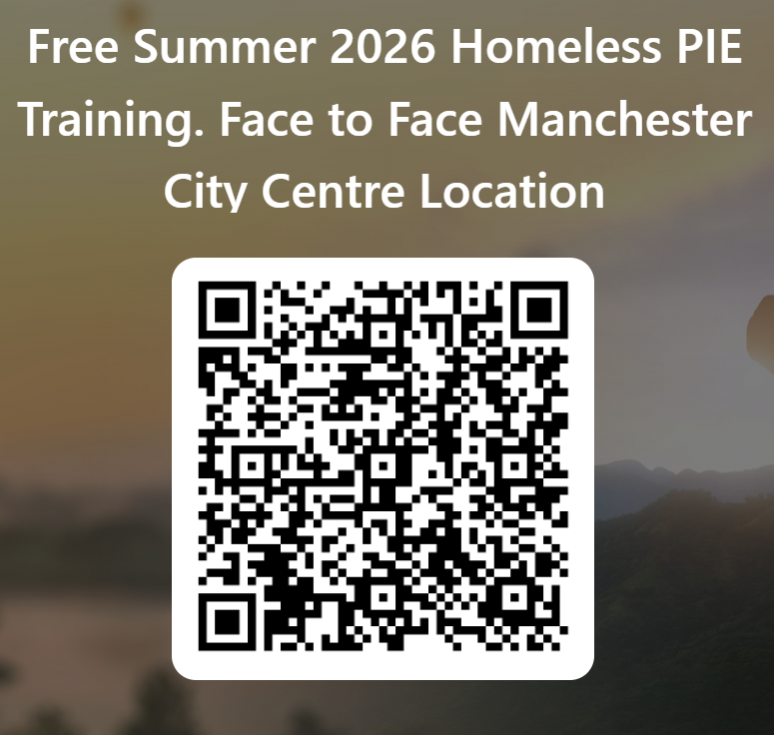

About this event
This is a 2-day course, run by mental health professionals. It is open to anyone working in the Homeless Sector in Greater Manchester. The training session will run from 10am-4pm. Please aim to arrive at least 10 minutes early. Details of the Central Manchester venue will be sent out for successful candidates within 2 weeks of your application and at least 5 days before the start of the course. When all places are taken it will be made clear on the application form.

Monday 6th July 10am-4pm
- Introduction to Psychologically Informed Environments in Homelessness. How the approach enables organisations to understand and support homeless people who have had challenging experiences in life.
- Becoming Trauma Informed - Early life experiences and their impact on adult relationships and mental health.

Friday 10th July 10am-4pm
- Substance Use and Managing Dysregulation - Understanding and working with substance use difficulties. Trauma’s impact on personality development and a focus on dealing with intense emotion in ourselves and others.
- Trauma Informed Approaches to Change - Practical ideas about how to approach the subject of change, using supportive conversations.

If you want to reserve a place, please complete the application form:

Free Summer 2026 Homeless PIE Training. Face to Face Manchester City Centre Location – Fill in form

Frequent Questions about the course

Can I attend just one session?
Unfortunately, no. The course is made up of four sessions over two days which fit together as a whole. Themes run through the course and references are made to other sessions which would make less sense out of context. Further courses will be held, when planning them we consider people’s circumstances. If there is a reason attendance is difficult you think we might be able to help with, please let us know.

When are the details being sent out?
After you complete the application form the details of the venue will be sent out
Please check your junk mail and contact homelessPIE@gmmh.nhs.uk if you have not received it by the Wednesday before the first session.

I have a disability or health condition which makes it difficult for me to fully participate.
Please let us know what you need prior to the course and we will aim to make it more accessible for you. There will be two comfort breaks and a lunch break in each session and a variety of media and exercises are used. The venue will be accessible throughout. Please contact us if you need anything else homelessPIE@gmmh.nhs.uk

I don't work in Greater Manchester. Can I still attend?
The face-to-face course is only open to people that work in Greater Manchester. You are welcome to attend an online course, the next one will run in September.

I am volunteering in a homeless charity. Will it be relevant to me?
It will be relevant to anyone working in homelessness. We aim to keep the courses accessible for people with all levels of previous knowledge. We try to use plenty of examples from practice and use a range of different teaching styles. The contribution of attendees with different backgrounds is central and valuable. Please let us know if you agree in the feedback after the course.

I am a manager / CEO. Will this training be relevant to me?
PIE is a systemic approach, understanding the principles of trauma informed care and knowledge of the complexity of the support required is relevant to KPIs you may write, stipulating achievable outcomes for a project you are funding.
Email us for more info homelessPIE@gmmh.nhs.uk

Do we get the slides?
We will send the slides out to the address you have registered with us after each session. Please let us know if you do not receive the slides via the above email address

Free Summer 2026 Homeless PIE Training. Face to Face Manchester City Centre Location – Fill in form

