PRESS RELEASE – FOR IMMEDIATE RELEASE – 14.03.14

Students sleep rough in bid to end to destitution of asylum seekers

Manchester STAR and Amnesty will tonight hold a Sleep-out on Oxford Road to campaign against the destitution of asylum seekers.

Thousands of asylum seekers are living in extreme poverty or destitute in Britain. Some are supported by the government, but simply do not receive enough to meet their basic needs, and others have been refused asylum and receive no support at all.

There are an estimated 2,000 destitute asylum seekers and refugees in Greater Manchester – and students, local community members, refugees and Labour MP Kate Green – will tonight turn out to call for changes to Government policies that force people into this situation.

This follows the release of a disturbing report by British Red Cross that a humanitarian crisis is gripping Greater Manchester and has left many of the area’s most vulnerable people homeless and destitute for more than a decade.

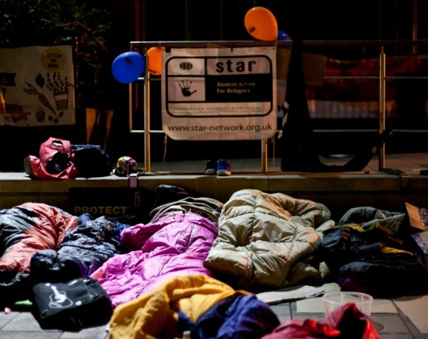

No permission to work and living on little more than £5 a day
People seeking asylum have been forced to flee their home countries due to conflict and persecution. Many arrive in the UK after having been threatened, detained, beaten or tortured. The UK asylum system is strictly controlled and it is very difficult to get asylum.

While they wait for a decision on their claim for refugee protection, the vast majority of asylum seekers are not permitted to work. People who are seeking asylum have fled with nothing but their lives and, without work, are forced to rely on a meagre amount of weekly support from the government.

A single adult receives just over £5 a day to cover basic necessities like food, transport, toiletries, and clothes (no-choice often poor-quality dispersal accommodation is provided separately). This is simply too low to meet anybody’s basic needs and forces people who have come to the UK to seek safety to live in poverty.

People seeking asylum face the indignity and fear of life on the streets
Worse still, those whose asylum claim has been refused can have this meagre support withdrawn, leaving them utterly destitute. Many are refused asylum because they could not access legal advice or could not prove their stories, meaning they reach the end of the process without their need for protection being properly recognised by the Home Office. Others cannot go back home because they are stateless, or their government will not issue travel documents. Nevertheless, when they are refused asylum here they are entitled to nothing at all. They have no right to work. They have no financial support. They have nowhere to live. They are unable to provide for themselves and are forced to depend upon charities and friends for housing, money and food, or face the indignity and fear of life on the streets.

Betty is a refused asylum seeker living in Manchester who has been given temporary accommodation by local Charity, the Boaz Trust. She told us: “For six years I sign for hope I get papers, I get stay. To the end, they refused. So I became destitute, I start sleeping on my friend’s floor; sometimes I can’t sleep for the whole night [because of the] cold. Now I am living in a Boaz house - four of us, we take care of the house.
I was working, I had a good job. I came here because of problems with my government, I can’t go back; they would still come after me. Six years then refused, it is heart-breaking.”

Local activist, Estelle Worthington commented: “Many people who came to the UK in god faith to seek refugee protection have been let down and their protection needs have not been recognised. With support withdrawn and no permission to work they are forced to live in fear, not knowing when they will get their next meal or where they will sleep tonight. I was appalled to learn that some people have been stuck in this situation for up to a decade. This is no way to treat human beings.

And this isn’t just happening somewhere over there, but here in our local community. There is a simple solution to this problem and it’s high time the government takes action to relieve this unnecessary suffering.”

This week STAR (Student Action for Refugee) groups across the country are taking action in support of the Still Human Still Here campaign calling for an end to the destitution of refused asylum seekers in the UK. This is supported by a coalition of more than 60 organisations including Amnesty, Oxfam and the British Red Cross who are campaigning for a fairer asylum system in which nobody is forced to live in extreme poverty.

__________________

NOTE TO EDITORS

Sleepout begins at 7.30pm, at Manchester Universities’ Catholic Chaplaincy (Opposite the Students’ Union, 355 – 359 Oxford Road)

Featuring speeches from:
Dave Smith of the Boaz Trust,
Kate Green MP,
The United for Change Coalition.
Plus music from Sobi, Oh Man, the Mountain and more.

For enquiries and interviews, please contact Estelle Worthington, Regional Asylum Activism Project. Email: northwest@regionalasylumactivism.org | Mobile: 07557983264.

Post event Press Release plus event photos available 15.03.14

