Tree of Life Centre Wythenshawe

Membership of the Management Committee

The main responsibilities of Committee Members are:

- To ensure that the Project uses its resources in the pursuance of its objectives

- To make sure that all staff and volunteers are supported and his/her performance is monitored in an appropriate way.

- To safeguard the good name, principles and values of the Project

- To contribute to the appointment of staff

- To contribute to the differing goals of the Project

- To contribute to setting targets and evaluating performance against those targets

- To ensure the effective administration of the Project

- To provide guidance in issues in which the member has special expertise

- To ensure the financial stability of the project

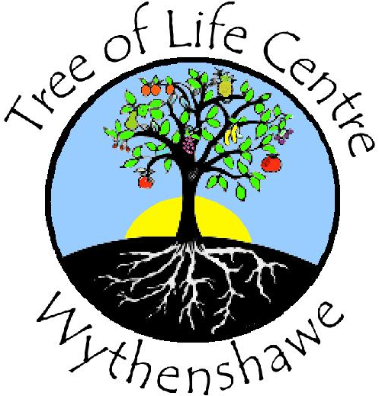
Application form to join the Management Committee of

The Tree of Life Centre – Wythenshawe

Name:
Address:
Work No. / Address (if convenient):
Home No Work No:
Email:
Are You disabled? |  | Yes/No
Do you have any specific requirements for us to enable you to fully participate? (e.g. translator, minicom, etc.)
What do you feel you would be able/willing to contribute to the organisation?

What Experience do you feel will be of assistance to us? (e.g. personal, professional or general life skills)

What would you hope to gain from your involvement?
What Commitment would you hope to be able to offer?

Declaration
I declare that:

I am over the age of 18.

I am not an undisclosed bankrupt.

I have not previously been removed form membership of a charity by a court
or the charity commissioners.

I am not under a disqualification order under the Company Directors’
disqualification Act. 1986.

I am in the light of the above, not disqualified by the Charities Act 1993
(section 72) from acting as a charity member.

I undertake to fulfil my responsibilities and duties as a member of the Tree of

Life Centre, Wythenshawe in good faith and in accordance with the law and

within the Tree of Life Centre’s Objectives/mission.

I do not have any financial interests in conflict with those of The Tree of Life

Centre, Wythenshawe (either in person or through family connections)

except those which I have formally notified in a conflict of interest statement.

I will specifically notify any such interest at any meeting where members are

required to make a decision, which affects my personal interests, and will

absent myself entirely from any decision on the matter and will not vote on it.
Signed: |  | Date:

