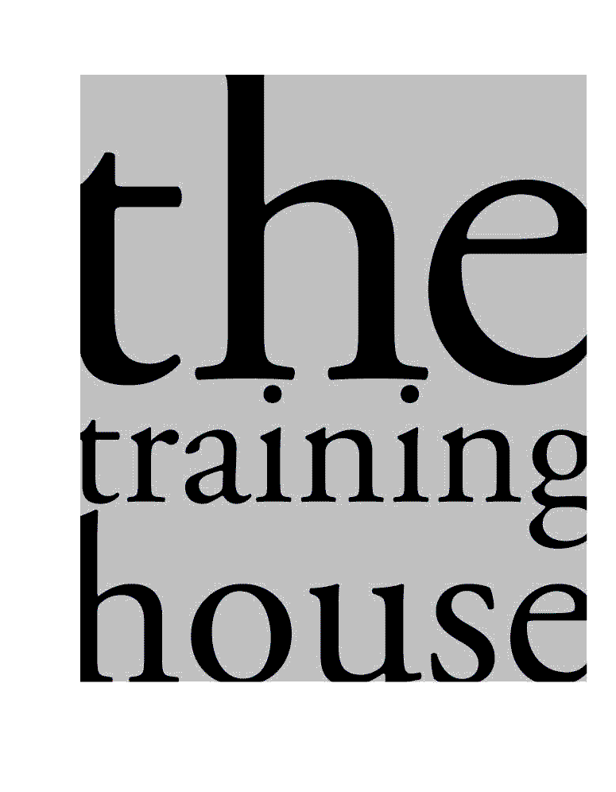
Training House Booking Form

Delegate Name

Delegate Contact | Phone:  Email:
Delegate Role

Name and Address of Organisation
Any special needs you'd like us to be aware of?

Please put a cross [X] next to the courses you wish to book onto:

Course | Length | Date | Time | Cost per place | Put a X below
Leading a Team | 1 day | Wednesday 12th June | 9.30am – 4.00pm | £95
Leading Successful Meetings | ½ day | Thursday 13th June | 9.30am – 12.30pm | £65
Assertive Communication | 1 day | Wednesday 19th June | 9.30am – 4.00pm | £95
Managing Difficult Conversations | 1 day | Friday 21st June | 9.30am – 4.00pm | £95

Please note that all places booked must be paid for unless cancelled with 2 weeks notice. This also applies if someone is unable to attend on the day due to illness.

Payment
We will email the invoice 2 weeks before the course. Payment must be made within 30 days.

Name and address you need on the invoice

Email address to send the invoice to

PLEASE RETURN THIS BOOKING FORM TO: melanietraininghouse@hotmail.com

We will send you a confirmation email on receipt of your booking form and joining instructions 2 weeks
before the course. All courses take place in Central Manchester at Swan Buildings, 20 Swan Street, M4 5JW.

We also run the following courses in-house from £650 (full day) and £450 (half day).

- Volunteer Support & Development
- Team Development – Mediating, Troubleshooting, Action Planning
- Preventing & Managing Stress in Staff
- Stress Busting (for Staff)
- Sharps Training / Blood Borne Viruses
- Health and Safety Levels 1,2,3
- Infection Control and Prevention
- Emergency First Aid at Work
- Fire Safety
- Food Safety Levels 1,2,3,4
- Manual Handling
- Supervision / Appraisal
- Recruitment and Selection
- 1 to 1 Coaching
- Business Writing Skills
- Professional Boundaries
- Delivering Quality Customer Services
- Presentation Skills
- Project Management
- Teambuilding / Contributing to Teams
- Facilitating Groups / Training the Trainer
- Time Management
- Communication Skills
- Managing Difficult Conversations
- Handling Conflict
- Assertive Communication
- Preventing & De-escalating Aggression
- Applying for Jobs / Interview Skills
- Health and Wellbeing for Staff
- Mindfulness – How to Stay Calm
- Motivational Interviewing

For further details on any course or to book training for groups of staff on your premises please email melanietraininghouse@hotmail.com or phone 07733 268088.

Office Use Only | Emailed | Date
Confirmation & T C
Joining instructions
Invoice

