**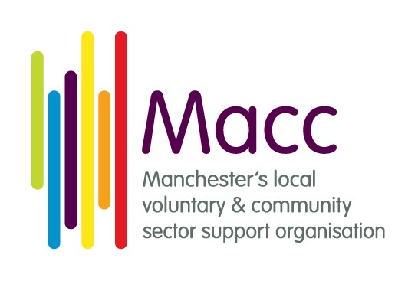**

**Recruitment Pack**

Volunteering Development Worker

Macc

Swan Buildings

20 Swan Street

Manchester M4 5JW

0161 834 9823

[www.manchestercommunitycentral.org](http://www.manchestercommunitycentral.org)

Macc is a Charity Registered in England and Wales No 1145921 and a Company Limited by Guarantee No. 7788593

**Thank you for your interest in joining the team at Macc.**

Macc is a charity and put simply, our purpose is the city of Manchester. We work to inspire, enable and support the people of Manchester to get involved and build the communities where we live, work and grow. Macc delivers a wide range of activities including:

* **Helping local charities, community groups and social enterprises** to be well-run, successful organisations with the resources they need to make a real difference.
* **Supporting local people to be active citizens through volunteering** – matching local people with local organisations and causes through our Volunteer Centre.
* **Building an influential and connected community through policy, insight and collaboration** - convening the city’s Voluntary and Community Sector Assembly, building partnerships between charities, the local public sector and private businesses.
* **Celebrating the work, talents, creativity and diversity of all our local communities** through our annual Spirit of Manchester programme, telling the story of the wealth of activity in local communities across the city.

We believe every individual and community has unique skills, talents, knowledge and insights that are important. We also believe that our collective skills, knowledge and lived experience uniquely equip us to do the work we do. All of our work is informed by three key values:

* Being **supportive** - providing mutual support and encouraging one another
* Being **collaborative** - facilitating positive change in society by working with people
* Being **influential** - harnessing people’s skills and building their confidence to shape and inform policy and practice

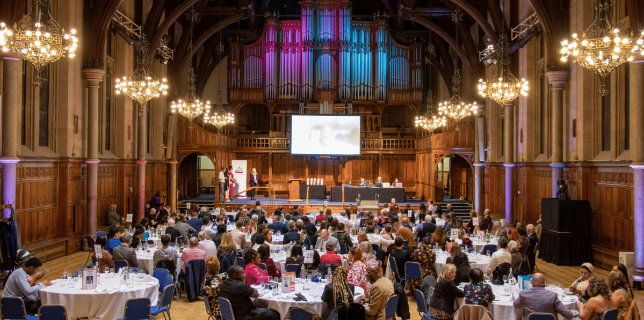

**Spirit of Manchester Awards 2022**

**A Message from the Chief Executive**

When people ask me what my job is, I often say that it’s to make more good stuff happen in Manchester. Macc’s position is at the heart of Manchester’s voluntary, community and social enterprise sector, working alongside public bodies and local businesses. This gives us a unique perspective on this city and a role unlike any other organisation.

We support, encourage and celebrate the good and useful and amazing work of our local voluntary, community, and social enterprise sector – VCSE sector for short. We help set up new groups, develop existing organisations, find funding and resources, and encourage, support and - sometimes - challenge our sector. We help local people be active in their communities. We run Volunteer Centre Manchester, we bring organisations together to collaborate and influence the City Council, the NHS, often working with colleagues across Greater Manchester. Macc aims to be an active, influential and inspiring voice in the city.

I’m proud of the work we do and the impact we have on our local community. And as we do all that work, we try to lead by example in being a good employer and a great place to work. It’s important to us to provide a safe, welcoming and supportive environment for all our staff where you can develop your skills and knowledge as well as supporting our communities.

* We operate through flexible working and home working: we have office space in the city centre but our approach balances personal choice, building teamwork and the needs of the people and groups we work with.
* All staff have Personal Development Plans and a budget to cover the costs of external training and/or personal development activities.
* Our Staff Health and Wellbeing Group: leads on ensuring we have a culture which supports the health and wellbeing of everyone at Macc. This includes “re-energise afternoons” taking time out to recharge and refresh; Mental Aid First Aid confidential support for staff who are struggling and a range of social and team activities throughout the year.
* Volunteering leave: staff are entitled to up to 2 days per year (pro rata), with pay, to engage in voluntary work - just as we ask other businesses to do.
* We encourage active travel and have incentives such as a support in buying public transport season tickets, a Cycle to Work scheme and travel expenses for cyclists.
* We have been an accredited Real Living Wage employer since 2013.

Thanks for your interest in Macc and we look forward to hearing from you….

Best wishes

Mike Wild, Chief Executive

**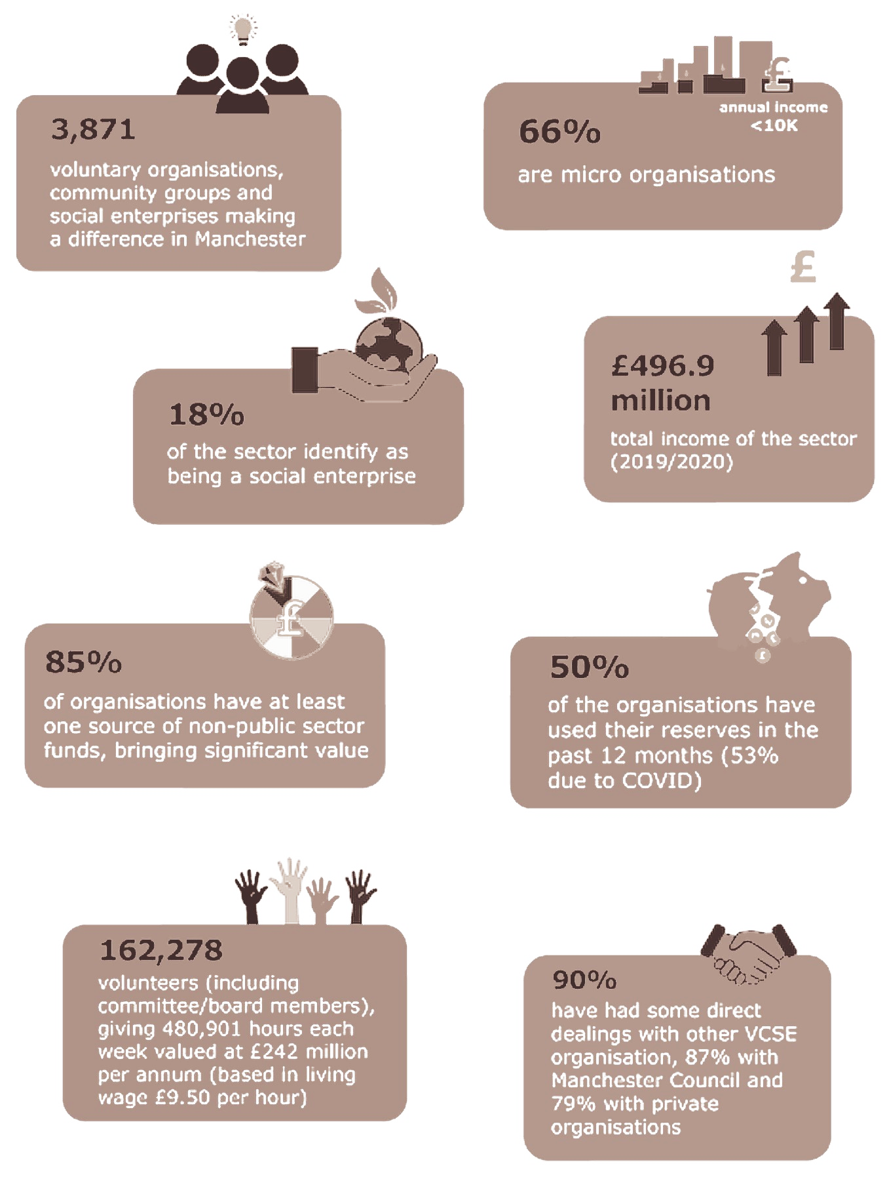**

Key facts from Macc’s **State of the Sector** research into the scale of the work done by charities, community groups and social enterprises across Manchester. This was part of a collaborative project with partners across Greater Manchester to show the contribution we make to the city region.

**Some of Macc’s achievements of the last 3 years**

**What the people we work with say about us**

**On support from Macc**

**“Thank you so much for the great guidance and support in building [our group]!”**

**“The Health check is a fantastic opportunity for us all to learn and grow as an organisation so all the Board is really appreciative of the time and effort Macc have put in to it.”**

**“I have been to other Macc training sessions. I found all of them very helpful and knew this one was going to be the same”**

**“We’ve had some serious challenges - [the kinds of] Covid-generated crises familiar across the voluntary sector. Macc has been a consistent source of practical help and I just wanted to let you know how incredibly valuable Macc’s support has been. Thank you all!”**

**“Made me more confident in the role"**

**It is going well with the volunteers - there is no way we could have done this without you holding my hand. You have done a great job!**

**“You never cease to be amazingly helpful and supportive. It's been so good to know you're there, during what has been a tough few years.”**

**On our role in the city**

“Macc's policy and influence bulletin is always the most insightful, and useful newsletter/update I receive”

“Plays a critical linking role between different sectors, organisations and individuals with roles to play in building a better society; builds understanding and encourages people to think differently about their work”

“Thanks for showing and demonstrating much needed leadership and for being there for our sector in unprecedented times.”

**On the Spirit of Manchester**

**“Our hearts are full after an amazing celebration of Manchester's community groups and charities. It’s such a privilege to be part of this group of change makers.   
Congratulations and huge thank you to all involved.”**

**“Thanks for lifting my spirits this evening, it’s just been brilliant.   
Thanks again to everyone working across the voluntary sector”**

**About the Role**

Manchester’s Voluntary, Community and Social Enterprise (VCSE) sector is made of thousands of organisations and individuals who use their skills to improve the quality of life in the city. They have insight that can help shape policy and decision making locally, regionally and nationally.

In Manchester, there are more than 160,000 volunteers that provide almost 500,000 hours of time, passion, skills and enthusiasm per week in support of the City’s Voluntary, Community and Social Enterprise (VCSE) sector.

Whether it is helping a neighbour with tasks such as shopping, being a trustee and coaching a sports team, or acting with others to help tackle issues ranging from climate change and racism to food and fuel poverty, Macc recognises all forms of voluntary action as valid, relevant and valued.

Volunteer Centre Manchester (managed by Macc), provides information, support and training to Manchester residents who want to volunteer and to organisations that work with or involve volunteers.

The Volunteering Development Worker will support the delivery and ongoing development of a quality and responsive volunteering brokerage service for people that want to volunteer in Manchester; and for volunteer-involving organisations and groups by providing a range of services and support.

The role also involves providing input and support with practical action that enhances Macc’s Volunteer Centre Quality Accreditation status (VCQA), and the 5 core functions of a volunteer centre: Strategic Development of Volunteering, Good Practice Development, Developing Volunteering Opportunities, Voice of Volunteering and Brokerage.

**Who we’re looking for**

The right person for this job will be someone who:

* Understands, demonstrates and applies their knowledge about volunteering and voluntary action;

* is able to identify appropriate and supportive pathways into volunteering (and other relevant programmes)
* can help volunteer-involving organisations to identify 'new' and creative approaches to developing volunteering opportunities and volunteer-based projects

* Is effective in providing support and dispensing information, advice and guidance that is appropriate for the recipient

* Enjoys tackling a diverse and varied workload in terms of tasks, duties, audience and beneficiaries as per the delivery of a volunteer centre service

* Demonstrates a willingness to learn and undertake training where required; and has a commitment to inclusion and equality

As with all roles at Macc, we are looking for someone who has a strong commitment to

Macc’s values; someone who can plan and manage their own workload, dealing with multiple tasks and working to tight deadlines. Experience of monitoring and evaluation of activities will be helpful.

You will need good working knowledge of MS office applications (Outlook, Word, Excel, PowerPoint) and be able to produce concise and accurate written reports, presentations, webpage and newsletter content as required.

You will also need to be willing and able to travel around Manchester - though driving ability is not essential as we encourage use of public transport and ’active travel’ (such as walking or cycling).

**Position:** Volunteering Development Worker

**Salary:** £27,291 per annum, pro rata

**Hours:** 35 hours per week (flexi-time system).

**Location:** Based in Manchester City Centre but with some remote working

**Contract:** Permanent (subject to funding)

**Reporting to:** Volunteering and Active Communities Manager

**Working at Macc**

**Our culture**

**Macc’s Purpose**

To encourage and support voluntary and community groups, charities, social enterprises and local people to make a difference on issues that matter to them, to our communities and to our city, Manchester.

**Our Beliefs**

* Every individual and community has unique skills, talents, knowledge and insights that are important.
* Diversity is a strength: our collective skills, knowledge and lived experience uniquely equip us to do the work we do.
* Our people are central: we appreciate all that our people make possible and are committed to supporting them to continue to develop.

**We value**

**Being Supportive**: increasing mutual support and inclusive opportunities, helping to create more impact.

**Being Influential**: leading by doing and enabling ourselves and others to make a difference on issues of inequality, poverty, environment and social justice.

**Being Collaborative**: joining others in a common purpose of improving our city for all communities, sharing the work, the challenges and the ambitions.

**Purpose of the Role**

To support the delivery and ongoing development of a quality and responsive volunteering brokerage service for people that live, work or study in the City of Manchester; by working closely with volunteer-involving organisations and groups to identify and develop new volunteering opportunities; and to provide a range of services in support of developing good practice in volunteer involvement. This role will lead on the active communities’ objective to support a growing range of opportunities for local people to be active citizens in their communities.

The role involves supporting to deliver activities that are based on or enhance Macc’s Volunteer Centre Quality accreditation status (VCQA), and the 5 core functions of a volunteer centre: Strategic Development of Volunteering, Good Practice Development, Developing Volunteering Opportunities, Voice of Volunteering and Brokerage.

**Main Duties of the Role**

*These are subject to change throughout employment in response to changes in priorities and ways of working. Your line manager will work with you to turn these into annual objectives.*

**Being Supportive**

* Providing information, advice and guidance that offers supportive pathways into volunteering and other relevant programmes and initiatives that are of benefit and value (e.g. education, employment and training).
* Engage people that access the volunteer centre, projects and services as stakeholders in reviewing satisfaction and developing services.
* Contributing to bid writing and fundraising activities to support income generation and sustainability of projects and services; and similar in pursuit of achieving awards and accreditation (e.g. Volunteer Centre Quality Accreditation).
* Contribute to maintaining Macc’s database of volunteers and records of opportunities advertised.

**Being Collaborative**

* Work with volunteer-involving organisations to help them identify 'new' and creative approaches to developing volunteering opportunities and volunteer-based projects; that respond to needs and areas for development, and build capacity.
* Maintain and seek new opportunities for relationships with key agencies across Manchester (and further afield) and develop suitable partnerships with partner and provider organisations; to promote and raise the profile of the volunteer centre and other projects, deliver information sessions and training, and engage them as stakeholders in review and development.
* Support with volunteer co-ordinators forum to increase networking and collaboration and provide peer to peer support and development.

**Being Influential**

* Organising and delivering presentations and workshops to facilitate volunteering brokerage and share information about the volunteer centre and other projects and services (e.g. annual Volunteering and Social Justice Fair).
* Organising or participating in relevant events, meetings and networks to raise the profile of volunteering projects, and support people in the profession of volunteer management.
* Providing information, advice and guidance to volunteer-involving organisations to help them develop and uphold good practice; policies, procedures and processes in their work with volunteers, and where appropriate referring to Macc’s Support for Groups and other teams within the organisation.
* Work with the membership team on marketing and promotion activities for the volunteer centre; developing materials that are engaging and accessible, devising and composing content and campaigns for sharing via e-mail, social media and other methods that is consistent and in line with Macc’s branding and reputation.
* Support the organising of Volunteers week and engaging in outreach activities to promote the programme to support Manchester’s national celebration to recognise and reward volunteers for their hard work and participation in improving society.
* Support with recognising and encouraging the community led mutual aid groups and informal volunteering in order to offer them support and encourage people to get involved with them.
* Support with promoting a widening view of volunteering through providing information about opportunities to get involved in civic roles such as school governors, Magistrates, Older peoples network, Health Watch, community sponsorship, trustees to encourage citizens to get involved.
* Support Macc's approach to employer supported volunteering to improve the quantity, quality and diversity of opportunities for people to give their time and skills through their employer.
* Support with recording and sharing stories through our digital platforms to celebrate the strengths of the sector as a call to action more volunteers to get involved.

**General Responsibilities of all Macc Staff**

* Uphold and promote the purpose, beliefs and values of Macc, supporting others to do so and reaching out to build new relationships
* Be kind: work to be inclusive and treat people with dignity, respect and empathy
* Be accountable internally and externally for your work
* Work collaboratively as a member of the Macc team, and to contribute to the development of ideas, thinking, policy and good practice within Macc
* Share general responsibility for
* Macc’s communications newsletters, bulletins, social media and online resources
* Macc’s contact & casework database
* Reporting and being accountable for Macc’s impact
* Supporting meetings, events and training opportunities
* Macc’s annual Spirit of Manchester programme celebrating the local voluntary, community and social enterprise sector’s work in the city
* Responding to enquiries and administration
* Contribute to income generation and general fundraising, including providing charged-for services where required
* Always be willing to learn and to undertake training when required.
* Work in accordance with key policies to ensure Macc exemplifies good practice as a VCSE organisation
* Value diversity and be inclusive in line with Macc’s Equality, Diversity and Inclusion statement, anti-racism policy and other relevant policies.
* Stay safe and well, being responsible for your own health & safety and that of colleagues, in accordance with Macc’s policies on Health and Safety, Safeguarding and Staff Welfare
* Protect the integrity of our information and systems, being mindful of Macc policies on Data Protection, Cybersecurity and Open Data

**How to apply**

If you believe you can fulfil the role summary, we’d love to hear from you!

Attached with this pack is a short application form in which we ask you for some basic details and a few questions about your skills, knowledge and experience which are relevant to the role. An equalities monitoring form with simple questions and a GDPR statement which we ask you to confirm you have read. Applications can be emailed to [pauline@macc.org.uk](mailto:pauline@macc.org.uk)

The closing date is **Monday 15 January 2024** **at 12 noon**.

Interviews for this post will take place on **31 January, 2024 in person at our office**. If you will not be available on this date, please note this in your application.

For an informal conversation regarding this post, please contact Pauline Clark before submitting your application. Email: [pauline@macc.org.uk](mailto:pauline@macc.org.uk) or telephone 0161 834 9823.

Macc is passionate about ensuring that everyone has a fair chance and that they are treated equally. We are aware of the underrepresentation of certain groups and communities in our sector. These include but are not limited to, people from racialised or minoritised backgrounds, disabled people, LGBT+QIA and those from working-class backgrounds. We want to change this and commit to playing our part in eradicating inequalities in both what we do and the way we do it.

Macc is an inclusive employer committed to building a diverse, effective workforce which reflects our local communities. We work hard to create a supportive, accessible environment. We celebrate difference, and welcome applications from a wide range of backgrounds, skills and abilities, recognising value in different perspectives.

If you require access to these documents in alternative formats, or if you have comments that would support us to improve access to our application processes more generally, please do contact us via email [pauline@macc.org.uk](mailto:pauline@macc.org.uk) or telephone us on 0161 834 9823.

**Connect with us**

|  |  |
| --- | --- |
|  | @McrCommCentral  @VolunteeringMcr  @PolicyVoiceMacc  @MikeWildMacc |
|  | [www.facebook.com/spiritofmanchester/](http://www.facebook.com/spiritofmanchester/) |
| Image result for youtube logo | [Macc Manchester](https://www.youtube.com/user/maccmanchester) |
|  | [MikeWildMacc](https://www.instagram.com/mikewildmacc) |
|  | [www.manchestercommunitycentral.org](http://www.manchestercommunitycentral.org/) |
| Macc_Strap_COL | Macc,  Swan Buildings, 20 Swan Street,  Manchester M4 5JW Tel: 0161 834 9823 |

|  |  |  |  |  |
| --- | --- | --- | --- | --- |
| C:\Users\Mike.Wild\Dropbox\Mike Documents\10GM\Logos\10GM Logo (no text).jpg | | **Macc is a founding partner of 10GM, a joint venture to support the local VCSE sector in Greater Manchester** | | |
| NAVCA | | Good Employment in Greater Manchester | https://www.manchestercommunitycentral.org/sites/manchestercommunitycentral.co.uk/files/LW_logo_employer_rgb.jpg | https://manchestercommunitycentral.org/sites/manchestercommunitycentral.co.uk/files/u5/GMPA%20PP%202020.jpg |
| C:\Users\mah_w\Downloads\2.png | Open to All | Disability Confident Committed | we're supporting cancer screening in Greater Manchester | cid:image003.png@01D70065.0DFBC660 |

**Macc is a Charity Registered in England and Wales No 1145921**

**and a Company Limited by Guarantee No. 7788593.**