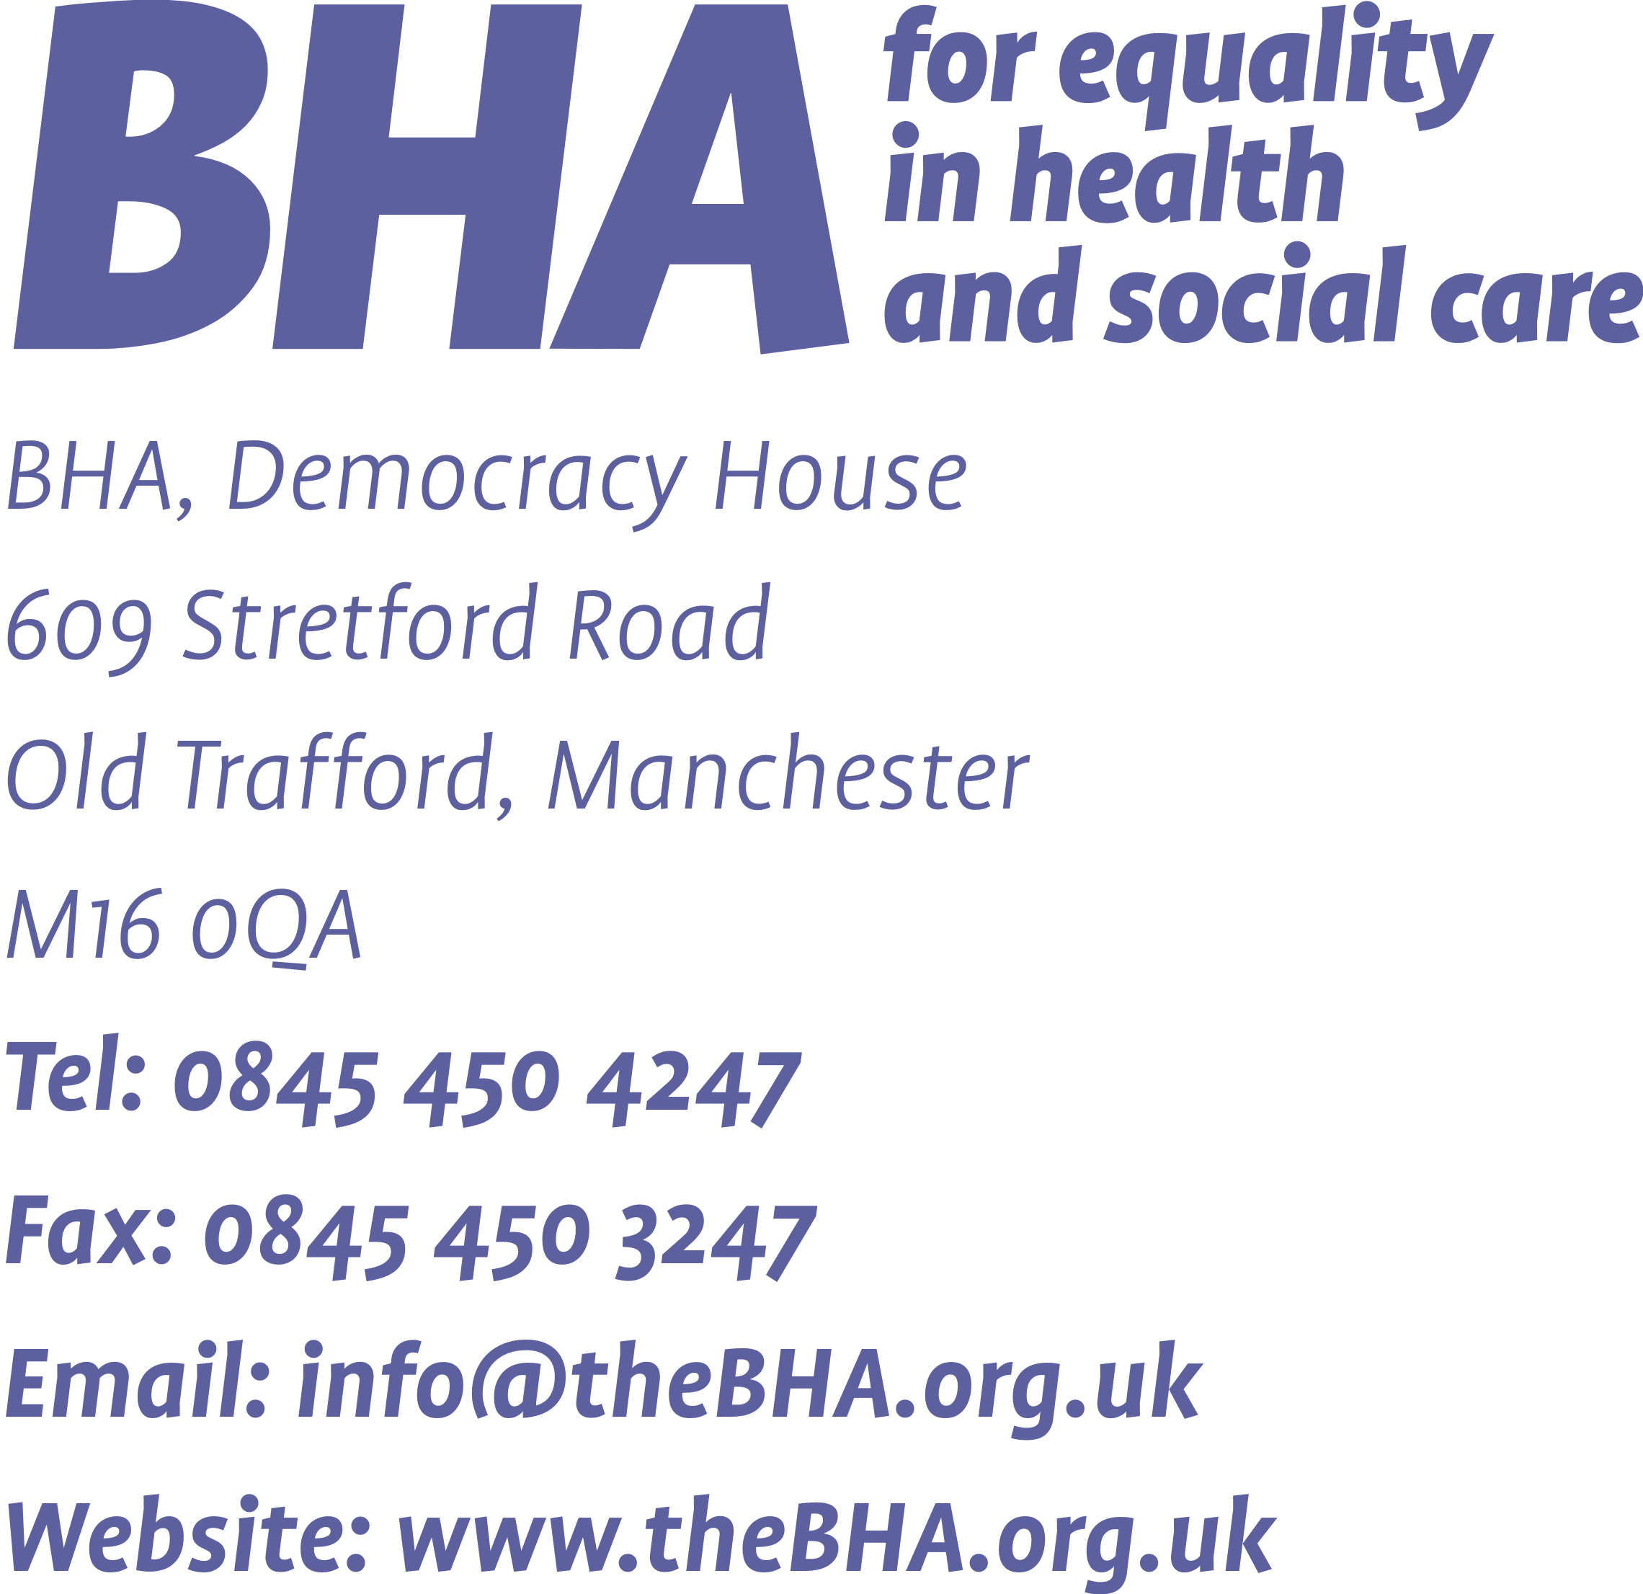

Dear colleagues,

To celebrate World Aids Day we will be holding a Market Place event and workshops that promote the health and wellbeing of BME individuals and communities in Manchester.
The event will take place on Saturday 3rd of December 11am-4pm at St. Thomas Centre, Ardwick Green North, Manchester, M12 6FZ.
As a community provider, we invite you to hold an information stall at the event. There is no charge for the stall at the event or if you want to hold a workshop for participants. If you would like to hold a health workshop at the event or offer testing please indicate this on the booking form below.
Typically each stall will be equipped with 2 chairs and a 6ft trestle table (no linens will be provided). Due to the limited space we will only be able to allocate one stall per provider.
To book your stall please complete the booking form and return by email to
emma@thebha.org.uk
If you have any questions, please call the above number for my support.

Kind regards,

Emma Zurowski
Team Leader

‘Our Stories’ World Aids Day Event
St. Thomas Centre
Saturday 3rd of December
11am-4pm

Booking form

Please complete and email back to emma@thebha.org.uk
Organisation Name | Contact number and email | Description of stall and service. (If you wish to offer testing or a workshop (up to 1hr) please give further information). | Number of staff attending *

