Your funding Your ideas Your decision

Adactus Housing has once again set aside a pot of money and would like to put you in control of how it’s spent. Miles Platting - You Decide lets Miles Platting residents decide for themselves which projects are needed in their area.

If there are too many applications before the event, a local panel will select those which best meet the conditions and invite them to showcase on the day.  
WHAT CAN YOU APPLY FOR?
We need your ideas for projects that will:
- benefit as many people as possible from across the community.
- help to make Miles Platting a better place for everyone.
- meet a real need that is not already met in the area.
Whether you want to organise a dance for young people, a healthy living project, a crime prevention idea, a lunch club for older residents, a community art project, hanging baskets for your alleyway or a street party for your neighbours, the only limit is your imagination.
WHO CAN APPLY?
Any local community, voluntary or non-profit organisation - even informal groups of friends and neighbours - can apply for up to £2,000 to put ideas into action. All groups applying will have to be operating in Miles Platting, and any activities will have to happen here or mostly benefit Miles Platting people.

You don't have to come from an existing
organisation to apply for this fund, but if you are an individual resident, we’ll ask you to find some local friends or neighbours who are prepared to get involved and support your application.
HOW DO YOU APPLY?
To apply for the funding you must return this form before Friday 19th October 2012.
If your idea fits, you will need to showcase your project idea at a public event on 17th November where residents will get to vote for the best ideas.
If you can convince your neighbours that your idea is a good one, you will get the cash!
All Miles Platting residents are invited to the event to be held on 17th November 2012.
The event will be held at St George’s Community Centre on Livesey Street.

You don’t need to be connected to any
project to attend the event, but you do need to arrive between 10.30am – 11am to register to vote and then stay for the presentations. The winners will be announced around 2pm.
If you apply for funding yourself, you’re welcome to bring your friends with you who live in the Miles Platting area, but you will have to vote on all the projects who are presenting, not just your own! Even small groups and new groups have a great chance of getting funded if they have a good idea.
Listen to the presentations, discuss the ideas, pick your favourites, enjoy lunch and entertainment and get the results the same day!

This is Miles Platting - You Decide

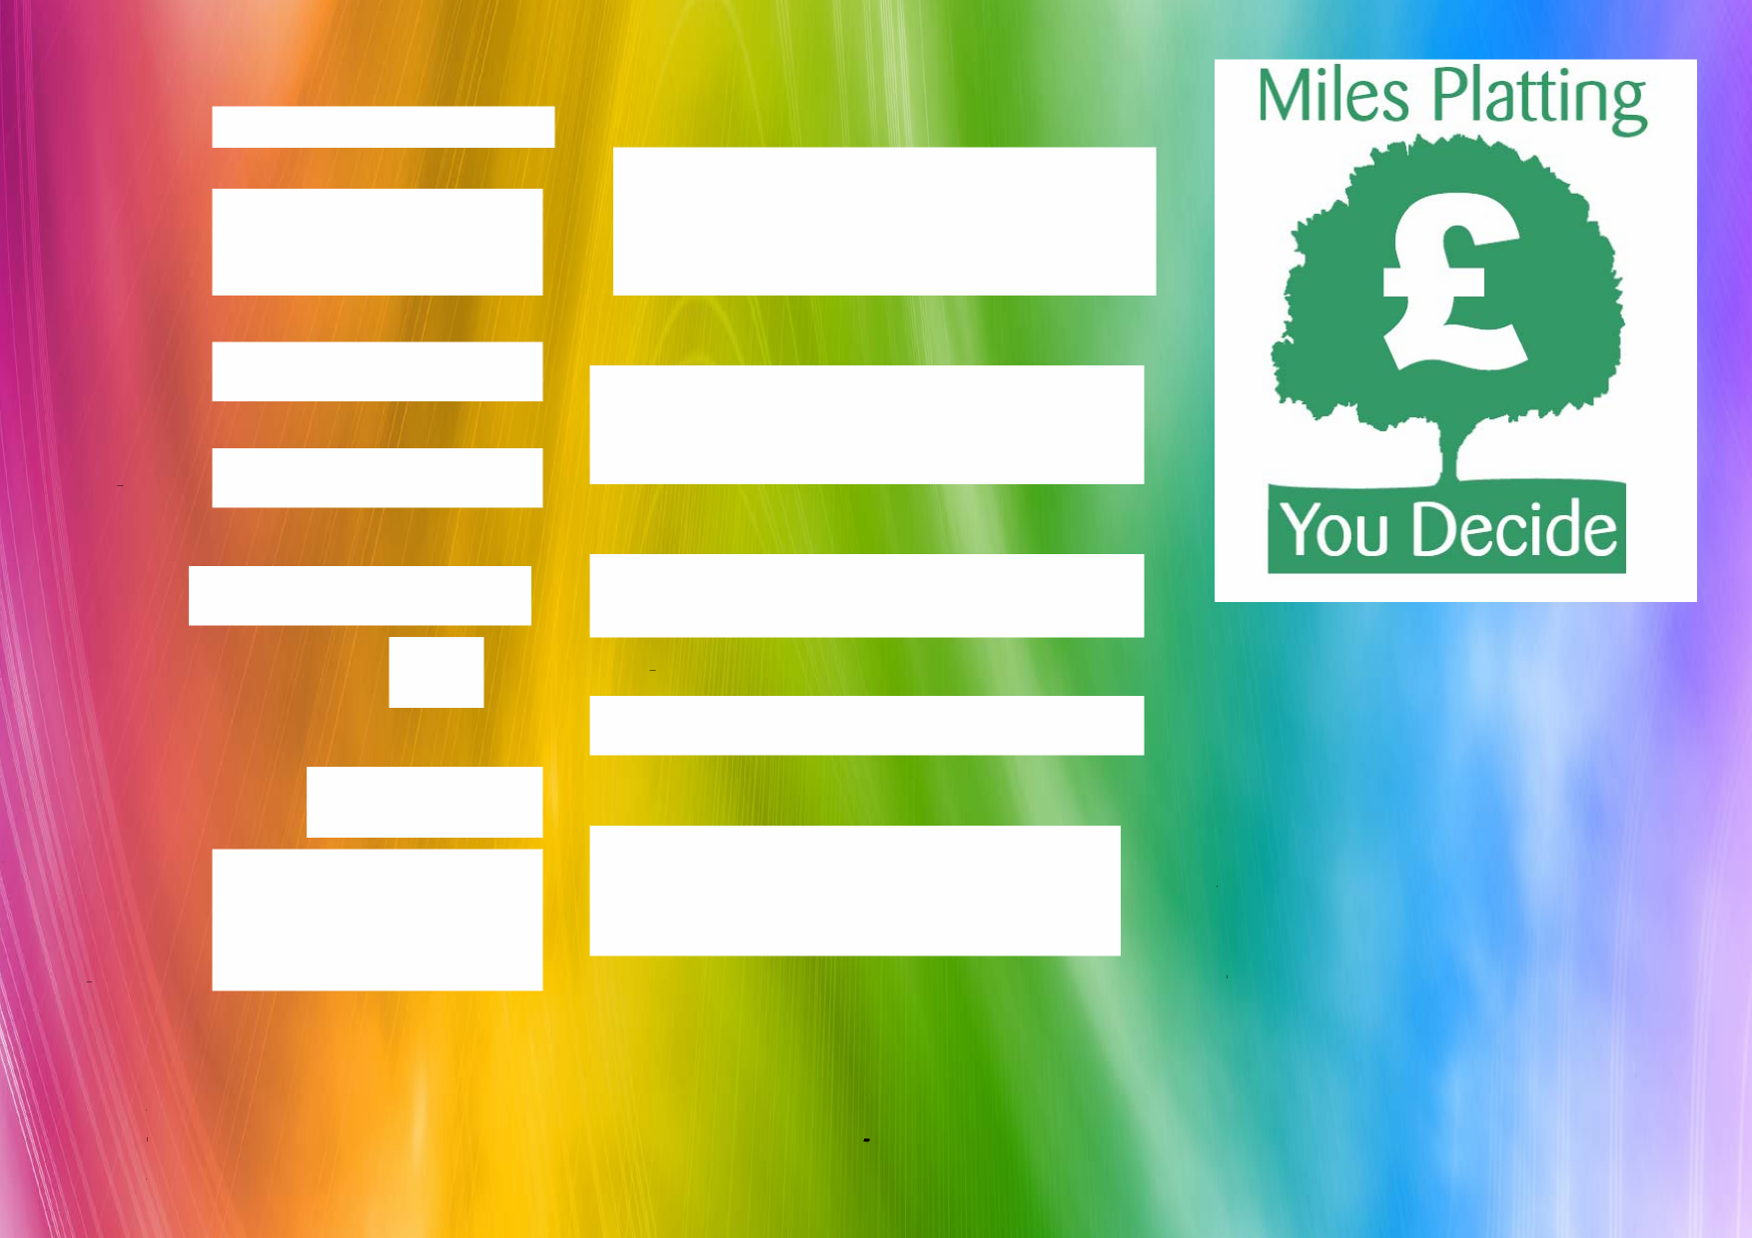
REGISTER YOUR IDEA AND ENTER THE EVENT!
Your full name : Briefly outline the project you’d like some funding for :
Your address (this may be the address of your group if you prefer) :
How will it make Miles Platting a better place for everyone?
Your postcode :
How many different people do you think it might benefit?
Your email :
What particular need will it address?
If you have an idea to make Miles Platting a better place for everyone...
Do you YES
represent an
organisation?
If you could use up to £2,000 to put your idea into action....
How much money do you need?
If yes, what is the name?
What is the main purpose or activity of your group or organisation?
If you’d like your say in what groups or ideas get funding to develop projects in Miles Platting...

.

Then Miles Platting - You Decide is for you!

Please return this form to Adactus Housing Association, Baker House, 542 Oldham Road, Miles Platting, M40 8BS by Friday 19th October 2012.

If you need help filling in this form, or want to discuss your idea before applying, call Issie or Vicki on 0800 234 6826 or drop in to the Adactus Housing Office.

Good luck!

DEADLINE FOR ENTRIES IS FRIDAY 19th OCTOBER
Organised by Adactus Housing Association

Your phone no :

