**Booking Form**

**Equality Delivery System 2 (EDS2) Stakeholder Event**

**The Pennine Acute Hospital**

**Event Details :**



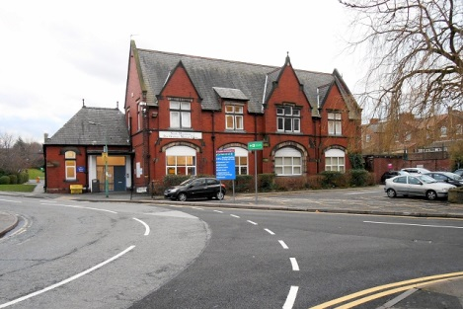 **Venue is North Manchester General Hospital, Post Graduate Centre**

|  |  |
| --- | --- |
| **Contact details** | |
| Name |  |
| Organisation, if applicable |  |
| Address |  |
| Telephone Number |  |
| Email address |  |

|  |  |  |  |
| --- | --- | --- | --- |
| **Which protected group are you representing (please choose all that apply)** | | | |
| Age |  | Marriage and Civil Partnership |  |
| Carers |  | Pregnancy and Maternity |  |
| Gender (male or female) |  | Race and Ethnicity |  |
| Gender Reassignment |  | Religion or Belief |  |
| Disability |  | Sexual Orientation |  |
| Do not wish to disclose |  | Socio-economic deprivation |  |

|  |  |  |
| --- | --- | --- |
| **Type of need/ requirement** | | **Please provide details** |
| C:\Users\jw12ag\AppData\Local\Microsoft\Windows\Temporary Internet Files\Content.IE5\4K4RT7PS\Vector_cup_of_coffee.svg[1].pngC:\Users\jw12ag\AppData\Local\Microsoft\Windows\Temporary Internet Files\Content.IE5\0XQSR372\BrownBagLunchIdeas[1].jpg | Dietary requirements (refreshments will be provided and lunch will be provided at the grading event 28th March) |  |
|  | Information needs e.g. large print |  |
|  | Communication needs e.g. BSL interpreter |  |
| C:\Program Files\Microsoft Office\MEDIA\CAGCAT10\j0293238.wmf | Access requirements |  |
| Other |  | |

|  |  |
| --- | --- |
| **Which event will you be attending**?  Attendees are encouraged to attend the training event also to be able to prepare for the grading event. | |
| **Review and Training Event**  8 March 2018, 9.30 to 1.00  North Manchester General Hospital, Post Graduate Centre |  |
| **Grading Event**  28 March 2018, 9.30 to 2.30  North Manchester General Hospital, Post Graduate Centre |  |

**Please return completed forms to:**

**Email:** equality@pat.nhs.uk

**By Post:** Jerish Devine

Administration Assistant

Equality & Inclusion - Workforce Department

Northern Care Alliance

The Pennine Acute Hospitals NHS Trust

The North Manchester Hospital - Trust Headquarters

Delaunays Road.

Crumpsall. Manchester.

M8 5RB.

**Telephone:** 0161 604 5893