Manchester Care and Repair Cuts Case study
Manchester Care and Repair has been a mainstay of Manchester’s Voluntary and Community Sector since 1991. They started as one of many Home Improvement Agencies (HIA) set up around that time as a service to help local authorities facilitate repairs, renovations and home adaptations for older and vulnerable owner occupiers. They are a registered charity and one of the few independent HIAs in England.
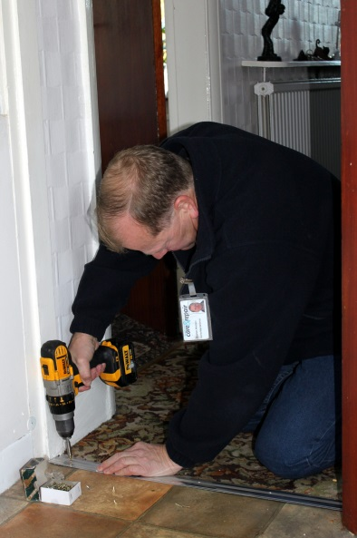
Handyperson fits a carpet trim to prevent trip hazard
In the years following, in the typical way of VCS agencies, they changed and developed in response to the needs of people who used their services. Many clients needed more than just physical changes to their homes, they needed an approach that treated them as whole people with a range of support needs. Their mission to help people to remain living independently at home and to make sure their home is warm, safe, secure and adapted to their needs is under threat with a proposed cut of £234,000 in Manchester City Council contracts.
The Home from Hospital Service is the mostly badly affected by the cuts. The prime purpose of this service is to support the transition from hospital to home, a difficult time for anyone, but even more so for people who are vulnerable and isolated and where there isn’t family or friend who can help, For people who are over 60, going through A&E or coming out of hospital it’s a quick phone call to check all is well and to introduce Manchester Care & Repair’s range of low level support services but for some who don’t have support it’s more.
In the words of the Executive Director “It’s nothing fancy”, it just does the basics, helping someone to settle in, get some food, make sure the house is safe and secure, the heating is on and then assess if there is anything else further that might need to be done such as applying for benefits. Nothing fancy, but this is the friendly, human approach that can make all the difference, that helps people on the way to a full recovery, prevents re-admission and falls. It fits in beautifully with both national and local initiatives on integrated care and moving from hospital to community care.

Mrs D is 83 years old and lives in Newton Heath. She attended A&E at NMGH in March this year. As a result of a Home from Hospital follow-up phone call she accepted our caseworker service to do a welfare benefits check.
Mrs D has several health conditions including vertigo, arthritis and poor mobility. Mrs D knew that she might be entitled to health related benefits but didn’t know who to approach and felt unable to travel to an appointment. Our home visiting caseworker completed an application for Attendance Allowance in April and also sorted out a number of other benefits. The result of our HfH phone call and caseworker intervention means that Mrs D now receives £123.02 per week extra income which she can use to purchase additional support with tasks that she can no longer manage herself.
She was delighted with the installation of a second stair rail and grab rails at the front and back doors free of charge by our Handyperson Service. She now has “the peace of mind of knowing who to call for help with small jobs around the home”.
If the cuts go ahead there will be no more taking people home, instead it will only be a telephone service which will refer on to a much reduced casework service, funded mainly through BIG Lottery. This casework service is one of the only home visiting casework services left in Manchester and is referred into from social workers and health professionals. It deals with housing options, adaptations and income maximisation. Every caseworker brings in an average of £250k per year to their clients at a cost of just £29k/worker (including all staffing costs). The casework service will close to external referrals so they can concentrate on the clients that have no support at all.
Another service that will go is the Suresteps Child Safety Project which fits child safety equipment in the houses of vulnerable families who are referred by early years staff. For £60k per annum it installs stair gates, fireguards etc. in over 500 homes, playing a key role in safe-guarding children.
In total, it is expected that the organisation will lose 9 permanent and 6 fixed term staff, as well as reduction in hours for other staff. Some of the staff have worked for the organisation for 15 years, a huge reservoir of experience and knowledge. The fundraising and marketing assistant is one of the staff that will go, reducing the potential to raise further funding and the organisation will be running on reserves at a deficit of £40-50k/yr. In reality the contracts from Manchester City Council are insufficient to cover their costs and have always been subsidised from other sources.
Prevention is at the heart of what Manchester Care and Repair does and the grim reality is that cuts in their services will mean more falls, more hospital re-admissions, more preventable illness and in the end more unnecessary deaths.

