Manchester Refugee Support Network

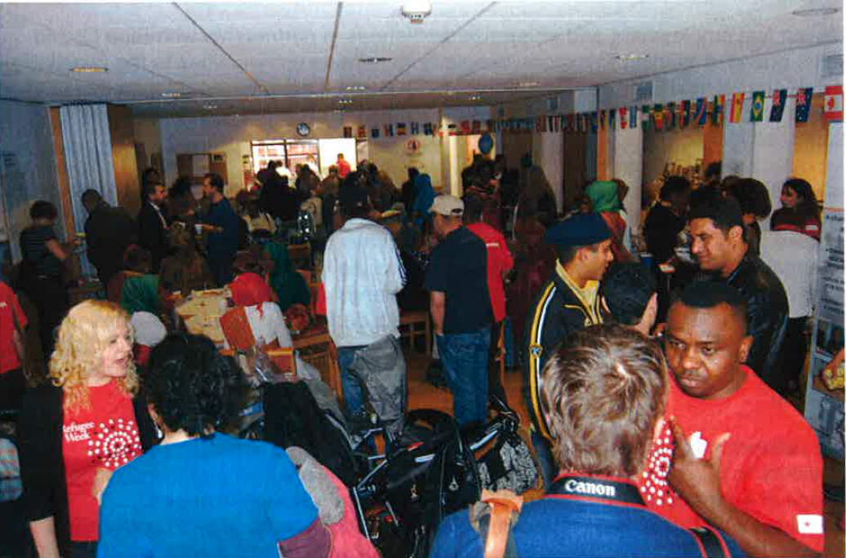
Refugee Celebration Event at Cross St Chapel

MRSN was established in 1995 and has been core funded by Manchester City Council for all that time. It is facing potential closure if Equality Grants are discontinued and a key Manchester voluntary organisation will be lost.

Now, as ever, MRSN is working with some of the most disadvantaged people living in Manchester including recent arrivals from Syria, Eritrea and Sudan. They give advice and assistance to refugees to help them start their life in Manchester, to find housing, to apply for benefits, to look for work, to access health services. They work closely with other advice givers in the city who form the Manchester Volunteer Advice Partnership.

Just as importantly, they help newly arrived refugees to meet other refugees from their communities and assist them to set up community groups to assist others. They continue to work with all the refugee community groups in the city assisting them to develop. Last year they supported 40 refugee community organisations.

Due to language and cultural issues, refugees can be difficult types for public services to reach or help. MRSN acts as a bridge between public services and refugees helping to shape future services. This has been a key part of their long-term relationship with Manchester City Council.

MRSN depends heavily on volunteers and provides many volunteering opportunities helping refugees and other Manchester citizens to gain skills, increase their knowledge and improve their chances of employment.

Overall MRSN plays a key role in helping Manchester’s refugee communities to become active and engaged citizens who play a full part in the life of the city. Every year they help organise Refugee Week activities across the city to celebrate the contribution that refugees make to the life of Manchester.

Equality funding accounts for 60% of the running costs of MRSN. Without it they will no longer be viable and will close, also losing the additional income that they raise to support other activities, such as a homework club and a refugee old people’s project. At a time when Manchester’s communities are becoming increasingly diverse and there is mounting antipathy toward migrants, it seems, at the very least, a false economy to lose a key organisation that improves community cohesion.

