Our Manchester VCS Funding Co-design Boundaries
This document sets out the areas that delimit the work of the co-design group.

Strategic Context

Our Manchester Strategy
The Our Manchester Strategy sets out the strategy for the city (not just the Council) for the next 10 years. This funding must support the aims of the Our Manchester strategy. The key themes of which are:
- A thriving and sustainable city
- A highly skilled city
- A progressive and equitable city
- A liveable and low carbon city
- A connected city
Local ‘place groups’ are working on implementation at neighbourhood level.

Locality Plan
The Manchester Locality Plan sets out a vision for an integrated health and social care offer which supports Manchester residents to improve their own health and wellbeing. This funding needs to support the aims of the Locality Plan, helping VCS organisations in Manchester play their role in improving the health and wellbeing of Manchester residents.

Decision-Making
The Our Manchester VCS Funding Co-design Group is advisory. The final decision on the funding model will be made by Manchester City councillors.

Budget
Neither the budget nor the length of funding has been decided.

Draft Timescale
October /December 2016: co-design group works to generate options for consultation
January 2017: Communities and Equalities Scrutiny Committee
January/February 2017: consultation
February 2017: Co-design group meets to refine model based on consultation
March 2017: Council decision making process
Spring/Summer 2017: Procurement Process
Autumn 2017: New funding arrangements in place

Procurement
No decisions have been made about a procurement process.
If competitive grants are used, there is a presumption the agreed standard process, which was co-designed with the VCS, will be used unless there are good reasons to modify it.

Governance of Our Manchester VCS Funding
No decisions have been made.

Operational Responsibility for Our Manchester VCS Funding
No decisions have been made.

In scope existing funding
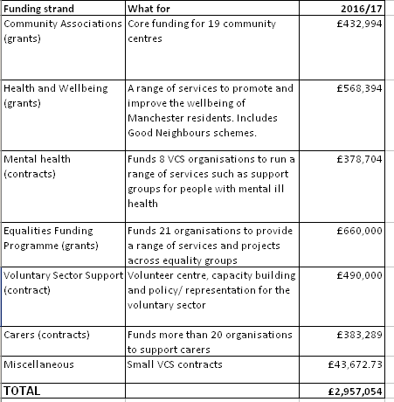

Legal Boundaries
Under the requirements of the Local Government Transparency Code, Manchester City Council is required to publish details of all grants made to voluntary sector organisations.
The Equality Funding Programme contributes to the Council’s fulfilment of its duties under the Equality Act 2010
Carers contracts contribute to the meeting the Council’s responsibilities under the Care Act 2014
Any grants or contracts need to meet the requirements of Manchester City’s Council’s Financial Regulations

