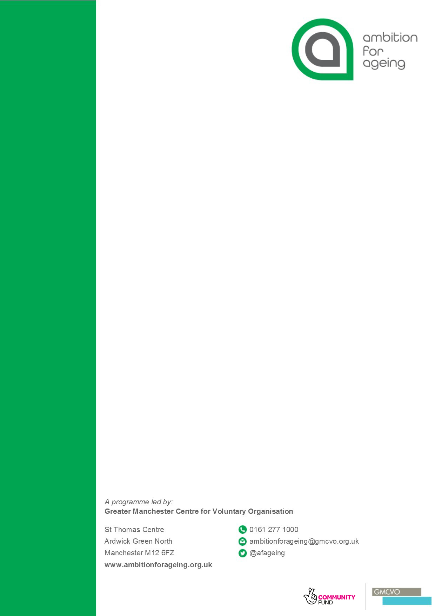

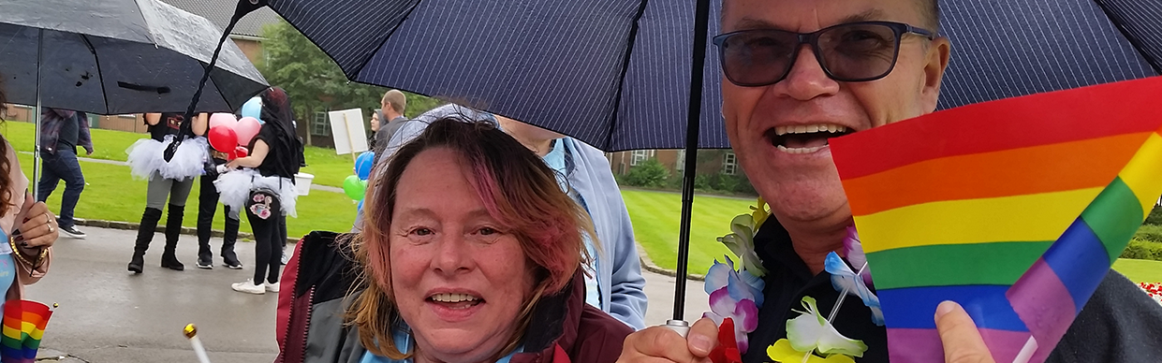

How to Work Inclusively to Make Neighbourhoods Age-Friendly

Equalities Board briefing document

Clare Bonetree, Sarah Wilkinson, Hannah Berry
April 2019

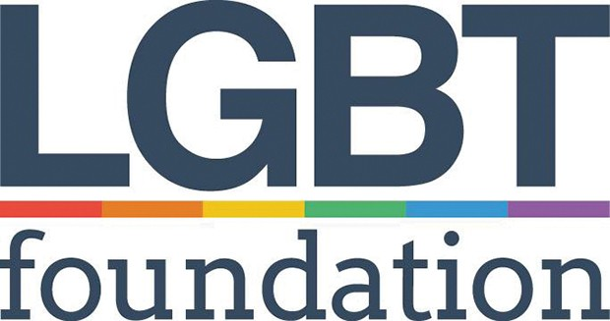

Glossary / List of new terms
Ambition for Ageing
= a programme that is working to make communities more age-friendly and improve older people’s quality of life in Greater Manchester
BAME
= Black, Asian or Minority Ethnic, anyone in the UK who does not identify as White British
context
= social setting – includes history, geography and economy
discrimination
= treating someone badly because of something about them, such as their race, sex, class, age, disability
diverse
= a group that contains many different kinds of people
diversity
= a way to describe a community having a lot of different kinds of people in it, or a way of working having lots of different methods and tools
equalities
= another way of talking about ‘equality and diversity’, a way of working that focuses on helping everyone have equal chances
inclusion
= a way of working that includes people from different backgrounds and communities, who have different experiences of discrimination and life
intersectionality
= the way that marginalised identities overlap, and specific forms of discrimination intersect or cross over, and make new kinds of discrimination
marginalised
= not noticed by the majority, or treated as if they are less important than the majority
minority communities
= groups of people with a shared background or ethnicity that are different from the majority population, such as: South Asian people in Britain, LGBT people, disabled people
social isolation
= when someone does not have very much, or any contact with their community

What this briefing is about

Introduction
This briefing is for organisations who want to improve life for older people by making changes in neighbourhoods. It says that it is extremely important to understand equality, diversity and inclusion if you want to make a place better for older people. If you are doing work to make sure that older residents do not feel isolated, you need to start by considering equality, diversity and inclusion. If you have these in mind right from the start, your projects will be better designed and will reach more people. You will also reach the older people who find life hardest. They are the ones who will benefit most from the changes you want to make.

This briefing has been produced by the staff at the Ambition for Ageing Equalities Board. In the last three years we have learned a lot about equality, diversity and inclusion by talking to the organisations and volunteers involved in Ambition for Ageing, and by doing our own research.

There is a lot of specialist language in equalities work. We use specialist words so that we can say exactly what we mean. We have included a glossary at the start of this briefing to help with understanding these words. We also have a glossary and other resources, including videos and links to more information, on our website: lgbt.foundation/ambition-for-ageing/resources

What is Ambition for Ageing?
Ambition for Ageing is a five year programme based in Greater Manchester. It works with older people to make communities more age-friendly, and to empower people as they get older. The programme provides funding for small neighbourhood projects, which local older people design and run. It also funds larger projects across the region, and carries out research. Ambition for Ageing is part of Ageing Better, a national programme set up by The National Lottery Community Fund.

What is the Equalities Board?
The Equalities Board advises Ambition for Ageing on equalities, diversity and inclusion. We do this through research, taking part in meetings and consultations, and learning about equalities together. The Equalities Board members are older people who understand marginalisation and discrimination from personal experience, and local equalities organisations. It was set up by staff at the LGBT Foundation and older people working together to decide how the Equalities Board should work. The Equalities Board is a way to make sure that the voices and experiences of older people from marginalised communities are heard. We would like other organisations to learn from it and also work in this way with older people.

The key points of this briefing
In this briefing our research findings are explained in three sections:

- Things you need to know to make sure that age-friendly work is inclusive.
- Ways of working that make inclusion deeper.
- Why it is important to think with an equalities mindset.

1: Knowledge you need to work inclusively

Summary
We have found that when you are doing age-friendly community work you need to understand the communities you are working with very well. You also need to understand the wider world. This will make your work to improve older people’s quality of life and reduce loneliness more effective.

A. Knowing what ‘age-friendly’ means for different communities
This means gathering information from people in marginalised communities about what they think makes a neighbourhood age-friendly. People in smaller minority communities may have different ideas about age-friendly neighbourhoods from people in the majority community. They may identify more with each other even if they live in different areas, than with people in their area.

B. Knowing how to be flexible with project boundaries
This is because small minority communities can be spread out across different local areas. You may have to cross the boundaries of project areas to make sure you include people who are hard to reach.

C. Knowing how diverse approaches affect equalities
This means you need to understand that different ways of making decisions, and other different ways of working, can have effects on marginalised communities. All ways of working exclude some people and include some people. You need to make sure that your project has ways to reduce the effects of ways of working on marginalised people.

D. Knowing about the wider context
In our research we found that organisations doing local community work need to understand history, geography and economic issues in the wider world. This is because these affect local neighbourhoods. For example, government decisions about funding cuts can affect social isolation of older people, by reducing social welfare and local services. Another example is the way that decisions about transport and town planning can increase social isolation of older people.

E. Collecting good information about project users
You need to know about the people who use your project so that you know if you are reaching the people who need it most. If you have this information you can review the project and change the way you are working to be more effective. You need to make sure that you collect enough information and it is correct.
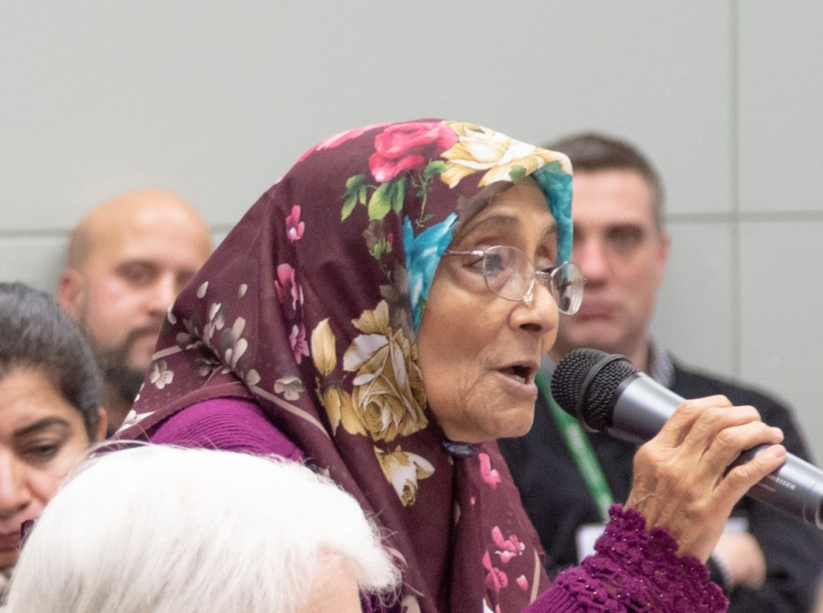
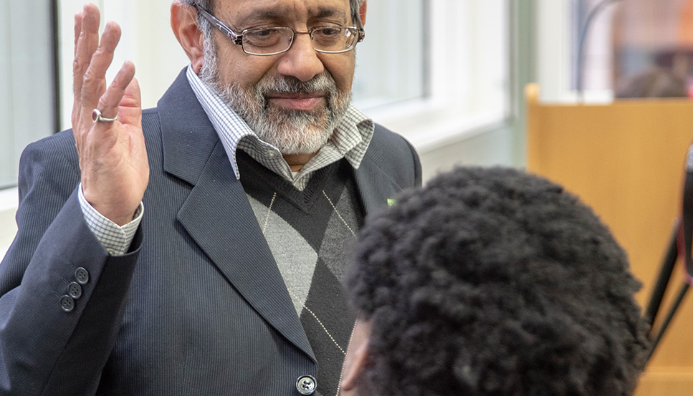

2: Ways of working that make inclusion deeper

Summary
Sometimes you must work in ways that take longer or need more funding. We have found that these ways of working are important to make sure your project includes marginalised people. We are including them in this briefing so that they get attention.

A. Targeting work for particular communities
We have found that it is important to target particular minority communities with some funding and project work to make sure that you reach marginalised people. You need to do this in addition to making sure all your events and projects are open to these groups. In our research we found that sometimes organisations do not do targeted work because they do not want to single people out. But we also found that if you do it sensitively you can break down the social barriers that isolate people.

B. Universal project designing to include all
This means that you need to design your project in a way that means anyone from any background or community can access it. If you design a project in this inclusive way then it will benefit more than one target group. For example, a project that makes changes to the local area for older people can help disabled people too. Another example is providing hot food - this can benefit disabled people, people who live alone, and people who don’t have much money.

Universal design is the opposite of designing a project for one community or group and hoping that everyone can access it, but without changing it.

3: Working with an ‘equalities mindset’

Summary
Last year the Equalities Board did an equalities review of Ambition for Ageing work. We found that you need to think with equalities in mind right from the start if you want your project to make older people less isolated. We call this working with an ‘equalities mindset’.

There are two things you must do to have an equalities mindset in your project.

A. Make sure everyone understands equalities, diversity, inclusion and intersectionality better
This means all the staff and volunteers in your project must learn about equalities, diversity, inclusion and intersectionality. These things sound difficult, but we have found that if you have training and resources then most people can understand them. We have also found that most people understand a little about these issues from personal experience. Training can help people learn how their personal experience fits with other people’s experience and the wider world.

There are three things that everyone needs to understand:
- That inequality is about differences in people’s backgrounds or cultures, and also about the power differences between groups and people in society.
- How minority communities are also diverse and have many differences within them.
- How the intersection, or crossing over, of different identities and different kinds of discrimination make new kinds of discrimination for some people

B. Keep on learning about equalities, diversity, inclusion and intersectionality
This means your project must give staff and volunteers regular training to learn more about equalities, diversity, inclusion and intersectionality and how to work in inclusive ways. This will make your project more effective because everyone will understand how to include minority communities and reach marginalised people.

When more people understand more about equalities then knowledge about equality, diversity and inclusion will carry on after the project ends.

More information online
You can download this document at: http://lgbt.foundation/ambition-for-ageing/publications There is also a link to the AfA website for the full briefing.

