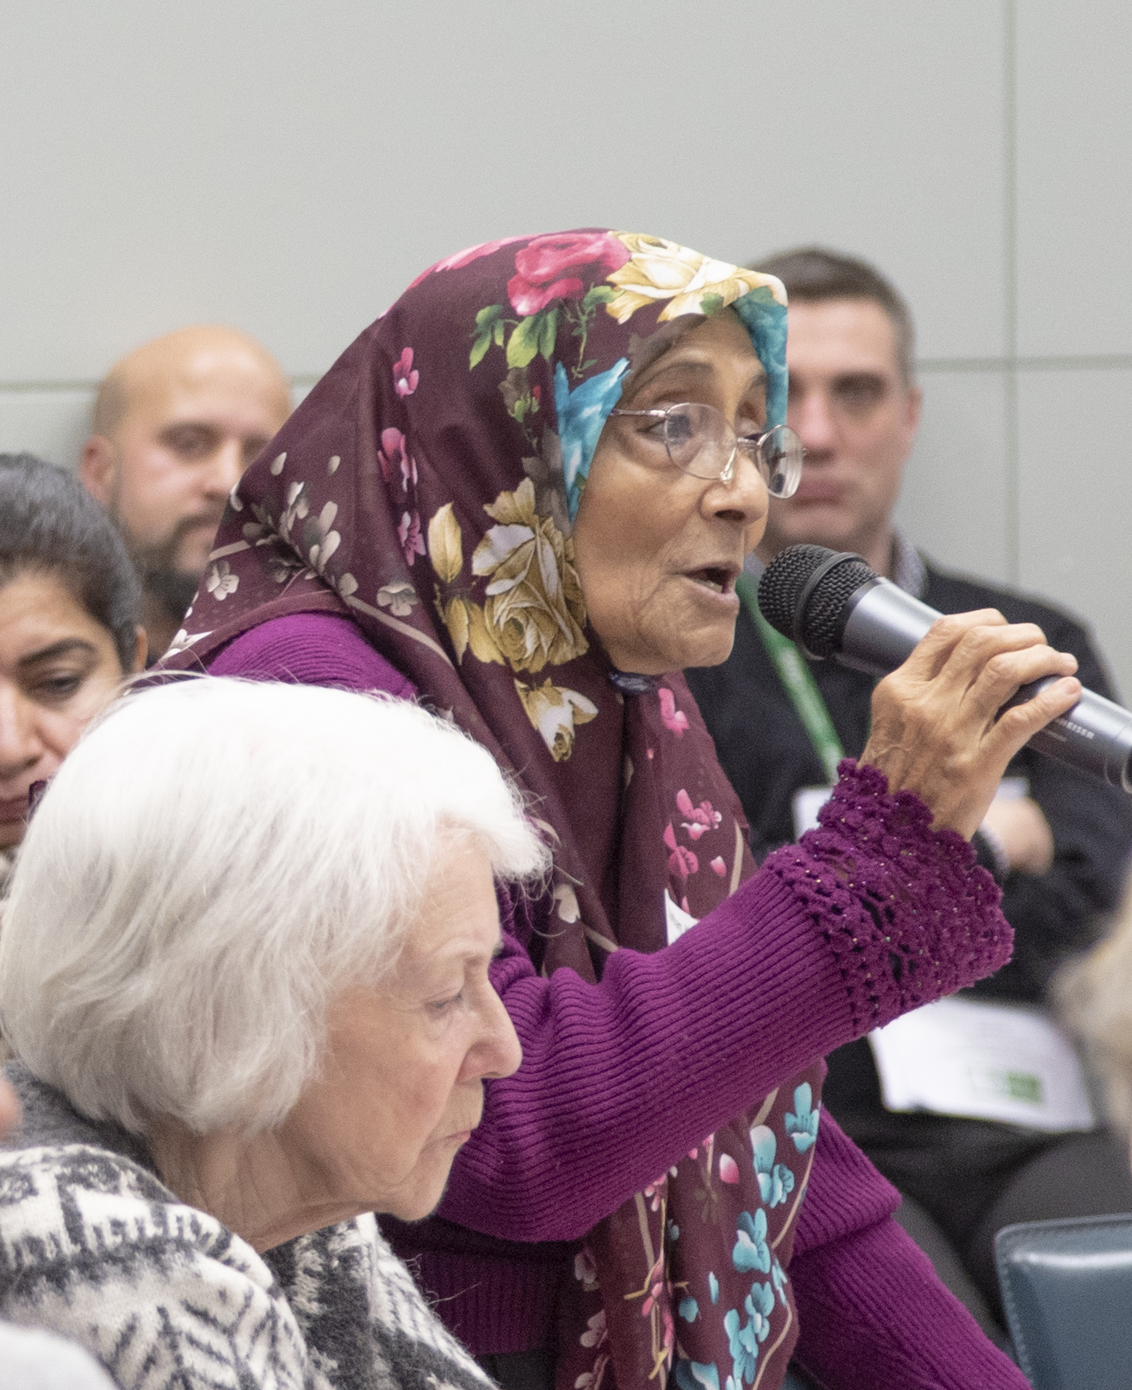

The value of small community-led equalities research projects

Sarah Wilkinson,
Clare Bonetree and Hannah Berry

February 2020

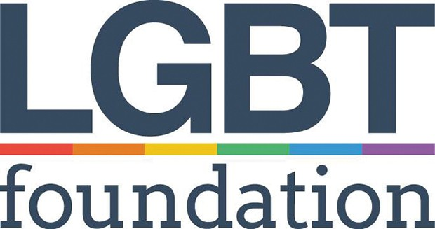

Ambition for Ageing is a Greater Manchester wide cross-sector partnership, led by GMCVO and funded by the National Lottery Community Fund, aimed at creating more age friendly places by connecting communities and people through the creation of relationships, development of existing assets and putting older people at the heart of designing the places they live.
Thank you to the staff and volunteers from equality organisations who carried out short research projects on behalf of the Equalities Board. Thank you also to members of the Equalities Board who have supported the research programmes and the writing of this report, especially Tendayi Madzunzu for piloting the interview questions.

Ambition for Ageing is part of Ageing Better, a programme set up by The National Lottery Community Fund, the largest funder of community activity in the UK. Ageing Better aims to develop creative ways for people aged over 50 to be actively involved in their local communities, helping to combat social isolation and loneliness. It is one of five major programmes set up by The National Lottery Community Fund to test and learn from new approaches to designing services which aim to make people’s lives healthier and happier.

Contents
Glossary / List of new terms 4
Executive summary 6
1. Introduction 8
2. Findings: Effects of a community-led approach on the research 10
3. Findings: The wider impacts of a community-led approach 18
4. Key messages about what makes a good place to grow older for people in minority communities 22
5. Conclusion 24

Photos: Ambition for Ageing (cover) S Choudhury (p17, p23), S Wilkinson (p21, p25)

Glossary / List of new terms
AfA = Ambition for Ageing: a Greater Manchester programme that aims to make communities more age-friendly and improve older people’s quality of life
Ageing Equally? = a programme of community research which focuses on what makes a good place in which to grow older for people who belong to minority communities
BAME = Black, Asian or Minority Ethnic: anyone in the UK who does not identify as White British
Bedoun / Bidoon = are a stateless Arab minority in Kuwait who were not made citizens at the time of the country’s independence
Co-design = when communities and service providers or professionals work together as equals to design services
Co-researchers = people involved as investigators in research who are also participants, or from the community that is being researched.
Community organisation = a not-for-profit group with a formal constitution that is set up to provide services for a specific local community, or community of identity
Dissemination = sharing the findings of research
EB = Equalities Board: the group responsible for making AfA inclusive and accessible for everyone
Equalities Organisation: an organisation that works to reduce inequality in general or for a particular group/community, and/or an organisation whose service users belong to a group/community that experiences inequalities, discrimination or marginalisation
Fieldwork = gathering data for research, for example through surveys or interviews
Inclusion = working in such a way that marginalised and minority groups are involved and able to participate in or benefit from a programme.
LGBT = Lesbian, Gay, Bisexual and Trans
Lived experience = knowledge gained through direct experience of an issue
Local Delivery Lead: the organisations responsible for AfA in the local wards
Mainstream = catering for the majority, not specialised
Marginalised = the result of being pushed to the margins of society: excluded or ignored
Microfunding = providing small amounts of money to individuals or organisations
Social isolation = a lack of social contact with other people (objective). It is different from loneliness which is a feeling related to the gap between someone’s desired social contact and their actual social contact (subjective).

Executive summary
This report explores the value of community-led equalities research by evaluating five short research projects in Ambition for Ageing’s Ageing Equally? programme. Five organisational members of the Equalities Board each received £2,000 to deliver a research project over six months in 2019. Each researched a specific marginalised community in a defined geographic area linked to the research question: “What makes a good place to grow older for people who belong to minority communities?”.
Organisations kept reflective research diaries during their projects and we interviewed community researchers from each organisation at the end of their projects. These were used, alongside data from Ageing Equally? meetings, to assess the value of community organisations delivering small equalities research projects.

Effects of a community-led approach on the research
The report findings are in two sections. The first section reviews learning about the benefits and challenges to the research process of community-based organisations doing research.
We found that community organisations have specialist knowledge about their community, understand cultural sensitivities and may also be more trusted within their communities than other types of organisations. This enables them to engage well with people from marginalised communities. Furthermore, the reports they produced used a writing style that may be more in tune with their communities. They are able to disseminate findings widely through community networks and they often put their findings into practice straight away in their work.
However, some community organisations may not have enough experience or skills in doing research. Some may need practical help and guidance with technical aspects of research, such as help with the planning stage, writing research questionnaires, analysing data, and writing recommendations. Community organisations may also need more time and flexibility so they can take risks and try new methods, or try to reach more marginalised people in their community. They may also need extra time and funding for interpreting or translation if community members do not speak English. Although they can disseminate findings widely in the community, some may need support from funders and commissioners to share research findings at more strategic levels.

This section of the report lists our recommendations for funders and community organisations for each stage of the research process from planning to dissemination. We found that the strengths of the community-based organisations were more in fieldwork and dissemination. They needed most help with the more technical stages aspects of planning the research, analysing data, and writing reports.

The wider impacts of a community-led approach
The second findings section shares what we learned about the specific benefits for community organisations that took part in Ageing Equally?, and for the research participants and their communities.
Organisations benefited by improving their research skills so they can do further research, gaining evidence of how their work is needed by their community, increasing their reputation, and involving new people in their organisations.
Individuals benefited from taking part by feeling heard and learning new skills. The wider community benefited from having increased knowledge available about community members’ needs.
We found that one advantage of delivering a programme of small projects was that, in addition to specific findings, it enabled us to gather learning across all projects to develop messages that may be relevant to other marginalised communities that were not included in the research programme. The key messages from Ageing Equally? form the next section of the report.

Conclusion and recommendations
The report concludes by summarising the benefits and challenges of community organisations delivering microfunded research. It emphasises the importance of providing good support to the organisations involved, and of understanding their motivation for participating in a research programme. The report concludes with a number of recommendations for commissioners of community research and community organisations planning small research projects.

Note: In addition to this executive summary we have written a simpler summary to help people understand the full report more easily. It is available here: https://lgbt.foundation/ambition-for-ageing/publications

Introduction
This report aims to explore the value of community-led equalities research by evaluating five short research projects in the Ageing Equally? programme. It evaluates both the research outcomes and the impact of the projects on participating organisations and communities.
Depending on their backgrounds, culture and life circumstances, different people need different things to feel socially connected and supported in their daily lives. People’s needs change as they age. Income, health and social networks change, and this can alter how people stay connected to their communities of interest and identity. Ambition for Ageing funded the Ageing Equally? research programme to find out more about this by asking:
“What makes a good place to grow older for people who belong to minority communities?”
Fifteen Ageing Equally? projects were funded in total. Ten £8,000 projects were carried out by a variety of groups, overseen by GMCVO. The Equalities Board managed five shorter projects by organisational members of the Equalities Board. These projects ran from March 2019 to September 2019. Equalities Board member organisations were eligible to apply for £2,000 to research a specific marginalised community in a defined geographic area.
- Ethnic Health Forum in Manchester researched the barriers to accessing services for older people in the Kuwaiti Bedoun community in Central Manchester wards
- Europia in Manchester researched the assets and skills of Polish people aged 50+ in Greater Manchester
- St George’s Centre in Bolton researched what makes an age-friendly neighbourhood for older people with long term mental illness who live in the BL1 postcode area
- Visible Outcomes in Salford researched what makes an age-friendly neighbourhood for refugees over 50 years old who live in Salford
- Wai Yin in Manchester researched how Chinese older people, especially disabled people and those who speak different community languages, can “grow old and happy”
You can find out more about the Ageing Equally? research programme and download reports here: https://www.ambitionforageing.org.uk/ageing-equally

1.1 Background to microfunding in Ambition for Ageing
Ambition for Ageing has used microfunding as the main approach to deliver projects with older people in local areas across Greater Manchester. The report Changing a place: Microfunding, co-production and community development assesses the learning from this approach in local areas, including the potential for this approach to engage more marginalised groups of people. Local programmes used a wraparound model in which support was offered alongside the funding. The report describes five key principles adopted by Local Delivery Leads in designing microfunding structures and processes locally as follows:
- Involvement of older people through co-production
- Intensive support from local delivery staff
- Community development and capacity building
- A “test and learn” approach
- Open funding criteria
We used a similar approach for this short research programme. Equality Board members were involved in decision-making, and staff provided intensive support and capacity building for the organisational members of the Equalities Board that delivered projects.

1.2 How this report was researched
As part of their contracts, all of the funded organisations were required to complete reflective research diaries. These looked at challenges and successes during the research process. The Equalities Board staff also maintained a learning log, and the Ageing Equally? steering group produced minutes. We analysed these sources for the five shorter research projects listed above. The aim was to identify the value of microfinanced community-led equalities research projects in terms of both research outcomes and the wider benefits to the organisations involved and the broader community. We also identified factors that need consideration when taking this approach.
Following this stage, we identified issues that we wanted to understand a bit better. We piloted a set of interview questions with a member of the Equalities Board, then used these to conduct telephone interviews with someone who had had responsibility for the research project in each of the five organisations.

Findings: Effects of a community-led approach on the research
This section looks at what is particular to microfunded community research. It follows the research process and for each stage looks at the benefits of using this model, and any risks or challenges are included under a list of factors to consider.

2.1 Planning and designing the research
A clear advantage of enabling people who have direct experience of discrimination or marginalisation to design a research project is that they bring a wealth of existing knowledge about their community to the research design process. The Ageing Equally? short projects were designed and delivered by relatively small local equalities organisations which were either led by members of the marginalised community that they proposed to research, or had done previous work with their chosen community.
Some of the projects used a co-design approach, involving people with ‘lived experience’ in decisions about the overall research approach, or in specific elements such as survey questions. This had the advantage of anticipating any sensitivities or barriers in suggested approaches or methods. Furthermore, some felt that involving community members in this way helped increase trust, especially in communities where bad previous experiences of authority may lead to individuals being unwilling to participate in research.
Wai Yin found that involving volunteers in the co-design process contributed some interesting early findings to the research itself:
The [co-researcher] workshops provided rich information of the gaps between services provided and the demands from service users. The dialogue was not just helpful to design questionnaire, but also can be seen as raw data of the research project.
However, there are certain factors that funders and commissioners of community research need to consider in relation to such projects:
- Community researchers need support and funded development time to produce realistic research proposals. This includes time and support to refine the initial research question, link this to planned fieldwork, and to plan data analysis. A brief expression of interest can be requested at the outset to identify good projects to support, avoiding the need for a group to fully develop their research proposal before funding has been agreed.
- It is vital to provide tailored support and guidance in the subsequent planning stage to avoid problems later on. Some community organisations may have limited research experience, and be eager to please in order to gain the funding. This may lead to research proposals being overambitious in scope with an over-emphasis on fieldwork. We found that there was a lack of attention to other stages of research including research design and piloting, analysis of data and producing the research outputs, such as reports.
- The planning stage should identify any potential skills gaps and prepare to address these through training or bringing in external resources. Some community organisations may underestimate the skills needed to produce valid research that addresses the overall research question or aim.
- It may be advisable for contracts to include requirements to share draft research tools with commissioners. The researchers may appreciate help with refining their questionnaires, or standardising elements such as demographic monitoring questions and consent information. We introduced this for the Ageing Equally? projects which resulted in improved and more focused questionnaires, but required both Equalities Board staff time and extra project time in the planning stage.
- It is important to enable researchers to take risks in how they engage with and research marginalised communities. We emphasised that the projects were as much about finding out how to do community research with marginalised communities, as they were about producing data. This may require changes to methods or other aspects of a project once underway. Key to this is creating open communication between projects and commissioners where challenges are viewed as learning and not as failure. Projects were required to write reflective diaries to capture the learning. Small community organisations may also be disproportionately affected by external factors, and this may be exacerbated by the short timescales for smaller projects. Uncertainty over Brexit had a particular impact on Europia’s project:
We’re a small organisation, in the summer our workload expanded due to the EU Settlement Scheme, our staff increased three-fold, there was lots of confusion and stress – I think the research project suffered, as people felt they could not give it the time it deserved.
- There should be enough flexibility in the research requirements for organisations to undertake research which will benefit them, whilst still meeting the overall research aims of the commissioner. Although we tried to be realistic about what could be achieved with limited funds, microfunding community research is unlikely to cover the full costs of a project. All the people we interviewed said that they had spent more time than anticipated on the project, but all were enthusiastic about their involvement. It is important to recognise that community organisations get involved in community research because it meets an organisational need of their own. This is explored later in this report.
- Research design should consider how taking part in the research will benefit participants. Some community members may have been subjects of previous research projects, or find themselves frequently asked for their views. Many marginalised individuals will associate providing personal data with poor experiences of authority, for example benefits, mental health or asylum systems. This is therefore not only a practical issue, in terms of the willingness of people to participate, but an ethical one. Financial compensation can value the time given, but other benefits may be of equal or greater value to participants. St George’s Centre, for example, used the funding to have extended one-to-one conversations with their service users, which is something they don’t always have the capacity to do:
Everywhere is underfunded, since the cuts have hit us hard. Members of staff have left. This [project] allowed us to work one to one with people. …Usually someone might come to us with an idea for a course or a group [to deliver] and we invite members to join. But with this project instead [we] discussed with each individual project member their feelings and memories. Then [we] … approached people to work together creatively if they wanted to… More people turned up every week, they were so eager to share their experiences
- Microfunding may limit the scope for full co-production or use of co-researchers. It costs money to involve community members in planning and delivering research, especially in training and supporting co-researchers. If it is important for the project to involve co-researchers as volunteers then microfunded projects may need to scale down fieldwork in order fully support volunteers within a limited budget.
- It is important to have smooth and proportionate contracting and finance processes in place, even for small amounts of money. Delays in these processes can have a critical impact on short projects.

2.2 Fieldwork
Commissioners may want to fund community-led research in the belief that community organisations will have existing connections to marginalised individuals, enabling them to reach and recruit participants more effectively than other types of organisations. We found that whilst this was true for some Ageing Equally? projects, others used the funding to broaden their own reach, either to be more inclusive of older people or to focus on a particular subsection within the community they serve.
When organisations attempted to engage beyond their existing client base, to reach people whose voices are not usually heard, some recorded having faced barriers such as gatekeepers and lack of trust. However, the fact that they were community-led organisations tended to mean that they had the expertise to recognise barriers and develop engagement strategies, and had relationships in the wider community to be able to seek help when needed:
We thought through our established clientele, it would be easier to engage potential FGD [focus group discussion] participants. This turned out to be a challenging task considering number of Bedoun community. We came across many gatekeepers within the community who were able to negatively influence other members of their community. This is a small community recently arrived in the UK as stateless refugees, [they] were more apprehensive of the fact that this might influence their benefits. Women within [the community of] Bedoun refugees [were] more difficult to engage. We used the potential place of their gatherings and found local library (Fallowfield) is a preferred place for them to hold FGD. [Ethnic Health Forum]
Four of the five Ageing Equally? projects focused on communities in which the majority of members did not have English as their first language. These projects conducted questionnaires and/or focus or activity groups in community languages, in some cases in addition to English. The presence of community language skills in community-led organisations is an obvious asset. However, commissioners and funders must recognise that translation is an additional factor that incurs time and financial costs. The approaches and skills to use community languages in a research situation also need consideration, and may require some trial and error:
The use of a bilingual Arabic Interpreter to facilitate the discussion was not useful as per our expectations. The move to recruit bilingual Arabic speaking Facilitator[s] to avoid the use of an interpreter during FGD was a success. After soft advertising using our email networks and social media, nine participants (four women and five men) attended the training and received certificates of attendance. The same day after the training we conducted short interviews and selected two participants (one male one female) to become facilitators in our proposed project FGD. [Ethnic Health Forum]
In addition to the challenges of reaching individuals beyond an organisation’s existing client base and conducting research in community languages, as already discussed, the following factors need to be considered by community organisations and commissioners when planning and conducting fieldwork:
- Community organisations may need training in fieldwork skills, or support to train volunteers. The skills developed during fieldwork can be one of the main benefits to the organisations of their involvement in the research, but support and training may need to be timetabled into the delivery plan, and may be needed on an ongoing basis.
- Support for co-researchers may be more demanding than anticipated. Using volunteer researchers requires a high level of support and training, including on issues such as research ethics, boundaries and bias.
- Community members can be involved in fieldwork in a range of ways. Some projects reported that using the term ‘researcher’ for volunteers felt empowering for them, but others reported that this term was intimidating. Projects found that the best approach was to offer different ways that individuals could get involved suited to their interests and skills:
This group of volunteers has shown their interest of learning new things, however… they were not confident in carry out interviews independently. They need a lot of support. Furthermore, volunteers think that a “researcher” is big name for them, therefore the role … made them feel very nervous …. It may be the reason that they were reluctant to join the research team after the meeting.
From the process of recruiting volunteers, I have learnt that volunteers may have different level of participation, and I need to review the aims of volunteers’ participation in this research project. I also learnt that I should value their participation even though they may not able to carry out an interview, but [providing] them with support to develop their skills and interests may have a big impact on reduce their own social isolation. [Wai Yin]

2.3 Analysis and reporting
The analysis and reporting stage of the research process is perhaps the stage where the advantages of using a community-led approach are least evident, and where some of the biggest potential challenges exist. A clear advantage of a community-led approach to analysis and reporting is that those doing the analysis will be likely to firstly have a high awareness of the context in which the research takes place, and secondly to be sensitive to cultural and other issues either explicitly raised or implicit in the findings. The language used in the report and the style of writing is more likely to be in tune with the marginalised community that the research is about. This not only brings a welcome diversity to reports but means reports may be more accepted and understood within the community that they concern.
However, we found that most of the organisations involved in Ageing Equally? were more confident in gathering data than they were in robust qualitative or quantitative analysis. Some needed considerable support in writing and editing reports. The following considerations should be borne in mind by both commissioners of community-led research, and those organisations that undertake them:

  - Skills development for analysis and reporting is important, as this is where research inexperience is often evident. It may be appropriate to bring in external expertise particularly for analysis and interpreting results.
  - Consider the need for resources for analysis at the planning stage. There is a particular risk of collecting too much qualitative information to be adequately transcribed and analysed. The challenge of working in community languages, which may also require translation, has greatest impact here and this may require specialist support.
  - Ensure that project timescales are realistic in terms of the time it takes to produce draft and final reports. It may be appropriate for contracts to require community organisations to provide draft reports for feedback. It should be clear who is responsible for proof reading as this is separate from commenting on the content of a report.
  - Take neutrality and perceived or actual bias into consideration when writing reports. Whilst subjectivity can be valued in community research, it is important to support researchers to separate personal opinions from findings uncovered through the research process. A disadvantage of using a community-led approach is that findings may be questioned if there is a perception that the organisation undertaking the research has a vested interest in the conclusions or recommendations. This is particularly the case when concluding recommendations are for increased funding to support a particular community or organisation(s) in the sector.
  - Report recommendations should be realistic and targeted. .Realism reduces the risk of raising expectations in a community which cannot be met. Community organisations may need help in identifying the appropriate audience for a recommendation – something which is important for effective dissemination of the research. Some recommendations may carry more weight if proposed at a programme level, or by the commissioner of the research.

2.4 Dissemination and action
Community-based organisations are likely to have good local networks for disseminating research. They are also able to empower research participants by sharing findings with them. The short Ageing Equally? projects achieved this in a range of ways, from including findings in an Annual General Meeting to producing printed leaflets and a radio programme.
Community organisations will already have relationships with a range of organisations in their sector and local area, facilitating the incorporation of individual findings from the research into meetings or reports. Several of the organisations funded by this programme did not initially have clear dissemination strategies. However, because they had conducted the research themselves, it was evident that new knowledge became embedded and in many cases informed practice relatively quickly.
The main points that need to consideration in this phase are:
  - Dissemination may suffer if projects overrun, since organisations may not be able to extend timescales due to staffing or other capacity issues. It can be difficult to monitor project delivery once final contract payments have been made, as organisations may have started to disengage and move on to other work.
  - It is important to consider at what level, and to whom, key messages should be directed. Responsibility for disseminating key findings should be outlined in the research contract. Community researchers need to plan how findings will be disseminated in their communities, although this may be flexible as new opportunities might arise out of the research. When community-led research is part of a bigger programme it may be more effective to disseminate some findings at programme level, especially if common issues emerge between projects. Commissioners may also have a role if they have, for example, relationships with relevant strategic bodies or if this would be beneficial in terms of perceived neutrality.
We are working with ethnic minorities, especially asylum seekers and refugees. [The research project] will give an opportunity to hear their voice with an evidence base. It all now depends on what we use the research for, how we will use it to engage with service providers or funders. [Visible Outcomes]
The key place-based messages from the short Ageing Equally? projects are included at the end of this report.
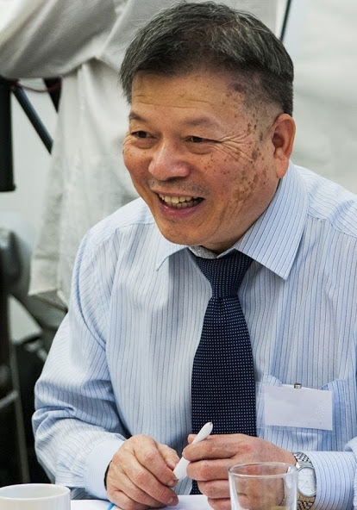

Findings: The wider impacts of a community-led approach

3.1 The impact on the community organisation leading the research
As outlined in section 2.1, it is important to define the benefits to community organisations of carrying out the research, as these are often as important, or more important, than the funding. The telephone interviews and reflective diaries highlighted a range of benefits to community organisations of taking part in microfunded research projects:
- Participating organisations can learn about new ways of working with community members or provide evidence for developing existing or new services
It helps us knowing how to plan services because we know what members and service users want…I know that people are interested in art. The research proved why they don’t want to go [to art groups]: because of the language barrier, they lack confidence, they need someone to go with, they need help to overcome barriers, feel accepted and supported. [Wai Yin]
- A small, funded research project can extend the knowledge of a community organisation about a specific community or equalities issue that is useful for the organisation, especially if there is some degree of flexibility in interpreting the research question
We have a better understanding of the dynamic of needs in terms of emerging vs settled communities, the differences between these communities, and different work that needs to be done. [Visible Outcomes]
- Research projects may enable organisations to reach and engage new service users, including from sections of the community that were previously underrepresented

- Research can lead to the recruitment of new volunteers with different skills, broadening the volunteer base

- Leading a microfunded research project can build the capacity of voluntary organisations to do research in the future, including developing research skills and identifying future areas for research
Female staff assisted the women’s [focus group] and learned skills about [focus groups] and community action [Ethnic Health Forum]
- Reports can be used by organisations to demonstrate their expertise and provide validation for the work they do
[We] felt validated – in the past we were a small organisation and could not attend events and make connections. This was a second opportunity [after the 2017-2018 EB research project] to do research with the same community, validating our knowledge with this community. [Europia]
- Reports can be used to demonstrate a need for further funding or support. However a limitation of this is that the research may not been seen as impartial.
We feel the report absolutely highlighted the issue with funding which is becoming harder and harder to fight for. [St George’s Centre]
- Association with a wider research programme commissioned by a respected third party can add weight to the findings of the research and enhance the reputation of the community organisation involved.
Being associated with ‘Ageing Equally?’, a research programme commissioned by Ambition for Ageing, a multimillion pound project funded by the National Lottery's Ageing Better initiative and led by the Greater Manchester Centre for Voluntary Organisation, will enhance the reputation of St George's Centre, adding weight to our research findings. [St George’s Centre]
- Involvement in research projects can make new connections with other organisations. In the case of this programme this included others doing research with different equalities expertise. Bringing organisations together for an induction session enabled them to share expertise and to support each other.
The research project helped the organisation to learn how to work collaboratively, and to develop future partnerships with larger organisations. [Ethnic Health Forum]

3.2 The impact on individuals involved in research
Individuals from marginalised communities involved in the research, as paid staff, volunteers or as participants, may benefit from their participation in research.

- Involvement as a volunteer or participant values their lived experience
They are feeling valued and that someone is listening to their issues, what they like and what they want, and feeling belonging as well. Maybe something will [now] change in their lives because of this collective voice. [Visible Outcomes]
- Research develops skills of individuals involved
Volunteers attended training at AllFM. All of them found the training was very interesting and this helped their IT skills as well. [Wai Yin]
- Participants may be supported with services or referred for support as a result of involvement in the research
[Participants were] pleased that somebody listens to them, cares about them, wants to ask them questions. They don’t engage with the voluntary sector, but now they know about an organisation that they can go to for help.
We will next translate the report into Polish and organise a lunch for participants to share the findings with them… This will also be a chance to check in with them, e.g. about the EU settlement scheme. [Europia]

3.3 The impact on the wider community
- Dissemination of knowledge locally, and/or within a specific marginalised community can increase community knowledge
A 15 minutes special programme [was] featured on Radio Sheung Lok, ALL FM 96.9, [called] On Lok Wo… Recording the programme provided an opportunity for presenters to ask questions and discuss the research findings. This created an opportunity for raising awareness and more understanding [of] the factors [in] social isolation and loneliness. [Wai Yin]
- Research can identify needs for new or existing services which, if acted on, benefit the local community or community of interest.
Something we have decided to do is to continue providing over 50s services for Polish people. The drop-in is ending in January and then we will spend three months planning and fundraising for a more sustainable project from March. [Europia]
- Strategic dissemination means that the voices of marginalised communities are considered by decision makers and funders, when planning future services
I do regular quarterly reports to CCG commissioners on the activities in the centre. The information from this research will go directly to the CCG, they will share it as good practice [St George’s Centre]
- A research programme about specific equalities issues or specific communities can reveal findings which have a broader relevance for dissemination to a wider audience.
Once the Equalities Board team had received all five research reports, we produced a shorter, more accessible summary report for each, for dissemination through Equality Board networks and on our website. The aims of this were
- to create accessible documentation of the learning from Equalities Board activities, as part of our commitment to inclusion

- to identify any learning from a specific marginalised community that may apply more generally across marginalised communities in relation to our research question: “What makes a good place to grow older for people who belong to minority communities?”
These key messages are included in the next section. The value of this approach is that, in addition to specific findings, it can highlight learning gathered across a small number of projects to develop messages which may be relevant to communities that were not included in the research programme.
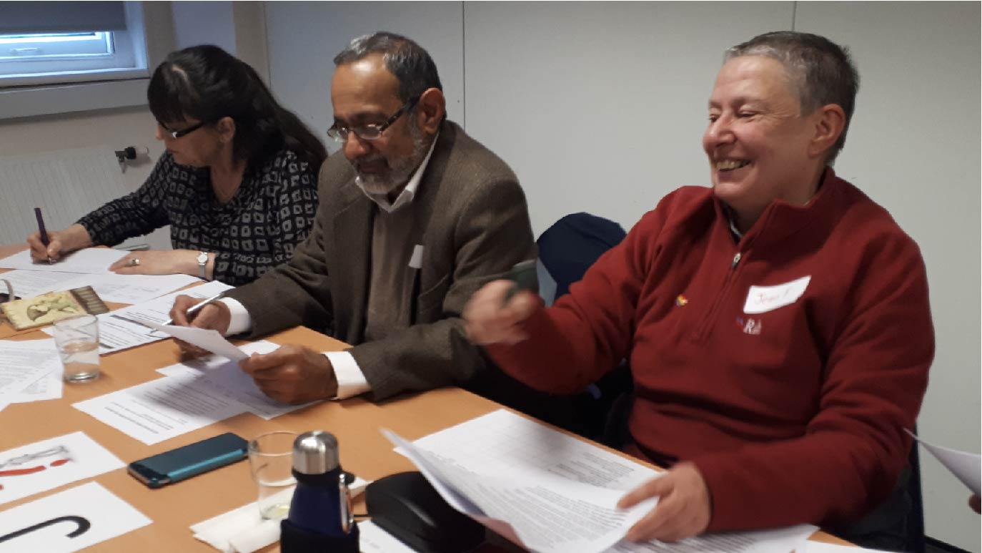

Key messages about what makes a good place to grow older for people in minority communities
We identified some findings in each of the five short research reports that could relate to marginalised groups more generally. These are grouped below by themes identified in Ambition for Ageing research into ‘What makes an age-friendly neighbourhood?’.
- Feelings of safety and security
- A sense of safety is related to feeling a sense of belonging and that your needs are met in the local area.
- Co-production is important in creating a safe place.
- Integration and belonging
- Even when there are differences between people in a minority community, they may feel they have more in common with each other than with the majority community in some parts of their lives.
- Diversity within a local area may make a place feel more welcoming for new arrivals from other minority communities.
- However, diversity within BAME communities means that even when there are places of worship and places to go for settled BAME communities, these may not meet the needs of new arrivals.
- Older people need to be able to maintain connections to places beyond their local areas. This may be particularly important for those who do not feel safe in their local area.

- Meeting and participation opportunities
- Older people in small minority communities need targeted appropriate social support plus culturally appropriate activities and services, as well as mainstream services being fully accessible.
- Services need to consider the culturally specific relationship between elders and younger people in a marginalised community when planning services.
- Co-production, where professionals and community members work together as equals, is important in creating a service that is trusted by people who are marginalised in their local area.

- Community resources and spaces
- Access to culturally-appropriate community spaces, including places of worship, is essential to a sense of belonging.
- Older people from migrant communities want and need support to integrate into their local communities, but also need their own mother-tongue community centres.

- Information and communication
- English language learning must be available and relevant to people of all ages to reduce social isolation in older age.
- Language learning provision needs to be age-friendly in both content, and how it is provided, to make it accessible, useful, and respectful.
- Language barriers can have hidden effects that increase social isolation; for example, even when people feel they are fully aware of local services, language difficulties may mean that there are things they do not know.

- Accessibility, transport and facilities
- Easy-to-access transport is particularly important for members of marginalised communities to maintain relationships outside their neighbourhoods and to access cultural and religious organisations for their community.
- However, people within marginalised communities may face additional cultural, language and financial barriers to accessing public transport.
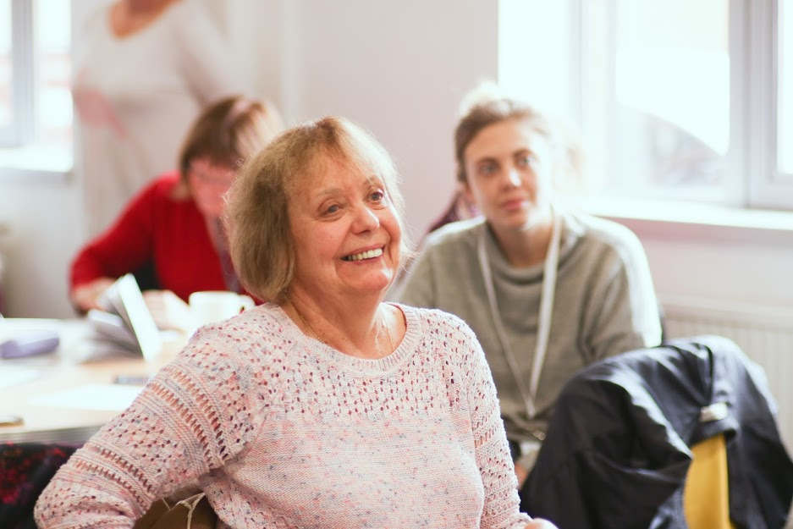

5. Conclusion
Community organisations are often best placed to reach and engage with the communities they serve. They are likely to have a head start in understanding what is important to members of their community and knowledge about the barriers they may face in participating in research. It is for these reasons that agencies interested in finding out more about marginalised communities may decide to commission community organisations to undertake research.

Funding community organisations to lead community research projects both shapes the nature of findings and outputs, and has implications for the organisations, individuals and communities involved.

Our post-project interviews highlighted the importance of supporting community organisations throughout the process, and of accepting that researching marginalised communities is difficult and may require flexibility and changes in methods. Using a ‘test and learn’ model for the research projects enabled researchers to take some risks by, for example, trying new methods or aiming to reach populations that they had not worked with before. The use of reflective diaries encouraged projects to record their learning about the research process, which has contributed to this report. We generally found that community organisations’ strengths lay in fieldwork and dissemination, and that they required more support with research design, data analysis and report writing. For each of these stages of research, this report has produced recommendations aimed at commissioners as well as organisations that may take part in future research.

It is important to understand what motivates community organisations to seek or take up opportunities for small research projects, not least because funding may not cover the full costs of doing the research. Ways in which our five organisations said they gained from their involvement included: generating new understandings about the communities they support; building capacity and networks for further research; validating and demonstrating the need for their work; enhancing their reputation; and involving new individuals in their organisations. Individuals involved as participants, volunteers or staff members directly benefitted from having their experience valued and developing new skills. Communities benefitted from increased knowledge, and potentially from more evidence-based services and the inclusion of marginalised voices in strategic decision-making.

5.1 Recommendations
Specific recommendations for each stage of the research process are included in section 2 of this report. In addition to these, the following broader points should be considered by those commissioning microfunded community research, and organisations wishing to undertake community research projects.

Commissioners should:
- Measure the success of a community research project by both the research outputs and how it has changed organisations, individuals and communities involved.
- Take a “test and learn” approach to community research, enabling learning from the process of undertaking the research project and organisations to take calculated risks to extend knowledge
- Recognise the additional resources required for involving co-researchers and / or researching in community languages and resource these adequately
- Consider the support that community organisations will need at all stages of research, but particularly the stages of data analysis and reporting

Community organisations should:
- Be realistic about what can be achieved within a microfinanced research project, in terms of the scope of the research and capacity and skills available
- Consider how the research may benefit their organisation and the individuals involved, whilst maintaining a clear focus on the research question
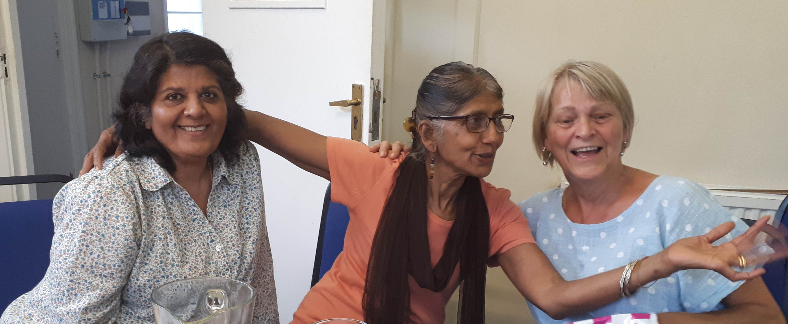

Yarker et al (2020) Changing a place: Microfunding, co-production and community development: Ambition for Ageing [online]
Thorley, J. (2018) Building Age-Friendly Neighbourhoods in Greater Manchester: evidence from the Ambition for Ageing programme, GMCVO https://www.ambitionforageing.org.uk/sites/default/files/Building%20Age-friendly%20neighbourhoods%20in%20GM%20FINAL.pdf
Key findings from several summary reports were combined for this section to avoid repetition
The two key findings in this section were not taken directly from any summary report, but project staff identified these as important when looking across findings from all five projects together.

