PROCEDURE FOR CLEANING AND REUSING EYE PROTECTION
To ensure that our staff are protected and safe, we are moving to the re-use of eye protection when used for:
- risk of splash to the face area (as outlined in Table 4)
https://assets.publishing.service.gov.uk/government/uploads/system/uploads/attachment_data/file/879111/T4_poster_Recommended_PPE_additional_considerations_of_COVID-19.pdf

Government guidance on the cleaning of equipment can be found here:
https://assets.publishing.service.gov.uk/government/uploads/system/uploads/attachment_data/file/877533/Routine_decontamination_of_reusable_noninvasive_equipment.pdf

For hygiene purposes, once issued with eye protection each staff member can
- Keep the eye protection for their own use
- Be responsible for its safe cleaning and storage

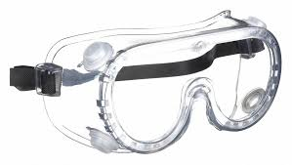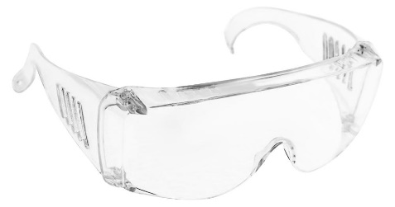

Eye protection should be removed first and then;
• Be decontaminated as per the Standard Operating Procedure (SOP) below
• All surfaces must be cleaned with a detergent / disinfectant wipe

Method 1- using combined disinfectant/detergent wipe

Action / Reasonable Adjustment | Rationale
Prepare a hard surface (large enough to place the visor/goggles on): clean the surface using disposable single use combined detergent and disinfectant wipes. Dispose of wipes | Detergent / disinfectant wipes will clean organic matter from the surface.  To reduce the risk of cross infection.
Wearing a clean pair of disposable gloves remove the goggles taking care not to contaminate the face whilst doing so.  Place the goggles face/strap side down onto the clean prepared surface and using a disposable single use combined detergent and disinfectant wipe clean the outer surface of the goggle  - Allow to air dry for 30 seconds  - Dispose of the cleaning wipe(s) | There is a potential risk of cross contamination if it the goggles are not correctly removed.
Turn the goggle over so that the internal surface is face upward. Using a clean combined detergent and disinfectant wipe clean the inner aspect of the visor.  - Allow to dry for 30 seconds.  - Dispose of the cleaning wipe(s) | To reduce the risk of cross infection.
Using a combined detergent and disinfectant wipe, clean the hard surface on which the goggle was placed.  - Dispose of the cleaning wipe(s)  - Discard disposable gloves and decontaminate hands | To reduce the risk of surface contamination
Store the goggle in a clean easily accessible place between each use for the remainder of the shift (clean plastic bag would be suitable, with the date and time of the cleaning undertaken). | To ensure the visor/goggle is accessible for use and the area remains clean to prevent cross contamination

Method 2- using a solution
- Decontaminate goggles with disposable cloths/paper roll and a fresh solution of detergent
- Rinse and dry
- Follow with a disinfectant solution of 1,000 parts per million available chlorine (ppm av cl)
- Rinse and thoroughly dry
Or
- Use a combined detergent/chlorine releasing solution with a concentration of 1,000 ppm av cl, rinse and thoroughly dry.

Points to bear in mind

- Follow manufacturer’s instructions for dilution, application and contact time.
- Discard disposable cloths / wipes & /paper roll immediately into the healthcare waste receptacle
- Discard detergent/disinfectant solution in the designated area
- Clean, dry and store re-usable decontamination equipment
- Remove and discard PPE
- Perform hand hygiene

