COVID 19 – PPE Hub Photographs of eyewear options – to accompany order form Rev D
Dispatch will depend upon stock availability
Type 1 – Disposable eye shield - WITHDRAWN Type 2 – DIY Style goggle
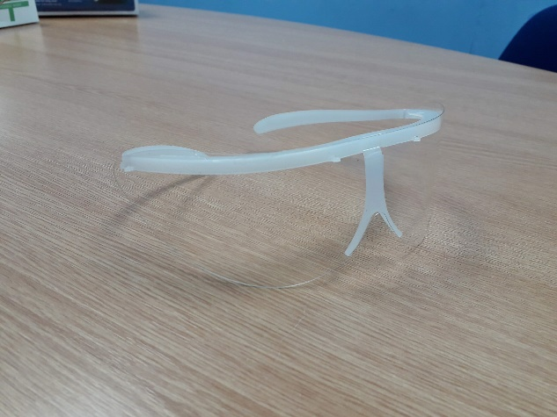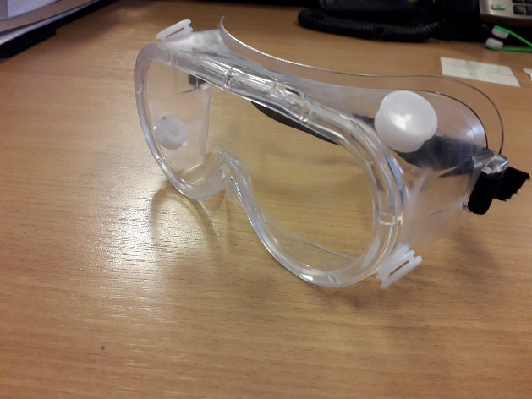
Withdrawn
Type 3 – Science goggles Type 4 – Face visor for AGP – foam headband
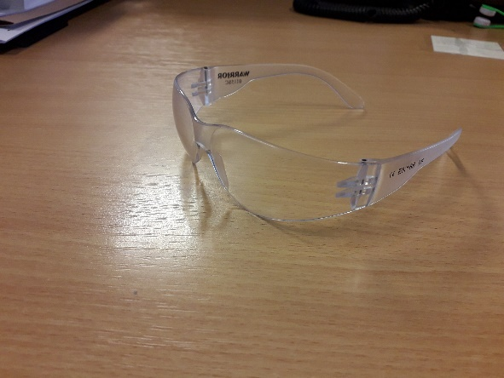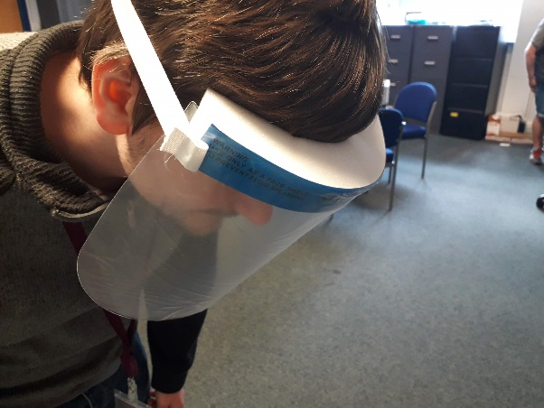
Type 5 – Non-AGP Visor (typically 3d printed)
