Tell Us Survey- Tameside and Glossop
Initial Analysis
September 4th 2015
Background
Tameside and Glossop CCG commissioned 42nd Street to conduct an online survey of young people aged 11-18 years living and being educated in Tameside and Glossop. An online questionnaire was designed in consultation with the Emotional Welbeing and CAMHS Programme Board set up to oversee the Department of Health national pilot project
The questionnaire was distributed across Tameside and Glossop by partners associated with this Programme Board from the end of July 2015 until early September 2015.
Young people were invited to complete the survey on their own. All answers were treated as confidential.

The Questionnaire was split into seven sections:

SECTION ONE was designed to capture basic demographics of postcode and age
SECTION TWO was designed to capture attitudes and behaviours in relation to low level stress and low mood and included a specific focus on support within school/college settings and specific questions around school health nurses.
SECTION THREE focused on the type of qualities young people would expect from professionals who might support them with their emotional health and wellbeing
SECTION FOUR explored how new technology and social media might support young people with their emotional health and wellbeing
SECTION FIVE was only completed by young people who had experienced statutory Child and Adolescent Mental Health Services (CAMHS) in Tameside and Glossop
SECTION SIX focused on appointment access
SECTION SEVEN was designed to capture attitudes and behaviours in relation to more serious, escalating mental health issues and ideas for future provision

A total of 139 questionnaires were completed; 41 young people completed the CAMHS section.
The results were compiled and analysed by 42nd Street

Demographics

There is clearly a large proportion of respondents from the SK16 area. This is likely to be due to the fact that a specific school completed more surveys than any other setting. This could skew the data as the young people from that school may have had a particular experience of services that may not be typical of services across Tameside and Glossop.

Again the age range is skewed, perhaps due to particualr year groups completing the surevy in a particular schools. It is also worthy of note that the Partnership board took a decision only to consult with young people aged 11-18 years old. It may be advisable to talk to some older young people that are able to reflect on services received to enhance the finding wtin this report and there is also a potential for consulting with younger children and parents in order to build up a wider understanding of need and experience

Accessing Support
Participants were asked to indicate where they would be most likely to go for support if they were feeling worried anxious or low for more than a week.a bit anxious or low. There were 8 prompts and a space for other/free text, unprompted responses. Respondents could choose any number of responses that were relevant to them. The language used was deliberately non-technical and based on the language used in the Thrive Model being adopted across Tameside and Glossop.
Early help
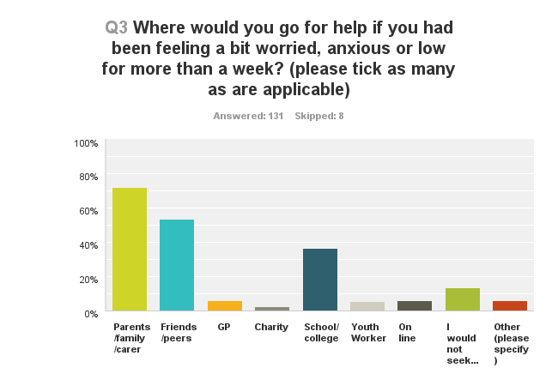
It is clear that young people’s parents, families and carers are very important to them when they need low level support followed closely by friends and peers. These responses make a clear case for ensuring that family and friends are equipped and trained to deal with these calls for support from young people; offering the wrong kind of advice at this stage could lead to escalation of issues. Conversely, if the right information is available to these networks then young people are more likely to receive trusted, informed support when they need it and from people that they trust.
Other sources of support identified were Granparents (1 response), boyfriend (1), doctor (1), “Everyone I trust” (1) and Childline (3)
Help in schools and colleges
Schools and colleges also represent significant importance for young people in terms of early help, the following section breaks down respondent’s attitudes and experience to provision within school and college settings.
Young people were asked and open, free text question “What support is available at your school/college when people are feeling a bit worried, anxious or low?”

Core teaching and teaching assistant staff represent 44% of the response from young people and going up to 52% if we include pastoral staff. Comments suggested that many young people feel teaching staff are approachable and available. For example comments included
“We can talk to our teachers any time in private”
“Teachers will help you feel happy”
“If any child feels upset, worried or scared our Yr 6 teacher would take us out of class and try to figure out what is effecting us
However, 14% of responses indicated that young people did not know what help was available or felt there was little or no support
Other services i.e. Oasis, Progress Leaders and counsellors all represented 6% of responses, the schools website was mentioned by 3% of respondents. CAMHS featuring in only 1% of responses alongside parents, peer mentors and bespoke school provision.
The survey focused two specific questions around school nurse provision: Have you ever accessed the school nurse for help with your emotional or mental health? And if so how would you rate the help that you received?
Only 14% indicated that they had accessed a school nurse for support in this way and of 21% rated the service as unsatisfactory, 7%-poor, 54%-good and 18%- excellent. This is an interesting spread with 72% rating the service well but 21% indicating dissatisfaction.
More Help
Later in the survey young people were asked where they would go to for more help if their mental health became more serious. Again the participants were asked to choose from a set of prompts with space for other/free text, unprompted responses. Respondents could choose any number of responses that were relevant to them. 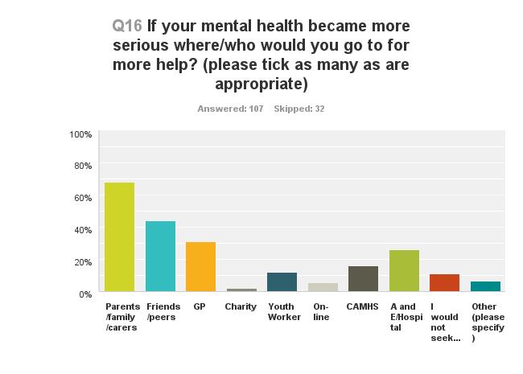
Parents, family and carers remain consistently high in the responses dropping by just 4%, friends and family also remain high but the drop is a more significant 9%. These trends suggest that family and friends remain a critical part of the young people’s support netwok as issues escalate. Perhaps the drop in responses in relation to friends and peers reflects increased stigma or isolation as issues escalate or perhaps that young people recognise that they need more experienced perhaps professional support at this stage.
This second explanation is supported by the fact that GPs become a much stronger feature of the support at this stage, with an increase of 25% and CAMHS is also indictaed by 16% of the respondents as a somewhere to go for more support as issues become more serious
The number that would not seek help at all does drop by 3% as the issues escalate, but it is still worthy of note considering the increased need for help.

Professional Qualities
Young people were asked the open question “What qualities would you look for in a person that could help you with your emotional wellbeing and mental health?”
The words used most were KIND and UNDERSTANDING (20% each) with GOOD LISTENER (19%), Supportive (18%) and Trustworthy (16%) also being popular choices.
Technology and Social Media
Respondents were asked: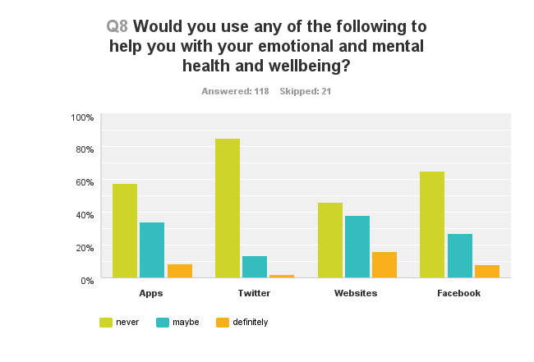
The responses indicate that young people generally do not feel the options presented would be helpful; with websites being the only medium where the combined “maybe” and “definitely” scored more highly than “never”. This is worthy of more exploration but may reflect the risks associated with accessing social media for young people and the fact that what they want is to access face to face professional support
Statutory Child and Adolescent Mental Health (CAMHS)
One section of the survey only completed respondents that had experienced statutory CAMHS. Of the 139 that responded to the survey in total, 41 young people completed this section
Young people were first asked to rate accessibility to CAMHS and then the quality of the service that they had received. The results are as follows

These charts indicates a relatively even split between very eay/easy and difficult/impossible responses in terms of accessibility. Comments associated with accessibility included:
Very easy/easy:
“It was done for me”
“Because it was sorted out by my social worker”
“They come into hospital and talk to you”
Difficult/ impossible:
“Not taken seriously by the people”
“3 referrals from health professions and nothing”
“Too many boxes to tick”
“Nobody rang me I had to do all the chasing around”
“My old school said they would get in contact with them for me but they didn't”
“I didn’t know what to do and they did not have a clue what i was saying”
It is interesting that the consistent theme here is that where young people are supported well in their referral they find access easy, but where they perceive they have been let down or not supported the accessibility feels much more difficult. There is perhaps something to explore here in terms of self- referral processes and integrated processes and services
Once accessed responses suggest that most young people felt the service was “good”, however there were still 44% of respondents that felt the service was poor or unsatisfactory.

When asked “What do you think worked best for you at CAMHS 11 of 24 respondents indicated “nothing” (4) or don’t know (7)
Other responses included:
“Weekly meeting with someone who understood and listened explained that's its ok sometimes to feel low”
“Allowed me expression which helped me understands my past. Activity based as well so it was not boring”
“My support coordinator”
“We get achievement”
“The talking”
“Professional workers”
When asked what could be improved at CAMHS responses included:
“Less group sessions and more one to one”
“More training in understanding ASD”
“Stop cutting this service children need it”
“Access post 18 as part of being a care leaver”
“Listening to parents”
“At times it was more about my mom than me”
“Out of hours service”
“Calming people who understand”
“Less waiting time”
If you were going to see a professional about your emotional health and wellbeing or mental health, where would you like your appointment to take place? 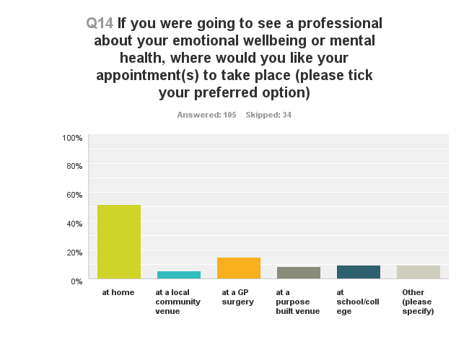

If you were going to see a professional about your emotional health and wellbeing or mental health, when would you like your appointment to take place? 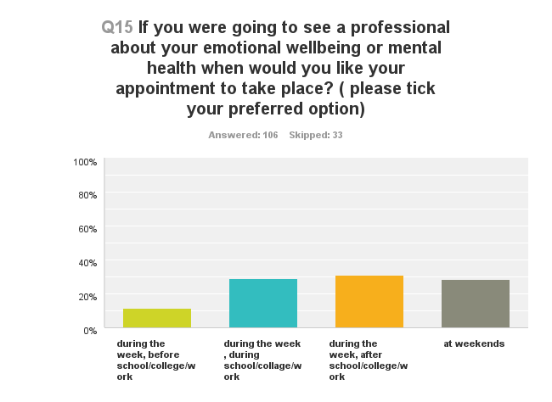

31% - during the week after school/college/work
29% - during the week during school/college/work
28%- at weekends
11% during the week before school/college/work

What would you like to see to help young people in Tameside and Glossop with their emotional wellbeing and mental health?
Responses included:
“A place just to pop into for advice”
“More investment and training in specific needs of children, to be taken seriously”
“More support for siblings and mums”
“Someone to talk to other than a referral to TAMESIDE hospital”
“More CAMHS workers, not so many boxes to tick and hoops to jump through, support for as long as it was needed with the same person”
“More services- less stigma”
“Better services”
“More advertising more awareness and leaflets through the post because this is serious”

