Free Weight Management Service
What is ENABLE?

ENABLE Manchester is a free Adult Weight Management Service, commissioned by Manchester City Council. The service is delivered by a team of experience and qualified Lifestyle Coaches who are supported by a multidisciplinary team which includes a GP, psychologist, nutritionist and exercise specialist.
WHO can access the service?

- Adults aged >18 years
- Living within the Manchester City Council boundary
- BMI 25+ (or 23+ from BME communities)
WHAT can clients expect from the programme?

- Personalised assessment incorporating expectations, challenges and aspirations
- 12 weekly group sessions including nutrition, exercise and behaviour change
- 6 x 1 hour bi-weekly sessions for adults requiring additional support
- Up to 9 months of monthly ‘Check In & Chat’ group support
- Evidence-based behaviour change support
- Signposting and connections to local community networks
HOW can clients book on?

- Referral through a GP, health professional
- Self-referral by phoning 0161 393 7576
- Email admin@ablhealth.co.uk
WHAT further information may I need?

ABL Health can provide tailored support to groups, i.e. clients with learning disabilities. These groups will be delivered in partnership with local services.
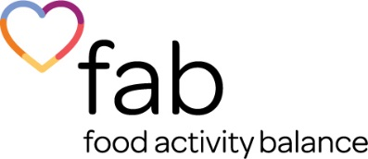

What is the FAB Health Service?

FAB is the Children & Family Weight Management Service commissioned by Manchester City Council to work with 2-17-year-old children and their families who are Manchester residents with a BMI greater than the 91st centile.
WHO can access the service?

- Any school aged child 2 - 17 and their family/parents/carers
- Living within the Manchester City Council boundary
- BMI ≥ 91st
WHAT can clients expect from the programme?

- A Multi-Disciplinary Assessment
- Weekly 1.5-hour physical activity and lifestyle group sessions over 12 weeks
- One-to-one sessions for those requiring additional support
- Fun, interactive activities and games
- Guidance on lifelong lifestyle and behavioural changes
- Nutrition and physical activity
- Information on appropriate BMI according to child growth charts
- A supportive and caring environment
- Review of eating habits and updating of a monitoring diary
- Personal goal setting
HOW can clients book on?

- Referral through a GP, school nurse, health professional or a family supporting service
- Self-referral by phoning 0161 393 7576
- Email admin@ablhealth.co.uk
WHAT further information may I need?

Clients aged 15+ are required to complete a PAR-Q before attending group sessions which ABL Health will complete with the client. Parental consent will be required for any child under the age of 16.

