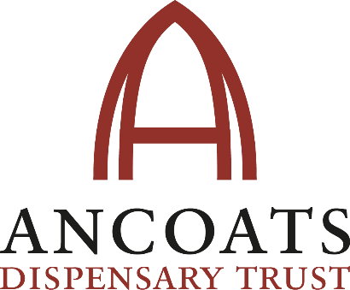

SECRETARY:

Remuneration: The role of Secretary is not accompanied by any financial remuneration, although expenses for travel may be claimed.

Time commitment: 12 Board meetings per year, with additional time for reporting

Reporting to: Board of Directors (Executive Committee)

JOB DESCRIPTION:

We need a Secretary who is excited by the project. Someone who loves Manchester. Someone who sticks up for the underdog. Someone who loves the idea of a genuine community hub in the centre of the huge Manchester Life regeneration initiative. Someone who will make it happen.

You will bring commitment, passion and the ability to harness all the resources to make the vision come true.

OBJECTIVE:

The Secretary will oversee the organisational matters of the ADT in line with good practice and in accordance with the governing document and legal requirements, and support the Board of Directors at regular intervals regarding matters of governance and everyday health of the organisation. The Secretary will ensure that effective administration, meetings, record keeping, general monitoring of meetings, financial measures, controls and procedures are put in place, and are appropriate for the ADT.

PRINCIPAL RESPONSIBILITIES:

- Plan and prepare the committee meetings, and the AGM with others as appropriate
- Planning meeting dates, booking rooms, sending out notifications, minutes and other papers
- Drawing up agendas together with the Chair
- Accurately record decisions and actions in the minutes and report to the next committee meeting on the progress of actions and the result of decisions
- Maintain accurate and up-to-date membership records, issuing renewal notices and recording subscription/membership fees together with the Treasurer
- Deal with correspondence, writing letters/emails as agreed at committee meetings summarising correspondence/emails received at the next committee meetings and drafting replies as appropriate.

MAIN DUTIES:
- To ensure that the requirements of Companies House are met;
- That committee meetings are properly administered and recorded;
- That the list of Directors at Companies House is kept up-to-date;
- To ensure that the AGM, EGMs etc. are properly administered;
- That membership records are kept up-to-date
- That annual returns are made to regulatory bodies as appropriate and in the correct format

BESPOKE RESPONSIBILITIES:
- Ensure that committee meetings and the AGM are run according to the Constitution and Companies House requirements
- Ensure nominations for directors are received in time and in the correct format
- Ensure voting procedures are followed correctly
- Ensuring that any required business is dealt with (such as appointment of auditors)
- Ensure that committee meetings, including decisions and actions, are adequately minuted
- Ensure accurate and up-to-date membership records are maintained in accordance with the Constitution and Companies House requirements
- Ensure that the annual return to Companies House is submitted on time
- The proper name for a constitution of a company is ‘The Memorandum and Articles of Association’.

ADVERT TEXT:

ANCOATS DISPENSARY TRUST NEEDS YOU!

Ancoats Dispensary Trust (ADT)is a grass roots community group dedicated to saving and restoring the Grade 11 Listed Ardwick and Ancoats Dispensary for the people of Manchester.

The project aims to capture and share the history of this pioneering building’s lasting witness to urban poverty, ill health and social welfare, and transform it into a thriving sustainable, mixed-use community hub owned by the community, for the community. The Dispensary will be focused on health and wellbeing activities, reflecting the building’s original purpose as a place of healing, and will also contain commercial space for charities and social enterprises whose work reflects the socially responsible vision for the new Dispensary.

We’re looking for a new Secretary to help us realise this vision and help manage the Trust’s record keeping, so if you’ve an eye for detail for figures, like a sense of order, and a passion for making a difference we want to hear from you!

Person Specification

Experience:

Individuals are sought who have a strong empathy with our mission to restore Ancoats Dispensary for the community, and an interest in heritage and community development. If you have experience in one or more of the following topics please get in touch.

Experience in/knowledge of:

- Companies House
- Record/minute keeping/organisation skills
- Successful experience of operating within a board in a voluntary, charitable, public sector or commercial organisation
- A proven track record of sound judgement and effective decision making;
- A history of impartiality, fairness and the ability to respect confidences
- A lively interest in, strong commitment to, and appreciative awareness of the social enterprise sector
the independent role and function of a community organisation

Knowledge, skills and understanding:

- Commitment to the organisation and a willingness to devote the necessary time and effort
- Preparedness to make unpopular recommendations to the board, and a willingness to speak their mind
- Good, independent judgement and strategic vision
- An understanding and acceptance of the legal duties, responsibilities and liabilities of Directorship
- An ability to work effectively as a member of a team
- An understanding of the respective roles of the Chair, Directors and Chief Executive

